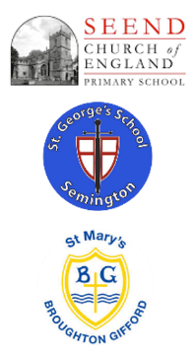

**Curriculum Impact**

Through playing, singing, creating and performing, children will develop confidence, communication, thinking and creative skills and improve their emotional well-being. The skills involved in playing and listening to music will also help learners develop the self-esteem, self-discipline, cooperation, creativity, and self-motivation necessary for success. Our children will have a love of singing and music making and will be confident to apply the skills they have learnt across a range of both un-tuned and tuned instruments.

**Curriculum Implementation**

At Seend, St George’s and St Mary’s, all children will have the opportunity to develop their understanding, skills and techniques in music throughout the year.

The national curriculum is our starting point for deciding upon the knowledge and skills that children will be taught in each year group. Our curriculum, through the use of Charanga is designed to ensure that, where possible, learning is relevant to our diverse community and rooted in our rich heritage. In Music we have developed the scheme of Charanga to ensure there are fun and exciting opportunities to learn during each music lesson. Learning is sequenced to ensure that prior learning can support what comes next. The Charanga scheme helps non-specialist teachers and TAs to deliver good quality lessons with confidence.

Our peripatetic teachers who come into school to teach music lessons are giving opportunities for children to learn and develop their skills from an experienced specialist teacher. These teachers are; guitar, piano and singing.

**Curriculum Intent**

At Seend, St George’s and St Mary’s, we aim to provide a high-quality music curriculum that is embedded in every aspect of school life and inspires a life- long love of music in every child. We aim for our music provision to provide a platform for every child to be a musician. We strongly believe that the opportunity to engage in musical experiences impacts positively on the development of the whole child, building upon social skills as well as other transferrable curricular skills such as counting.

Music at

‘The Three Schools’