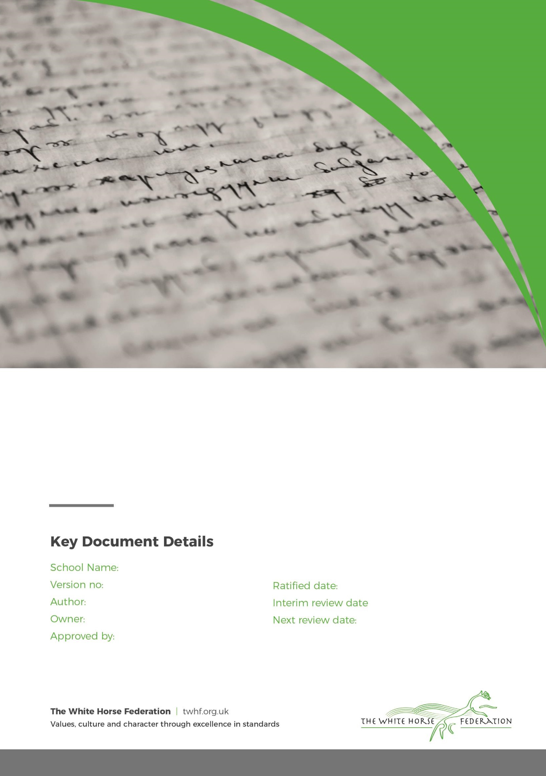
Regional Director for Primary Education

Anti-Bullying Policy

Principal

Principal

February 2026

September 2027

St Mary’s Broughton Gifford

2
n/a


Curriculum Intent Statement for St Mary’s Broughton Gifford Primary School

Our School Vision

We will strive to ensure that every child is valued as a unique individual who has been created in the image of God. Our Christian values of respect, community, wisdom and generosity will form the foundation of everything we do in school. Our Christian ethos will be demonstrated in the main through the relationships that people have with each other here.... between adults and children, adults and adults and children and children.

Together, grounded in respect, generosity, wisdom, and community, we will "let our light shine" in all that we do.

“I have come that they may have life, and have it to the full.” John 10:10.

Our Curriculum Pledge

At St Mary’s Broughton Gifford Primary School, our curriculum pledge is:

- We promise that we will have the highest expectations for all
- We promise that we will uphold our school Christian values
- We promise that we will all be inspired, excited, engaged and curious learners
- We promise to nurture life-long learning

Anti-Bullying Policy at St Mary’s Broughton Gifford Primary School

Aims

Studies carried out by KIDSCAPE and NSPCC show that 68% of children say they are bullied at some stage of their school life. At St Mary’s Broughton Gifford, we strive to create a safe, caring environment where children are not afraid to talk about, and discuss bullying, and where they know they will be listened to sympathetically. Secrecy and silence nurture bullying, children need to be encouraged to TELL, TELL, and TELL.

Definition of bullying

We define bullying as “deliberate, unprovoked, physical or psychological harm by a more powerful child, adult or group, against a weaker child, adult or group”. It may be distinguished from normal rough and tumble play or other unacceptable forms of aggression, in that it is often premeditated and usually forms a pattern of behaviour rather than an isolated incident.

We recognise that there is a distinction between one-off unkindness, whether accidental or on purpose, and so aim to empower our children by using a simple acronym to help them recognise bullying and response appropriately, whether victim, witness or perpetrator.

The following simple definition and approach to managing bullying is taught to children:

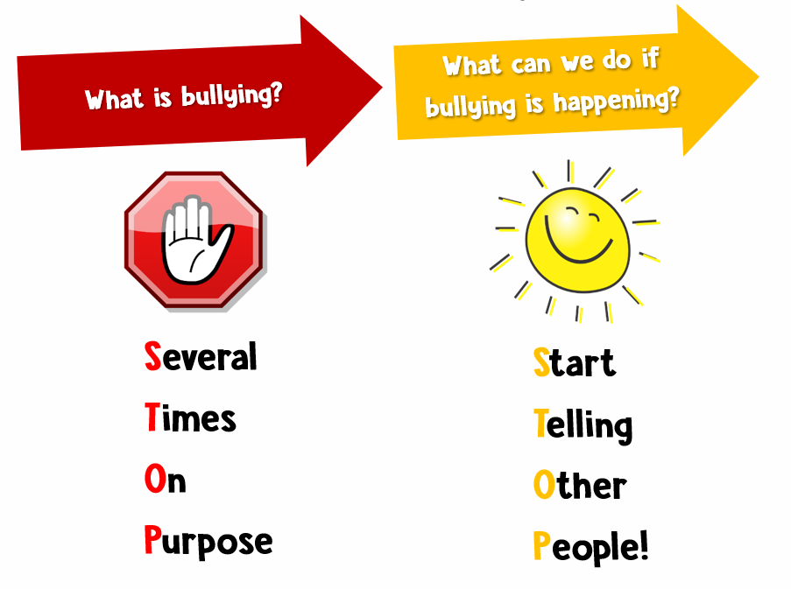

What is bullying?

Bullying is defined as the repetitive, intentional harming of one person or group by another person or group, where the relationship involves an imbalance of power. It is a form of child on child abuse and there is a zero-tolerance policy to bullying at St Mary’s Broughton Gifford.

Bullying is, therefore:

- Deliberately hurtful

- Repeated, often over a period of time

- Difficult to defend against

Bullying is a form of repeated and purposeful child on child abuse, which may be physical, verbal, emotional, online/cyber, silent, sexual or prejudice-based and discriminatory.

Examples of each type of bullying include:

Type of Bullying | Examples
Physical | Pushing, poking, kicking, hitting, biting, pinching, unwanted physical contact, inappropriate touching etc
Verbal | Name calling, sarcasm, spreading rumours, threats, teasing, belittling etc
Emotional | Isolating others, tormenting, hiding books, threatening gestures, ridicule, humiliation, intimidating, excluding, manipulation and coercion etc
Online/Cyber | Posting on social media, sharing photos, sending nasty text messages, social exclusion
Silent | Excluding someone on purpose, making nasty faces at someone, ignoring someone to be unkind, freezing a person out, telling others not to talk or play with a person, spreading rumours or gossip about a person, doing nothing to stop it happening to someone else
Sexual | Explicit sexual remarks, display of sexual material, sexual gestures, unwanted physical attention, comments about sexual reputation or performance, or inappropriate touching
Prejudice-based and  discriminatory, including:  - Racial  - Faith-based  - Gendered (sexist)  - Homophobic/biphobic  - Transphobic  - Disability-based | Taunts, gestures, graffiti or physical abuse focused on a particular characteristic (e.g., gender, race, sexuality)

Tell Tale signs

Children who are being bullied may:
- Be frightened of walking to school alone
- Be unwilling to go to school or feel ill every morning
- Begin performing poorly at school
- Have clothes or possessions destroyed quite often
- Have possessions go missing
- Cry when left alone
- Have unexplained cuts and bruises
- Ask for money or begin stealing (to give to the bully)
- Become withdrawn and start stammering
- Become depressed and anxious, may stop eating
- Have nightmares
- Begin to bully other children or siblings
- Give improbable excuses for any of the above

Strategies for prevention of bullying

As adults working in school we must:

- Tell children from day one that bullying (verbal or physical, including racist, homophobic bullying, or that relating to transgender issues) is NOT tolerated in school. Everyone is expected to ensure that it does not happen and has the responsibility to tell – this is not telling tales.
- Raise self-esteem of pupils through praise, reward system, positions of responsibility, circle times etc.
- Help the pupils to understand differences caused by illness, medication, handicap or disfigurement etc. in order to increase tolerance and reduce the likelihood of bullying.
- Use PHSEE/role play to teach co-operation skills, and non-bullying ways of resolving conflict.
- Provide on-going opportunities to bring problems out into the open through regular circle time or the use of puppets, etc.
- Teach children that by witnessing an incident of bullying and doing nothing they are actively encouraging bullying behaviour. Bystander power is the biggest weapon we have in tackling bullying, we need to teach pupils how to be effective bystanders and take on social responsibility.
- Teach the children strategies for dealing with bullying themselves (see Appendix 1)
- Use games lessons to teach the children that, when playing a game, the rules are laid down by all players, right at the beginning, and it is important to keep to these rules.
- Use assemblies to demonstrate anti-bullying attitudes and the values we want to promote.
- Have clearly defined, taught, playground rules and show that it is important to stick to the rules for everyone’s best interest.
- Reward appropriate behaviour, and ensure that everyone knows the consequences of breaking the rules

Reporting Bullying

Victims of bullying often feel very isolated and alone; they need to know that once they have told someone about being bullied they will be protected from further bullying. Children at St Mary’s Broughton Gifford, whether victim or bystander, need to know that they can report incidents of bullying to any adult member of staff, teaching or non-teaching and that all incidents will be taken seriously. Children should be given time to talk and be praised for telling.

Responding to bullying

All bullying allegations will be taken seriously and incidents investigated thoroughly. This includes incidents involving cyber-bullying, incidents relating to homophobia or transgender issues, including those which have taken place outside school.

Alleged bullies, victims and witnesses are interviewed separately and observations of the parties concerned are made. If the incident proves to be isolated a sanction will be imposed on the perpetrator.If there seems to be a pattern of behaviour, which indicates bullying, a written record will be made.

Both bully and victim will be supported:

For the bully:
- Analyse possible reasons for bully’s action by looking at the “whole child”, including family situation.
- Gather information, e.g. classroom observations.
- Investigate the underlying causes and take necessary steps in an attempt to resolve the bully’s problems, possibly including obtaining advice from outside agencies.

For the victim:
- Protection from the bully, e.g. asking duty staff to watch out for the victim, keeping the bully in at playtime and lunchtime.
- Assertiveness training.
- Using the strategies for prevention of bullying.

At this stage parents of both parties will be informed in writing and may be involved in helping to resolve the situation, e.g. home/school contract. If the situation is not able to be resolved, greater involvement of outside agencies may be requested.

Exclusion will be considered if difficulties cannot be resolved within the school environment.

Roles and responsibilities

Duty staff will report incidents to the class teacher and, if it is a case of bullying, it will be reported to the Principal who will keep a record and deal with the situation/discuss further action.

Monitoring and evaluation

Will be through an annual questionnaire completed by a sample of the pupils in order to measure the Bullying and Aggression Indexes of the school. Monitoring the Bullying and Racist log of incidents that happen within school

Supporting documentation:

• Internet E-Safety Policy
• Behaviour Policy

APPENDIX 1

Saying No
• Through assertiveness training and role-play the children should be given opportunities to
practice saying “NO”.

Broken Record
• An assertiveness method and a way of escaping from a bully. Pupils are taught to respond
assertively with the same sentence three times, rather than entering into an argument with the
bully, i.e. “I do not give my dinner money away”. After repeating the statement three times walk
away.

Fogging
• The purpose of this activity is to practice fogging in relation to insults. If the hurtful remark is
true respond “that’s right”, if it is wrong respond “you could be right”, or “it’s possible”.

What if…….
• Questions to help practice and plan responses to situations

