St Mary’s Catholic High School, Leyland
Royal Avenue, Leyland, PR25 1BS
Headteacher: Mr P. Thompson
Telephone: 01772 421909 Email: head@lsmchs.com www.lsmchs.com

January 2022
Dear Parent / Carer,
A visit to St Mary’s RC Church Cemetery (Worden Lane PR25 3EL)
As part of our ongoing commitment to support our local community, the Faith in Action team have been invited to visit, and help clean leaves at St Mary’s RC Cemetery on Tuesday, 8th February 2022.
There will be no charge for this off site visit.
The educational purpose and proposed activities of this visit are as follows:
1) To understand Pope Francis encyclical Laudato Si message and put it into action
2) To obtain more hours and evidence for the Faith in Action award
3) To be of service to our local community
4) To clear leaves away from headstones
The group will be leaving school at 3pm and will return back to school at 4pm. We shall be travelling by school minibus to St Mary’s RC Cemetery, Worden Lane, Leyland.
Pupils are requested to bring the following items:
• Warm coat, gloves and suitable shoes.
The following staff and volunteers will be accompanying this visit:
• Mrs Kelly, KS3 Pastoral Assistant and myself as Chaplain.
For emergencies during the visit please contact the school office on the following number: 01772 421909. Please ensure you have signed up to the school App as we will send out updates via social media.
It is vital that you inform the school office as soon as possible if there are any changes to any medical condition your child may have and to ensure the school office is informed of any changes to the emergency contact details they hold.
Please note that this visit is covered by Lancashire County Council public liability insurance* but there is no personal accident insurance for your child. If you feel that this is necessary, you will need to make separate arrangements. Copies of written Risk Assessments for the activities are available on request from the school. If you wish your child to take part in this visit, please complete the attached permission slip.
Yours sincerely
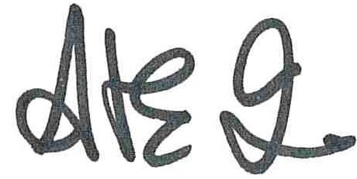
Anthony Cave
School Chaplain

PLEASE RETURN TO ANTHONY
St Mary’s RC Cemetery Clean, 8th February 2022 3pm until 4pm.

Child’s Name ................................................................... Form ..............................
I give permission [ ] I do not give permission [ ] for my child to take part in the above visit.

I confirm that there are no changes in medical information
You are reminded that the school has a code of conduct for the use of mobile phones and that you signed a ‘Use of Mobile Devices Agreement’.
Use of mobile devices on off site visits is prohibited and pupils will receive sanctions if they are seen with a mobile device.
Upon request, this agreement can be sent to you in order that you are aware of the expectations.

Name:....................................................................... Date: ..........................................

Parent / Carer Signature ...............................................

