September 2025

Dear Parent / Carer,

The Headteacher, governors and staff of St Mary’s warmly invite parents / carers to visit the school for our **Parents’ Information Evening**. At St Mary’s, we believe that young people flourish when school and home operate together in close partnership. There will be a welcome and presentations in the Drama Theatre covering the transition from Class Charts to Arbor.

**Tuesday, 9th September: 4:00 pm, 5:15 pm & 6:30 p.m.**

You only need to attend one session as they are not year specific.

As ever, your support for all we do at St Mary’s is very much appreciated, and we look forward in advance to your attendance.

Yours sincerely,

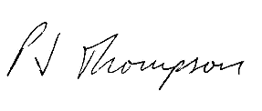

Mr P Thompson

Headteacher