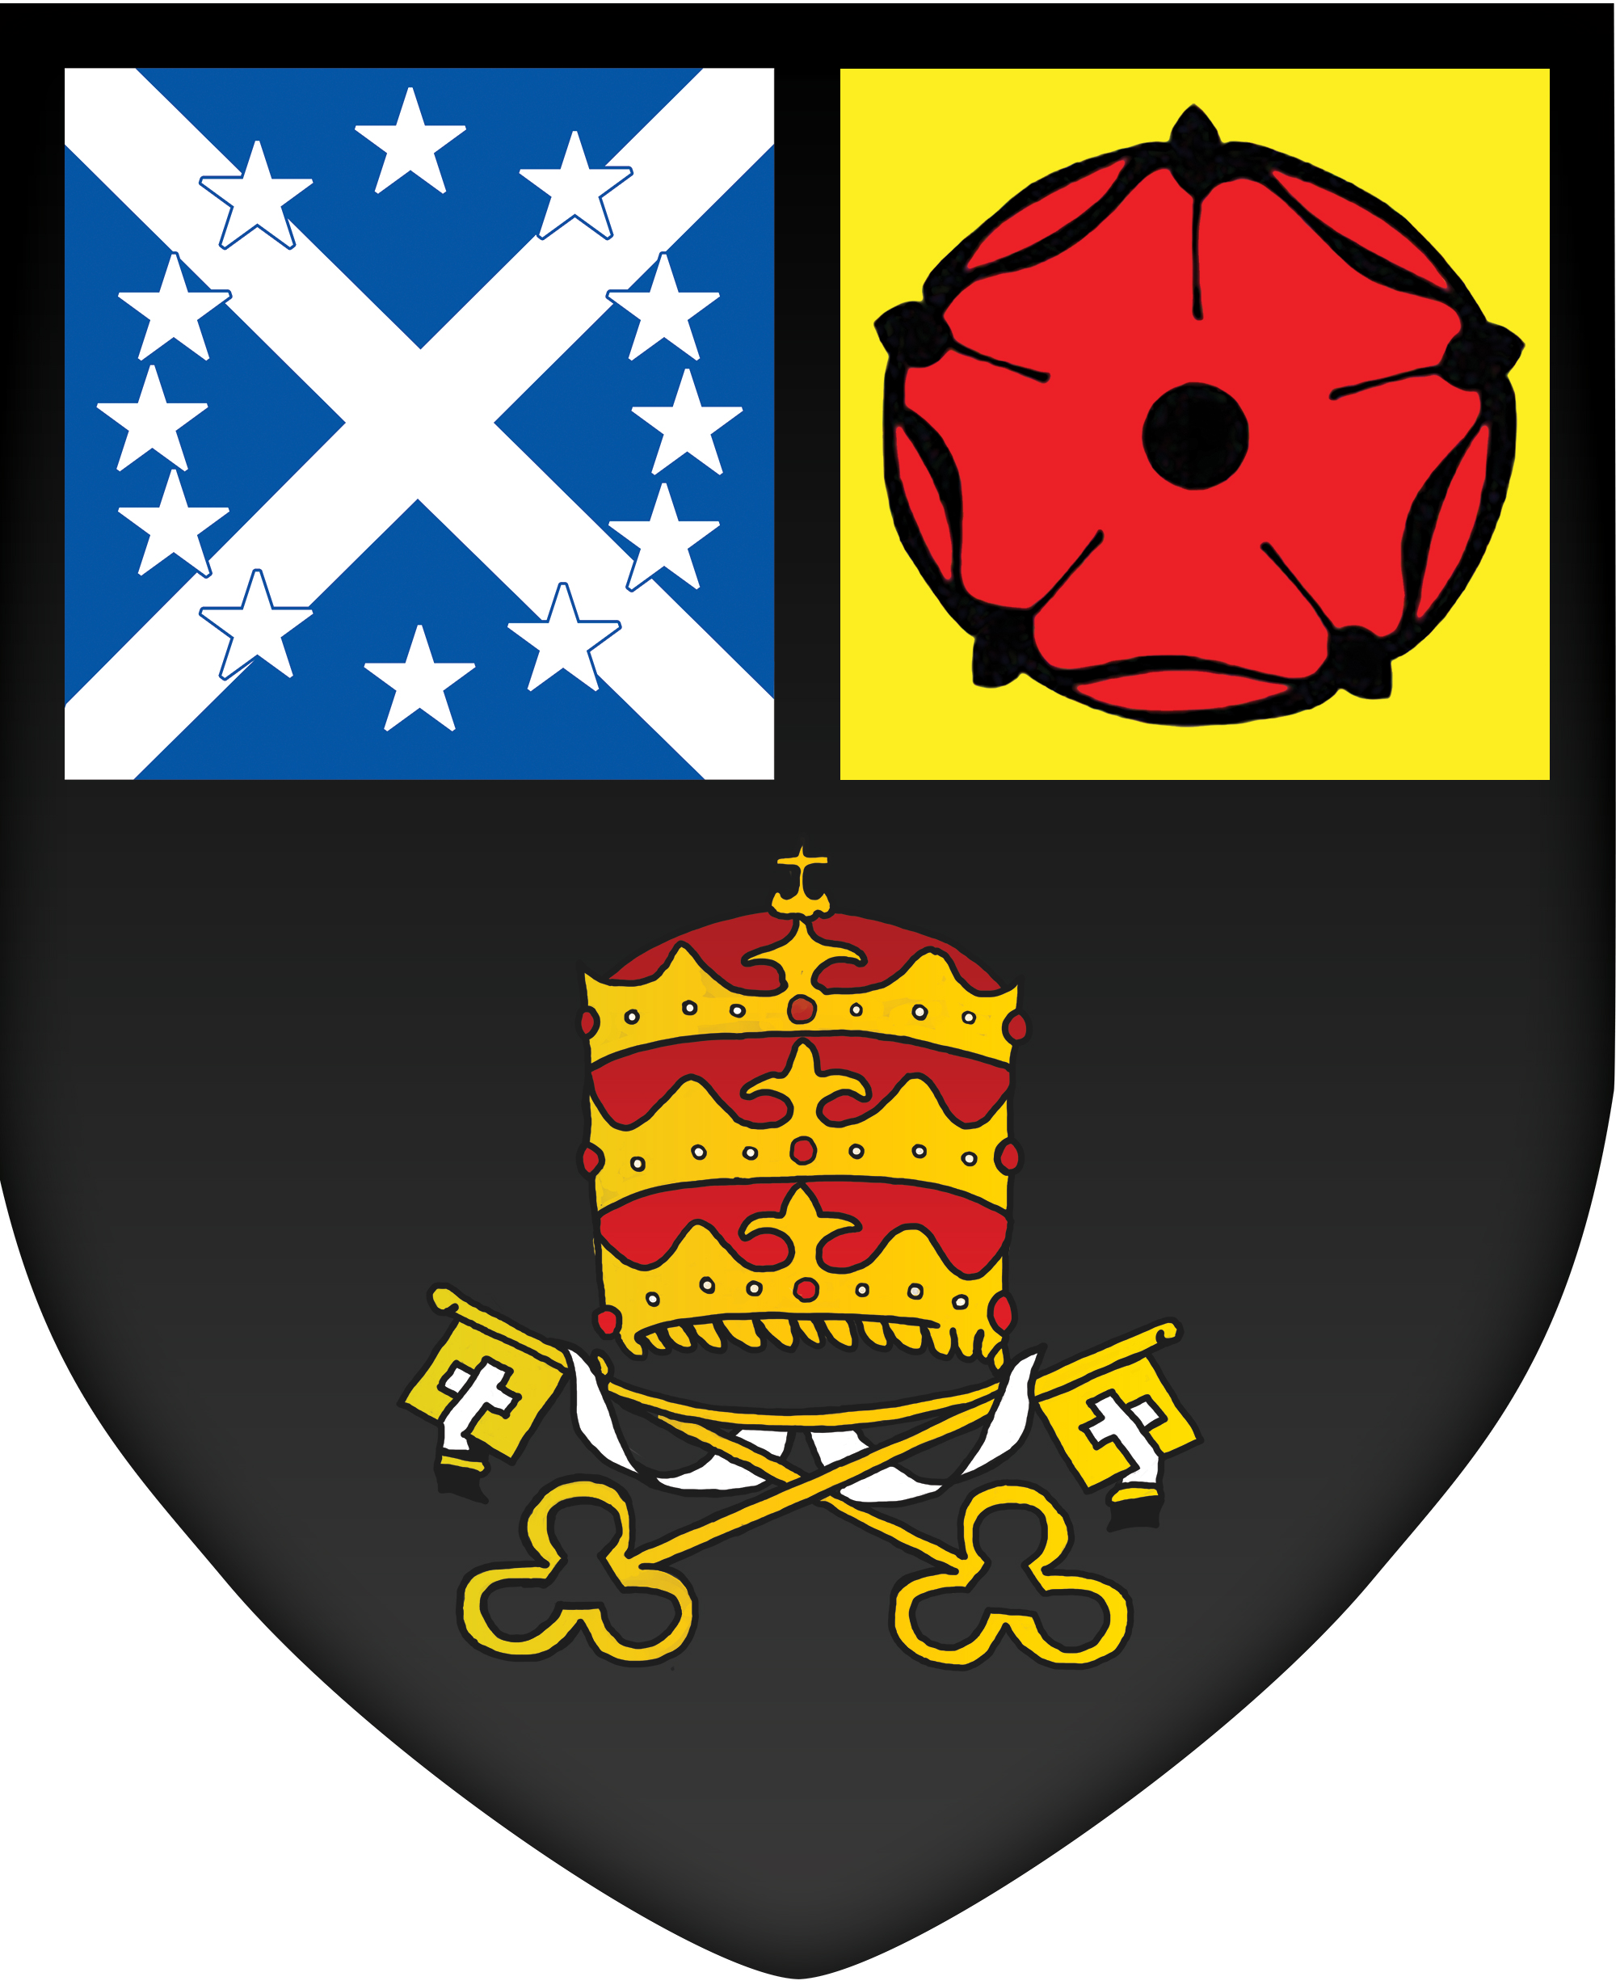
St Mary’s Catholic High School, Leyland
Royal Avenue, Leyland, PR25 1BS.
Telephone: 01772 421909
Email: head@lsmchs.com
www.lsmchs.com

Privacy notice – how school workforce information is used
What categories of information are processed?
The categories of personal information that we process include the following:
- Personal information – e.g. name, employee or teacher number, National Insurance number, and contact details
- Characteristics information – e.g. gender, age and ethnicity
- Contract information – e.g. start date, hours worked, post, roles and salary information
- Work absence information – e.g. number of absences and reasons for absence
- Qualifications and, where relevant, the subjects taught
- Medical information
- Next of Kin
- Payroll information, including bank details
This list is not exhaustive – to access the current list of categories of information the school processes, please see the school’s Data Asset Register.
Why do we collect and use your information?
We collect and use your information for the following reasons:
- To enable the development of a comprehensive picture of the workforce and how it is deployed
- To inform the development of recruitment and retention policies
- To enable individuals to be paid
Under the UK General Data Protection Regulation (UK GDPR), the legal basis/bases we rely on for processing personal information for general purposes are:
- Processing of personal data revealing racial or ethnic origin, political opinions, religious or philosophical beliefs, or trade union membership, and the processing of genetic data, biometric data for the purpose of uniquely identifying a natural person, data concerning health or data concerning a natural person’s sex life or sexual orientation shall be prohibited.
- Paragraph 1 shall not apply if one of the following applies:
  - the data subject has given explicit consent to the processing of those personal data for one or more specified purposes, except where Union or Member State law provide that the prohibition referred to in paragraph 1 may not be lifted by the data subject;
  - processing is necessary for the purposes of carrying out the obligations and exercising specific rights of the controller or of the data subject in the field of employment and social security and social protection law in so far as it is authorised by Union or Member State law or a collective agreement pursuant to Member State law providing for appropriate safeguards for the fundamental rights and the interests of the data subject;
  - processing is necessary to protect the vital interests of the data subject or of another natural person where the data subject is physically or legally incapable of giving consent;
  - processing is carried out in the course of its legitimate activities with appropriate safeguards by a foundation, association or any other not-for-profit body with a political, philosophical, religious or trade union aim and on condition that the processing relates solely to the members or to former members of the body or to persons who have regular contact with it in connection with its purposes and that the personal data are not disclosed outside that body without the consent of the data subjects;
  - processing relates to personal data which are manifestly made public by the data subject;
  - processing is necessary for the establishment, exercise or defence of legal claims or whenever courts are acting in their judicial capacity;
  - processing is necessary for reasons of substantial public interest, on the basis of Union or Member State law which shall be proportionate to the aim pursued, respect the essence of the right to data protection and provide for suitable and specific measures to safeguard the fundamental rights and the interests of the data subject;
  - processing is necessary for the purposes of preventive or occupational medicine, for the assessment of the working capacity of the employee, medical diagnosis, the provision of health or social care or treatment or the management of health or social care systems and services on the basis of Union or Member State law or pursuant to contract with a health professional and subject to the conditions and safeguards referred to in paragraph 3;
  - processing is necessary for reasons of public interest in the area of public health, such as protecting against serious cross-border threats to health or ensuring high standards of quality and safety of health care and of medicinal products or medical devices, on the basis of Union or Member State law which provides for suitable and specific measures to safeguard the rights and freedoms of the data subject, in particular professional secrecy;
  - processing is necessary for archiving purposes in the public interest, scientific or historical research purposes or statistical purposes in accordance with Article 89(1) based on Union or Member State law which shall be proportionate to the aim pursued, respect the essence of the right to data protection and provide for suitable and specific measures to safeguard the fundamental rights and the interests of the data subject.
- Personal data referred to in paragraph 1 may be processed for the purposes referred to in point (h) of paragraph 2 when those data are processed by or under the responsibility of a professional subject to the obligation of professional secrecy under Union or Member State law or rules established by national competent bodies or by another person also subject to an obligation of secrecy under Union or Member State law or rules established by national competent bodies.
- Member States may maintain or introduce further conditions, including limitations, with regard to the processing of genetic data, biometric data or data concerning health.

How do we collect your information?
We collect your personal information via the following methods:
- Staff contract forms
- Medication forms
Workforce data is essential for the school’s operational use. Whilst most information you provide to us is mandatory, some of it is requested on a voluntary basis. To comply with the UK GDPR, we will inform you at the point of collection whether you are required to provide certain information to us or if you have a choice.
How do we store your information?
Your personal information is retained in line with the school’s Records Management Policy, which can be on the school’s website.
For more information about how we securely store your information, please see the school’s Data and Cyber-security Breach Prevention and Management Plan.
Who do we share your information with?
We routinely share your information with:
- The LA, where applicable
- The DfE
- The Teachers’ Pensions Scheme, or LA Pension Fund
Why do we share your information?
We do not share information about you with anyone without your consent, unless the law and our policies allow us to do so.
Sharing with the LA
We are required to share information about our school workforce with our LA under section 5 of the Education (Supply of Information about the School Workforce) (England) Regulations 2007 and amendments.
Sharing with the DfE
The DfE collects personal data from educational settings and LAs via various statutory data collections.
We are required to share information about you with the DfE under for the purpose of these data collections, under:
We are required to share information about our school employees with the DfE section 5 of the Education (Supply of Information about the School Workforce) (England) Regulations 2007 and amendments.
All information we share with the DfE is transferred securely and held by the DfE under a combination of software and hardware controls which meet the current government security policy framework.
How does the government use your data?
The workforce information that we lawfully share with the DfE through data collections:
- Informs the DfE’s policy on pay and the monitoring of the effectiveness and diversity of the school workforce.
- Links to school funding and expenditure.
- Supports longer term research and monitoring of educational policy.
You can find more information about the data collection requirements placed on us by the DfE by following this link: https://www.gov.uk/education/data-collection-and-censuses-for-schools.
The DfE may share your information with third parties who promote the education or wellbeing of children or the effective deployment of school staff in England by:
- Conducting research or analysis.
- Producing statistics.
- Providing information, advice or guidance.
The DfE has robust processes in place to ensure that the confidentiality of personal data is maintained and there are stringent controls in place regarding access to and use of the information. The DfE makes decisions on whether they will share personal information with third parties based on an approval process, where the following areas are considered in detail:
- Who is requesting the information.
- The purpose for which the information is required.
- The level and sensitivity of the information requested.
- The arrangements in place to securely store and handle the information.
To have access to school workforce information, organisations must comply with strict terms and conditions covering the confidentiality and handling of information, security arrangements and retention of the information.
How to find out what personal information the DfE holds about you
Under the Data Protection Act 2018, you are entitled to ask the DfE what personal information it holds about you. You have the right to ask the DfE:
- If it processes your personal data.
- For a description of the data it holds about you.
- The reasons it is holding your data and any recipient it may be disclosed to.
- For a copy of your personal data and any details of its source.
To exercise these rights, you should make a subject access request. Information on how to do this can be found by following this link: https://www.gov.uk/government/organisations/department-for-education/about/personal-information-charter.
You can also contact the DfE directly using its online contact form by following this link: https://www.gov.uk/contact-dfe.
Pension funds
We share data with the pension funds, (either the Teachers’ Pension Scheme, or the LA Pension Fund), to allow accurate records to be kept of your pension entitlement.
This information is necessary to ensure they hold the correct data for the administration of the scheme as outlined in the scheme regulations, which can be found in the Teachers’ Pension Scheme Regulations or in the LGPS Pension Regulations.

What are your rights?
You have specific rights to the processing of your data; these are the right to:
- Request access to the information the school holds about you.
- Restrict our processing of your personal data, i.e. permitting its storage but no further processing.
- Object to direct marketing (including profiling) and processing for the purposes of scientific and/or historical research and statistics.
- Have your personal data rectified if it is inaccurate or incomplete.
- Not be subject to decisions based purely on automated processing where it produces a legal or similarly significant effect on you.
- Request the deletion or removal of personal data where there is no compelling reason for the continued processing.
If you want to request access to the personal information we hold about you, please contact Louise Martin, DPO on 01772 421909 Ext 423.
If you are concerned about the way we are collecting or using your information, please raise your concern with the school’s DPO in the first instance. You can also contact the ICO at https://ico.org.uk/concerns/.
How to withdraw consent and lodge complaints
Where our school processes your personal data with your consent, you have the right to withdraw your consent at any time.
If you change your mind or are unhappy with how our school uses your personal data, you should let us know by contacting the Louise Martin, DPO on 01772 421909 Ext 423.
Updating this privacy notice
We may need to update this privacy notice periodically if we change how we collect and process data. The school will inform you when this privacy notice has changed; however, we also recommend that you revisit this privacy notice periodically.
This privacy notice was last updated on July 2022.
How can you find out more information?
If you would like to discuss anything in this privacy notice, please contact Louise Martin, DPO on 01772 421909 Ext 423.
If you require further information about how we and/or the DfE store and use your personal data, please visit our website, www.lsmchs.com the Gov.UK website, or download our Data Protection Policy and Records Management Policy.
Declaration
I, ______________________________, declare that I understand:
- The categories of my personal information St Mary’s Catholic High School collects and uses.
- The school has a lawful basis for collecting and using my personal information.
- The school shares my information with the DfE, LA and other stated organisations.
- The school does not share information about me with anyone without my consent, unless the law and our policies allow the school to do so.
- My information is retained in line with the school’s Records Management Policy.
- My rights to the processing of my personal information.

Name of staff member: | _______________________________
Signature of staff member: | _______________________________
Date: | _______________________________

For school use only

Date privacy notice last updated: | July 2022

