
St Mary’s Catholic High School

Mobile Phone Free Policy

Next Review -Summer 2027
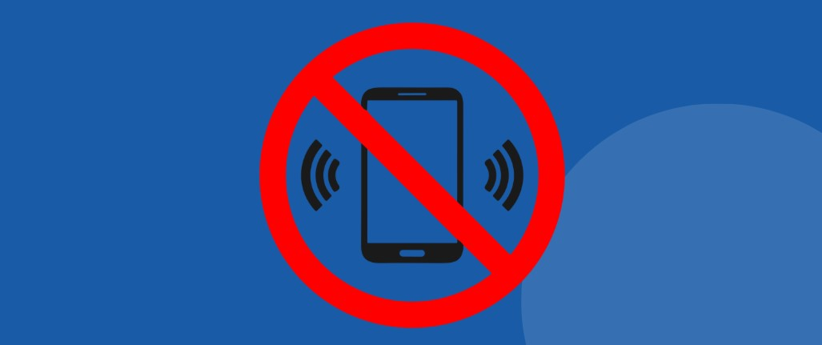
Policy Statement
At St Mary’s, we are committed to creating a safe, calm, focused and positive learning environment where all pupils can thrive academically, socially and emotionally. In line with revised guidance from the UK Department for Education (DfE), St Mary’s operates as a mobile phone free school during the school day.
This policy reflects the Government announcement made on 20 April 2026 confirming that mobile phone free expectations in schools will become statutory through updates to the Children’s Wellbeing and Schools Bill. The Government has also confirmed that Ofsted will monitor compliance with these expectations as part of the inspection framework.
St Mary’s recognises that unrestricted access to mobile phones can negatively affect:
- Teaching and learning
- Concentration and behaviour
- Safeguarding and online safety
- Mental health and wellbeing
- Social interaction and relationships between pupils
The school therefore requires all pupils to comply fully with this policy.

Aims of the Policy
This policy aims to:
- Promote high standards of behaviour and engagement in learning
- Reduce distractions during lessons and social times
- Support positive mental health and wellbeing
- Protect pupils from online harms, cyberbullying and inappropriate content
- Encourage face-to-face communication and positive relationships
- Ensure compliance with DfE expectations and statutory requirements

Expectations for Pupils
- Pupils must bring their Yondr pouch to school daily

Entering school and the beginning of the day
- Mobile phones must not be used, seen or heard during the school day
- Unlock the Yondr pouch on entry into school on one of the unlocking bases
- All pupils who bring a mobile phone to school must ensure it is switched off on entry into school and placed inside their Yondr pouch and locked.
- Yondr pouches must be stored securely in bags, to ensure security of the phone
- Smartwatches are not to be worn at all to school and devices such as air pods can also be stored securely in the Yondr pouch.
- If a pupil forgets their Yondr pouch, they will hand in their phone to be stored securely during the day and then collect it at 3pm
- If a pupil states they have no mobile phone on their person, they will be searched using the wand, a handheld scanner to clarify this.
- Pupils must not use mobile phones during:
  - Lessons
  - Breaktimes
  - Lunchtimes
  - Movement between lessons
  - Toilets or changing areas
  - Educational visits
St Mary’s is a mobile phone free school and therefore mobile phones should NOT be used at all throughout the school day. Sanctions will apply if a phone is seen during the school day or if any pupil fails to conform to the phone free policy.
- KS4 pupils will enter school via the back of Science
- KS3 pupils will enter school via the main corridor
- Any year group on Assembly will enter via the side car park and into the Drama Theatre
- Any Form group in the Humanities block will enter via that door
Exiting school at the end of the day
- All pupils will leave school via the nearest exit
- Pupils will open their Yondr pouch by tapping against the unlocking base
- Remove their phone from the pouch
- Close and lock the pouch to prevent the pin from bending and being damaged
- Place the pouch in their school bag overnight to keep it safe
Late Starters or Early Leavers
- Any pupil arriving late to school will follow the same entry expectations into school but via the main reception
- Any pupil leaving throughout the school day can unlock their pouch via a portable unlocking base after signing out at the main reception
Unlocking Stations/Bases
There will be 13 unlocking bases positioned around school. 5 will be on the external path behind Science, 4 at the main corridor entrance, 2 on the Humanities block and 2 near the Drama Theatre entrance. As well as these there will be a portable base available in reception. They will all be open and available to use at the start and end of the day. The only one available during the school day will be the one in reception, all others around school will be locked.
Any pupil who brings in a similar strength magnet and is found to be using it to open the pouches during the school day will be suspended.

Exceptions
The school recognises that, in exceptional circumstances, some pupils may require access to a mobile device for medical or safeguarding reasons.
Any exceptions must:
- Be agreed in advance with the Headteacher or designated safeguarding lead
- Be supported by appropriate evidence where required
- Include clear arrangements for appropriate use
- Pupils with specific medical reasons will be issued with a medical Yondr pouch.

Breaches of the Policy
Failure to follow this policy will result in appropriate sanctions in line with the school’s behaviour policy and mobile phone free policy.
Sanctions will be:
Failing to adhere to the policy | Consequences
1st occasion | Phone goes in school safe for 2 days
2nd occasion | Phone goes in school safe for 3 days
3rd occasion | Phone goes in school safe for 5 days
4th occasion | Suspension for a set period of time
Any further sanctions that are required will result in a meeting taking place with parents/carers, Headteacher and a Governor
Where necessary, school staff retain the right to search, examine or confiscate devices in accordance with statutory powers and safeguarding responsibilities. Pupils in these situations will be searched using the wand technology device.
Damaged or Lost Pouch
- Pupils will be checked weekly for any damages to the pouches
- If a pupil damages their Yondr pouch and cannot conform to the phone free school policy, they will hand in their phone for the day
- For all damaged pouches, a replacement one must be purchased within a 5-day period at a cost of £20
- If a pupil fails to bring in their pouch on at least 5 consecutive occasions, it will be suspected that the pouch has been lost and a replacement will have to be purchased at a cost of £20
- Examples of damage include:
- Ripped fabric
- Cutting the fabric
- Torn fabric
- Bent/cut pin
- Signs of force to the black button on the closing flap
- Damage to the black locking ball
- Pouch opens without the unlocking base
When a mobile phone is confiscated, it will be stored securely in the school safe both during the day and night for the duration of the consequence occasion. Parents/Carers will be informed regarding the length of time the phone has been confiscated for. Refusal to hand over the mobile phone will result in a suspension.
Accidental Damage
Both parents/carers and pupils must notify the school immediately explaining what has happened. If any damage is seen on entry into school by a member of staff, it will be considered intentional unless it has been raised previously. Damage as mentioned above will incur a cost.
Random Checks
SLT and Pastoral Leaders will conduct random checks on pupils and their pouches to enforce the policy. Consequences will occur for any pupil who is failing to adhere to the policy.

Responsibilities

Pupils
Pupils are responsible for:
- Following the expectations set out in this policy
- Ensuring devices remain switched off and out of sight in the Yondr pouch throughout the school day
- Respecting the learning environment of others
- Ensuring their pouch is looked after daily and does not get damaged or lost
- Respecting the unlocking bases around school so they do not get damaged

Parents and Carers
Parents and carers are expected to:
- Support the school’s mobile phone free approach
- Communicate through the school office or email pupilemergencymessage@lsmchs.com where communication is essential
- Reinforce the reasons of creating a safe, calm and focused learning environment where your child can thrive both academically and socially

Staff
Staff will:
- Apply the policy consistently and fairly
- Model appropriate professional use of technology and follow the staff mobile phone and smart devices policy
- Support pupils in understanding the reasons behind the policy
- Report and record any pupil seen to be using their phone during the school day
Staff are not permitted to use their mobile phone in any public area or in front of any pupil and must not wear any smart watches throughout the school day.
Visitors
All visitors will be told that we are a mobile phone free school and will be asked to turn their phones onto silent and told not to use their phone whilst on the school site.

Monitoring and Review
This policy will be reviewed annually or sooner in response to changes in legislation, DfE guidance or school needs.
The Governing Body and senior leadership team will monitor the implementation and effectiveness of the policy, including any updates linked to statutory Government requirements and Ofsted expectations.

Linked Policies

This policy should be read alongside:
- Behaviour Policy
- Safeguarding and Child Protection Policy
- Online Safety Policy
- Anti-Bullying Policy
- Acceptable Use of Technology Policy
- Online Safety Policy
- Artificial Intelligence Policy
- Searching, Screening and confiscation Policy
- Special Educational Needs and Disabilities Policy

