
St. Mary’s Primary School
Curriculum Overview- Year 2
 | Autumn 1 | Autumn 2 | Spring 1 | Spring 2 | Summer 1 | Summer 2
English – | Sounds Write daily teaching    Writing-character descriptions | Sounds Write daily teaching  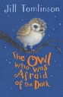  Writing-non-chronological report | Sounds Write daily teaching  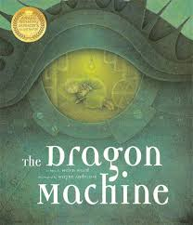  Writing-Fiction | Sounds Write daily teaching  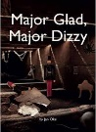  Writing- Diary/ recount | Sounds Write daily teaching  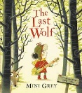  Writing-Letter | Sounds Write daily teaching  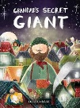  Writing-Fiction
History | Who is George Stephenson?  Significant Explorers- Captain Cook |  |  | The Great Fire of London
Geography |  | Planet Earth |  |  | Exploring the World
Art  Design & Technology | Still Life |  | Masks |  | Pop Art
Science | Animals Including Humans  Materials |  | Materials  Magnets |  | Plants  Electricity
Maths (WRM) | Place Value  Addition and Subtraction  Shape |  | Money  Multiplication and division  Length/height  Mass/capacity/temperature |  | Fractions  Time  Statistics  Position and Direction
Computing | IT around us | Creating Media- digital photography | Programming | Data and Information | Creating Media | Programming
PSHE | God |  | Family |  | Friendship
Music | Hands, feet, heart | Ho Ho Ho | I wanna play in a band | Friendship songs | Reflect, rewind, replay
PE | Fundamental Movement Skills | Invasion games | Gymnastic | Throwing and catching | Team games | Dance
Enrichment | Trip to Shildon Railway Museum

