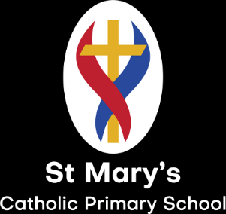
St. Mary’s Primary School
Curriculum Overview
Year 4 2024/25 – Mrs Stewart
 | Autumn 1 | Autumn 2 | Spring 1 |  | Spring 2 | Summer 1 |  | Summer 2
English – | The Lost Words – poetry  Persuasion – Zeraffa Giraffa | Historical Fiction – Escape from Pompei | Diary – Leon and the Place Between |  | Fiction (fantasy) – Gorilla | Fiction (adventure story) – Koji’s Islands and Amazing islands |  | Non-chronological report - Where the Forest Meets the Sea
History | The Romans |  |  |  | Early Islamic civilization
Geography |  | Angry Earth – Volcanoes and Earthquakes |  |  |  | Coasts – How they are formed and the impact of costal erosion
Art | Illuminated letters and patterns |  | Clay tiles |  |  | Printing patterns
Design & Technology |  | Cooking and nutrition – pizza (Link to modern day Italy) |  |  | Mechanical systems – greeting card (Easter link) |  |  | Electrical systems - Nightlight
Science | Living Things – life processes and classification | Animals including humans – digestive system, teeth and food chains | Materials – solids, liquids and gasses |  |  | Sound and hearing | Electricity – making circuits
Maths (WRM) | Place Value, Addition and Subtraction, Multiplication and Division |  | Multiplication and division, length and perimeter, fractions and decimals |  |  | Decimals, money, time, shape, statistics, position and direction
Computing | The internet | Audio Production | Repetition in Shapes |  | Data Logging | Photo Editing |  | Repetition in Games
PSHE  Picture News (Running alongside the curriculum) | Online safety  The sacraments  We don’t have to be the same  Respecting our bodies | What is puberty  Managing online information  Spending decisions  Understanding mental health  Bullying and mental well-being | Changing bodies  What am I looking at?  I am thankful  Life cycles  A time for everything |  | NSPCC Pants  Health well-being and lifestyle  Privacy  Advertising  Emotions and feelings | What am I feeling?  A community of love  What is a church?  How do I love others? |  | Copyright and ownership  Keeping track  Looking after our mental health  Healthy sleeping
Music | Reading music  Learning to play the ukulele (Taught my Durham music services)
PE

Spanish | Basics – greetings, counting days and months of the year |  | Family – sentence writing | Descriptions – describing people and places (consolidation of family unit) |  |  | Where I live – positional vocabulary
Enrichment | Houseteads Roman fort – Hadrian’s wall |  | Life centre – workshop (discovering chemistry) and museum visit |  |  | Trip to a local beach to explore the features of a coast. (Geography link)

