CATCH UP FUNDING

School | St Mary’s RC Primary School
Academic Year | 2020-2021 | Catch-Up Fund | £ 14,240 | Total Pupils | 178

DfE Guidance
Schools should use this funding for specific activities to support their pupils to catch up for lost teaching over the previous months, in line with the curriculum expectations for the next academic year in actions for schools during the coronavirus outbreak.
While schools can use their funding in a way that suits their cohort and circumstances, they are expected to use this funding for specific activities which will help pupils catch up on missed education.
To support schools to make the best use of this funding, the Education Endowment Foundation (EEF) has published a coronavirus (COVID-19) support guide for schools with evidence-based approaches to catch up for all students.
To support schools to implement their catch-up plans effectively, EEF has published the school planning guide: 2020 to 2021. This will provide further guidance on how schools should implement catch-up strategies and supporting case studies to highlight effective practice.

EEF Model for Evidence based Strategic Planning
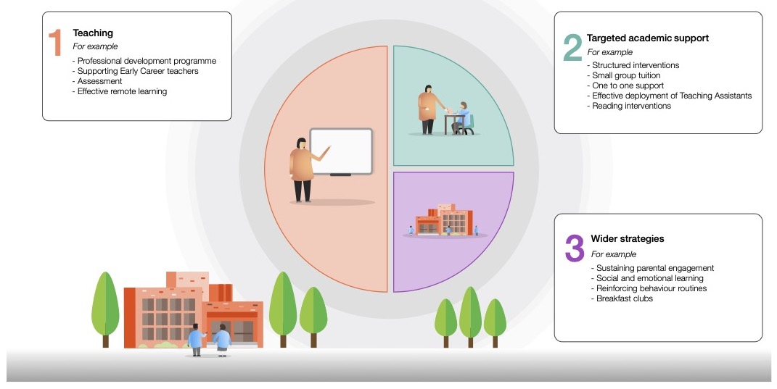

Identified Impact of COVID 19 (Primary)
Maths | There are marked gaps in areas of mathematics. Shape, space and measures has not been covered as it should, due to the difficulties of teaching this remotely.  Fluency has been an issue since the children have been in lockdown.  Some children did not engage consistently or with the necessary focus to make progress during the initial lockdown
Writing | Periods of sustained writing were limited.  We were unable to ascertain the amount of input from parents. Some children had their parents/carers working alongside through every activity, other children had no support.  Spelling has been identified as needing increased input and teaching throughout the coming year.
Reading | About 15% of the children did little or no reading during the first lockdown. Reading was an issue prior to the lockdown with reading fluency being lower than expected.  Fluency has dropped in approximately 75% of the children.
Foundation | During the initial lockdown the school put the emphasis on Literacy, numeracy, science and art as it was a new experience for the school staff, the children and the parents.

Planned Expenditure
For All Pupils (Universal Offer)
Supporting quality first teaching. Great teaching is the most important lever schools have to improve outcomes for their pupils. EEF Guidance
Ensuring every teacher is supported is essential to achieving the best outcomes for pupils. To ensure all children have access to quality teaching, supply may be required to accommodate for periods of staff isolation and absence. Wherever possible this will be done in house to cut down on cross contamination of bubbles. Each bubble has an HLTA assigned to cover short term absence or to manage in school children should the teacher be required to teach remotely due to isolation.
Desired Outcomes | Strategy and Cost | Impact | Staff Lead | Review date
Increased fitness and to help counter inactivity over the lockdown and increased weight that some children have gained | Each class to have a daily PE lesson and one other active lesson per day.  Use of PE with Joe workouts.  Sports apprentice to lead PE lessons. |  | A Robinson: PE lead  S Palmer: Sports Apprentice
Mental Health and Well Being  Outcomes:  Increased confidence  Emotional and physical wellbeing | OPAL  Outdoor Learning and Play Scheme.  To improve our Play offer. Play constitutes 20% of time spent in school. We need to make sure children have better opportunities for play, creativity and socialising skills  Training for staff  Materials to support the various areas that will be set up around the school site. |  | A Robinson: OPAL Lead  M Matthews: OPAL Core Team member
Maths:  Increased fluency  Identification of gaps in learning due to lockdown  Emphasis on 4Rules | With the gaps in maths being highlighted school will purchase PowerMaths to fill the gaps, this will then be supplemented by the scheme in school to provide challenge to those children who progressed beyond their peers during lockdown.  Staff training on PowerMaths  Fluency  Variation |  | A Robinson: Maths Lead
Literacy  Work on Oracy  Improved Reading Fluency  Increasing Vocabulary | Staff meetings on Oracy using EEF Research.  Introduction of Vocabulary Ninja and Word of the day. To be trialled in Y4 and then rolled out across the school.  Vending machine filled with books to be created. Children will be given a token to chose their own book from the machine.  Focus on reading fluency and comprehension.  Accelerated Reader to be purchased to be used with Y2-Y5 |  | D Hargreaves: English Lead

Planned Expenditure
Targeted Pupils
Desired Outcomes | Strategy and Cost | Impact | Staff Lead | Review date
Increased fluency in Maths & Literacy | Small group work to be carried out by TAS.  Teachers to run small group or whole class interventions for the children they will be receiving in Sept 2021 in order for them to plan with greater precision during the summer break

Planned Expenditure
Wider Strategies
High quality assessment is essential to great teaching, helping us understand what pupils have (or have not) learned. Targeted diagnostic assessment can support teachers to monitor pupils’ progress, particularly as they re-establish classroom routines and recover any learning loss.

Desired Outcomes | Strategy and Cost | Impact | Staff Lead | Review date
Baselining pupils on return to school and identifying gaps in learning and at which point learning may have stopped will be critical for teaching and learning moving forward.  Screening of pupils’ phonic ability will help to identify those pupils who have/ have not sustained their knowledge and understanding.  From this Pupil progress and target groups can be identified and gaps can be filled with appropriate booster/ group interventions etc. | Analysis of data  Pupil Progress Meetings to rack and monitor progress and identify appropriate and individualised provision where necessary.  Times Table Rockstars to be renewed  Clicker 7/8 to be renewed.  CPG books to be used where necessary.

