

St. Mary’s Catholic Primary School
SEND Information Report
School Offer
2026-27

St. Mary’s Catholic Primary School is a fully inclusive school where the needs of our children are central to our educational philosophy. We aim to develop the social, cultural, intellectual, moral and spiritual aspects of every child, supporting them to reach their full potential. In our pursuit of excellence and inclusion we recognize the need for a full range of educational and pastoral care support and aim to help children with special educational needs and disabilities, for them to make good levels of progress. We believe in the core values of our mission statement, in that we treat all of our children with humility, gentleness, patience and love. Children of all backgrounds and cultures are welcomed and valued and are supported effectively, to make the very best progress that they can. We aim to remove barriers to learning and participation and to promote the development of children as confident and independent learners. We understand and acknowledge that children have individual educational needs and require personalized strategies for learning and participation and will benefit from a range of different teaching approaches and experiences and we endeavor to meet these individual needs.

This document outlines details regarding the ways in which we support all children, including those with SEND (Special Educational Needs and/or Disabilities), in order that they can reach their full potential. It may not list every skill, resource and technique we use in order to achieve this as these are continually developed and used to modify our provision to meet the changing requirements for each individual child. Other useful documents, such as our SEND and Inclusion Policy, give further SEND information and can be found on the school website. http://www.stmarysjarrow.co.uk

If you require any further details, about the support that we can offer, then please do not hesitate to contact Mrs. Walker (School SENCo – 0191 4898336).
In addition, our school SEND link governor is contactable via school – 0191 4898336.

Children at St. Mary’s Catholic Primary School with SEND are identified and taught appropriately following the requirements of the SEND Code of Practice for Additional Educational Needs. Leaders and stakeholders in St. Mary’s have very high aspirations for pupils and this include pupils with SEND (Ofsted report 2023).

Children are identified as having SEND when their progress has slowed significantly and school based, universal interventions do not enable improvement. Concerns may be identified by school, a medical professional or by you as the parent/carer. Once this occurs, we will carry out school-based observations of your child, analyze their work to identify barriers to their learning and make referrals to outside agencies* if necessary, in order to develop appropriate targeted interventions to improve their progress. Throughout this process you and your child’s opinions will play a crucial part in addressing specific needs. The level of support your child receives may change throughout their time at school, as interventions will be continually monitored and reviewed and progress tracked using our assessment system.

*Details of Local Authority external agencies who are available to offer support and advice as required are available via this link: http://www.southtyneside.info/article/22412/Education-services

For all children at St. Mary’s, who have an additional need:

- We work in partnership with parents and carers as we recognize and value the expert role in
which families play in their children’s lives and educational development.
- We set clear targets and educational plans for children.
- We involve the child, parents and carers in the writing, reviewing and implementation of individual SEND education plans and targeted provision.
- We deliver high quality teaching, adapting the curriculum and our resources to support access to learning and to promote progress.
- We seek support and advice from a range of outside agencies such as Portage and preschool, Inclusion services, Educational Psychology Service, Occupational therapy, Speech and Language Therapy, School Health etc. to ensure that barriers to success are fully identified and responded to.
- We support access to teaching and learning, for children with SEN, monitored through our self- evaluation process. Lessons are as inclusive as possible with adjustments made depending on need.
- We routinely evaluate teaching resources to ensure that they are accessible to all children and young people.
- We evaluate our intervention groups and strategies on a regular basis.
- We use ICT hardware and software to promote access to the curriculum.
- We use strategies to promote emotional wellbeing and to reduce anxiety.
- We ensure that our educational visits and extra-curricular activities, as far as possible, are accessible to SEND children.
- We strategically place support staff, where they are most needed throughout the school, to ensure pupil progress, independence and value for money.
- We evaluate whole school policies (such as those for Behaviour for Learning, and SEN - Inclusion) on a regular basis with a focus on the impact upon pupils with SEN.
- We have a fully qualified SENCO (NPQ in SEND qualification), in the role of Senior Management, who leads SEN support and can provide advice and guidance to staff.
- We ensure that staff receive on-going training in relation to meeting individual needs within the classroom.
- We offer school transition support to children and parents/carers.
- We offer support to families and they are signposted to services and organizations which may provide appropriate input or advice via the South Tyneside Council’s Local Offer: http://www.southtyneside.info/article/8126/Special-educational-needs.

In addition to the above, we also offer further support to those children who have a higher level of additional need; an Education, Health and Care Plan (EHCP). This support includes:
- Very detailed planning and monitoring of progress.
- Individualized programs of work across several areas.
- Specific targeted interventions.
- Provision specified in an EHCP.
- Annual reviews of their EHCP with recommendations submitted to the Local authority.
- Multi-agency planning and assessment of targets at interim reviews

Specific provision is also provided for the different areas of need:

- Communication and Interaction
- Cognition and Learning
- Physical and medical Needs
- Social, Emotional and Mental Health

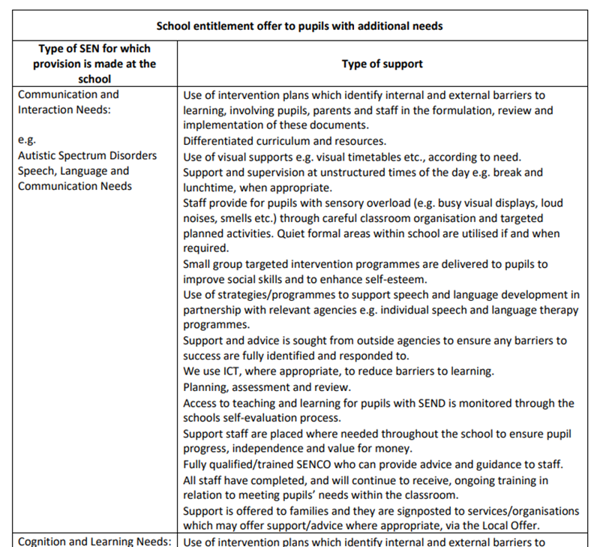

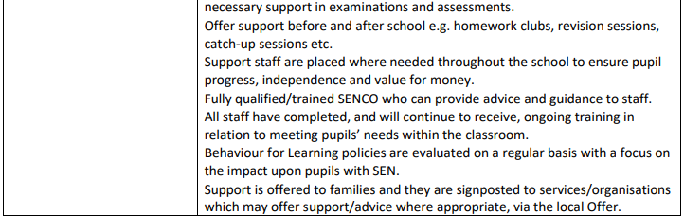
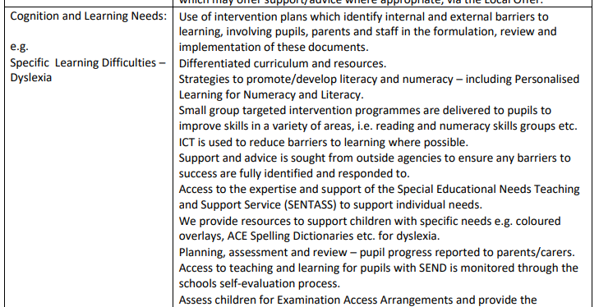

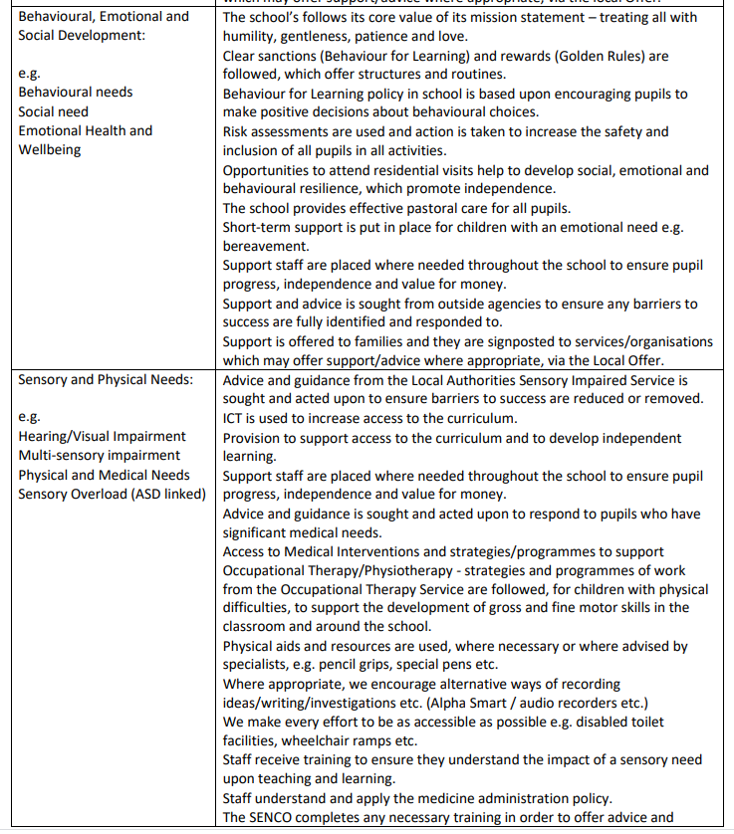
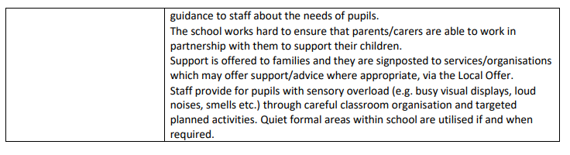

If you have any concerns about your child’s SEND, progress or provision we would urge you to come into school and discuss matters further with your child’s class teacher or the school SENCO.

Parents can also contact South Tyneside Special Educational Needs and Disability Information, Advice and Support Service (SENDIASS) which offers free and impartial information, advice and support to parents/ carers, children and young people with special educational needs and disabilities.

Contact details: 0191 424 6345 or email SENDIASS@southtyneside.gov.uk

Below is a glossary of terms, which is aimed to help explain some of the terminology, associated with SEND.

Glossary of terms:

Assessment This is a process, over time, which identifies strengths, weaknesses and needs across all areas of a child or young person’s life and involves parents, carers and practitioners.

Autism: The spectrum of autism is wide ranging. Autism is recognised from a variety and clear pattern of behaviours. These behaviours are common to the whole population and we could all be described as having features of autism. Some of us, for example, may always follow a set routine in the morning whilst others may dislike large crowds of people. An Autistic diagnosis is given, however, when there is a pattern of behaviours showing significant and persistent difficulties in the three areas of communication, social interaction and rigidity of behaviour and thinking. Individuals with Autism will vary significantly according to their personalities, general level of intelligence, the degree of their presentation in the three areas and any additional learning difficulties. The combination of these elements will affect how the child learns, how the environment needs to be organised and the child’s general functioning. Autism is a complex neurodevelopmental condition, marked by multiple symptoms, which include atypicality in: social interactions (i.e. people with autism may find it difficult to understand others' mental states and emotions, and respond accordingly); verbal and non-verbal communication; repetitive behaviour (i.e. people with autism may repeat certain words or actions, over and over, usually in a rigid rule-governed manner). There is a wide variability, in the degree to which these symptoms manifest themselves, leading to the use of the term 'autism’.

Carer: For the purpose of the SEND Code of Practice, a carer is a person named by a local authority to care for a child for whom the social services department has a parental responsibility.

Centiles: Educational Psychologists and Speech and Language Therapists may refer to centiles. These describe how a child functions compared to 100 children. If they are on the 75th centile, 74 children out of a hundred would have more difficulties than them and 25 children would have fewer difficulties than them. It is a benchmark from which progress can be measured.

Clinical Psychologist: A clinical psychologist can offer advice on eating, toileting and behavioural difficulties. Parents and carers may also find it helpful to talk to them about how their child's difficulties impact on the daily life of the whole family.

Children and Young People’s Services (CYPS): Child and adolescent services which provide assessment, treatment and care for a child or young person experiencing emotional or behavioural difficulties which impact upon their mental health and wellbeing.

DfE: Department for Education.

Dyscalculia Children and young people with dyscalculia have difficulty in acquiring mathematical skills. They may have difficulty understanding simple number concepts, lack an intuitive grasp of numbers and have problems learning number facts and procedures.

Dyslexia Children with dyslexia have a marked and persistent difficulty in learning to read, write and spell, despite progress in other areas. They may have poor reading comprehension, handwriting and punctuation. They may also have difficulties in concentration and organization and in remembering sequences of words. They may mispronounce common words or reverse letters and sounds in words.

Dyspraxia: Children with dyspraxia are affected by an impairment or immaturity of the organization of movement, often appearing clumsy. Gross and fine motor skills are hard to learn and difficult to retain and generalize. They may have poor balance and co-ordination and may be hesitant in many actions (running, skipping, hopping, holding a pencil, doing jigsaws, etc.). Their articulation may also be immature and their language late to develop. They may also have poor awareness of body position and poor social skills.

EAL: English as an Additional Language.

Early Intervention: This is the process of intervening when a child or young person first shows signs of difficulties. The aim is to ensure that help is received, as soon as possible, to prevent any difficulties escalating.

Educational Psychologists: Educational Psychologists (EPs) bring a specialized perspective to working with children. They are concerned with children's learning and development and they aim to bring about positive change for children. They have skills in a range of psychological and educational assessment techniques and in different methods of helping children and young people who are experiencing difficulties in learning, behaviour or social adjustment.

EHCP plan: An Educational and Health and Care Plan, which is used from birth to 25 years of age, requires a Statutory Assessment. This is the formal process whereby the Local Authority assesses a child's Special Educational Needs and/or Disabilities (SEND) and may result in an EHC Plan being issued. This is a legal document, which details a child’s Special Educational Needs and the provision required to meet those needs.

Inclusion: Inclusion is a term, which ensures equal learning opportunities for all children and young people.

Key Worker: A key worker co-ordinates the assessment, planning and provision for the child or young person and their family. The key worker helps to maintain relationships between the family and practitioners and helps the family through the assessment process. The key worker is a consistent presence for the child or young person and their family.

LA: Local Authority.

Looked After Child (LAC): The term used to describe a child in local authority care or in social accommodation for more than 24 hours.

MLD: Moderate Learning Difficulties.

Multi-agency: Multi-agency working is a true partnership between workers from two or more (normally statutory) agencies based on common goals and strategic vision. Multi-agency working means that parents and carers, children and young people are offered appropriate support in all areas of their life where this is needed.

Multi-agency Team around the Family Meeting: A meeting which brings together parents, carers and professionals, from a range of different services and agencies, to help and support an individual child or young person and their family.

Multi-disciplinary: Multi-disciplinary working is where practitioners from different professional backgrounds work together in an integrated way.

Planning: Planning is a process whereby parents, carers and practitioners come together to agree how their desired outcomes for the child or young person and the family can be achieved.

Personal Budget A personal budget is the amount of funding available to meet the desired outcomes set out in an EHCP for an individual child or young person. It will enable the child and their family to make choices to suit their particular circumstances about the way in which outcomes are achieved. The parents and carers, through a direct payment held on their behalf by an agency, or other organisation, or a combination of these, can hold the personal budget.

Parent/Carer Participation: Parent/carer participation is welcoming parents and carers to the strategic decision-making process as full partners from the start.

Practitioner: A practitioner is someone who is employed by an agency to work with children and young people with special educational needs or disabilities and their families.

Parent Partnership Service (PPS): The Parent Partnership Service aims to give confidential, impartial help and support to parents and carers who have a child needing extra help with pre-school or school education. This may be because the child or young person is disabled, has a learning difficulty, has a social, emotional or mental health difficulty or finds it more difficult to learn than other children of the same age.

Pupil Referral Unit (PRU): Pupil Referral Units are centers for children and young people who are unable to attend mainstream or special schools.

Special Educational Need (SEN): A special educational need is a learning difficulty or disability which makes it more difficult for a child to learn, or to access education, than for most children in the same age group.

Special Educational Needs Co-ordinator: (SENCO) The Special Educational Needs Co-ordinator is responsible for co-ordinating special educational provision within mainstream schools.

SEND: Special Educational Needs and Disabilities

Single Assessment A single assessment process is one in which parents, carers and practitioners pull together the range of assessment information and use this to identify their desired outcomes for the child or young person and their family. The single assessment process forms the basis for the development of their support plan. The single assessment process covers all areas of need and all relevant agencies contribute to it.

Single Plan: A single plan is one in which the parents, carers and practitioners build on the single assessment process to set out their desired outcomes for the child or young person and their family. The plan will identify the agreed priority of each of these outcomes and set out how they will be achieved. The single plan will cover the contribution of the family and all relevant agencies and set out clear responsibilities and accountabilities with timescales.

SLCN: Speech, Language and Communication Needs.

SpLD: Specific Learning Difficulties.

Transition: Transition is a change in a child’s or young person’s life where some or all of their support is undertaken by new services or other practitioners. This includes the transition between stages of education and the move from children’s to adult services.

