Cycle A EYFS 2026/2027 (Following Nursery plan)
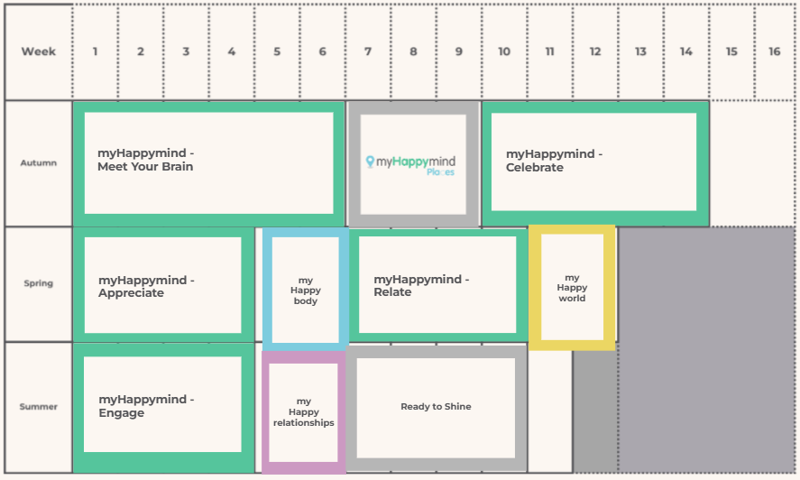

Cycle A KS1 2026/2027 (Following Year 1 plan)
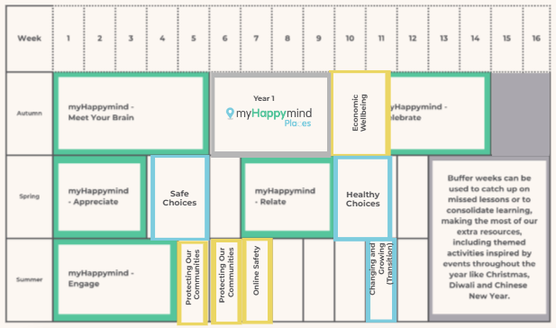
Cycle A Year 3/4 2026/2027 (Following Year 3 plan)
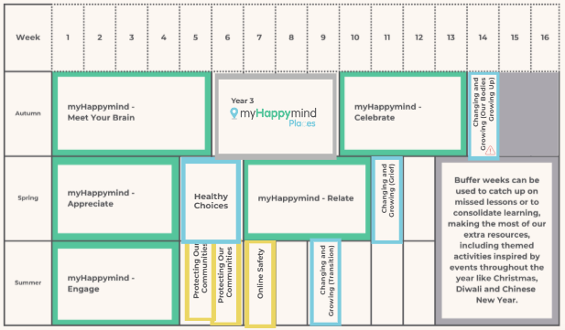

Cycle A Year 5/6 2026/2027 (Following Year 5 plan)
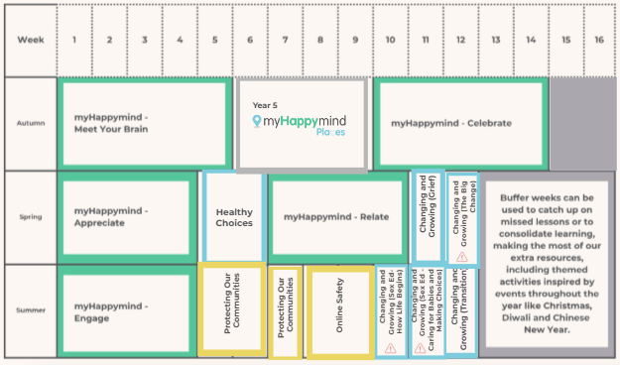

Cycle B EYFS 2027/2028 (Following Reception plan)
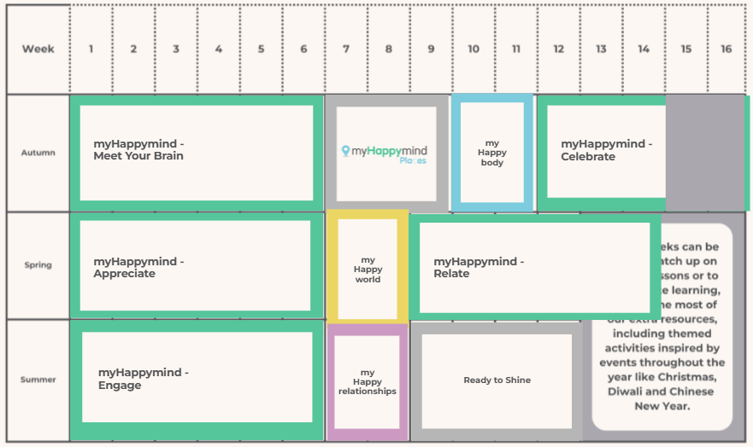
Cycle B KS1 2027/2028 (Following Year 2 plan)
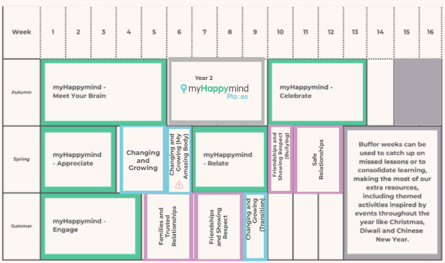
Cycle B Year 3/4 2027/2028 (Following Year 4 plan)
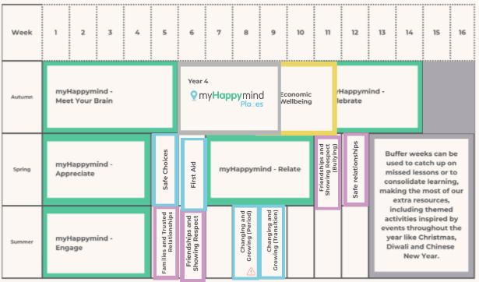
Cycle B Year 5/6 2027/2028 (Following Year 6 plan)
