St Mary’s, Mucklestone.
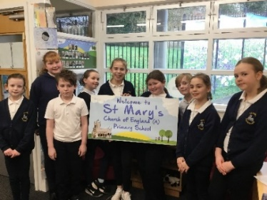
Welcome to St Mary’s Mucklestone, this is the Mucklestone Messenger. Our school have been getting up to a lot this term there is brand new journalists, editors and a designer. Everyone has put so much effort into this newsletter so why don’t we get started, we hope you enjoy reading this with a cup of tea or coffee and a biscuit!
Martha (Editor)

Our School Dog – Ozzy
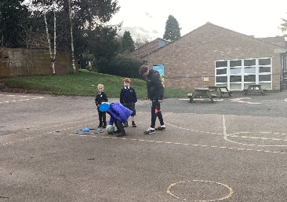
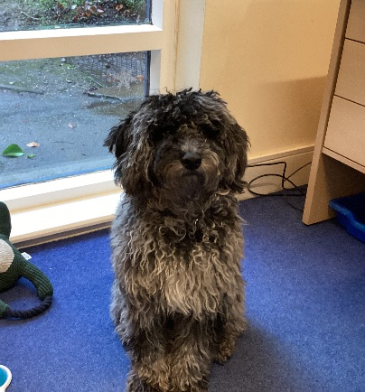
Ozzy is our school therapy dog he loves chasing leaves in the wind. Ozzy is very cheeky with his toys he likes stuff that he can’t play with and he loves playing with chickens and playing with other dogs. Ozzy is a labradoodle he visits the school once a week with Mrs. Graham. Ozzy helps our school pupils with all different emotions like: anxiety, stress, anger and sadness. This is what some of the pupils at our school think of Ozzy.They like Ozzy because he’s very fun, furry, comforting and calming. Some people said that he makes their day. Others say that he’s like a little surprise after break and lunchtime. We’re very lucky to have Ozzy in our St Mary’s family. Everybody that I spoke to said that Ozzy is a great aspect to our school everybody that I spoke to said Ozzy is a ten out of ten! Molly

Subjects
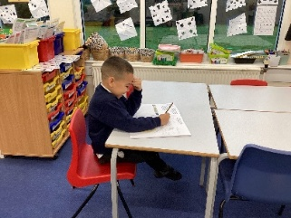
Our education is very important in St Mary’s. Many pupils love maths because they like that you learn something new every lesson and there can be maths in everything. Some people enjoy English because you can learn different things and you get to write a lot. A few of the younger ones like Phonics because it helps them understand more for when they grow up. Lacey

Sports
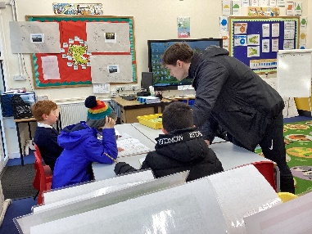
Physical education is loved in this school because it is fun, entertaining and makes us happy. We take part in different activities, we have loads of space to enjoy. Sports can be for everyone, there is always something to do or enjoy. There is a wide range of activities like my favourite sport football. Teachers in our school love sport because you stay healthy, it is competitive, it’s good for your mental health and you can meet new people and experience new things. Other pupils enjoy the teachers that teach P.E, and how it’s a workout in disguise. The year 3s and year 1s are enjoying with maths on the move led by our P.E teacher Mr Stevens. They said math on the move is good because you can see progress throughout the weeks, it tests our skills and builds our strength. Annabella
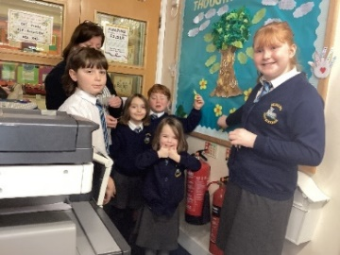
Family Circle
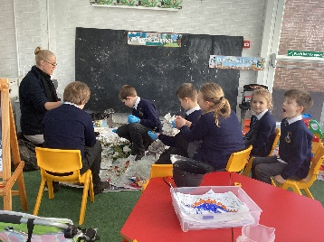
In our school we have family circle where everyone has something to do. We have seven family circles they are: gardening, safe gardening, sport, friendship, Picture news, charity and Christian values. Every child in the school gets to go in every family circle each family circle gets seven pupils one of each year group sometimes two depending on the size of the year group. The family circles are something we do every half term and most of the school think we should have it more often probably 2 times a half term. Everyone loves family circle! Evie
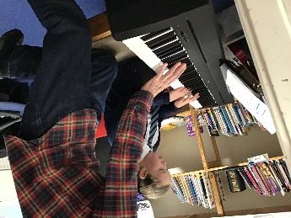
Music
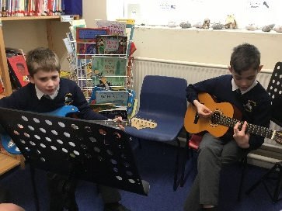
In our school we take pride in our music, Mrs Higgins who is head of music and she teaches the whole school music lessons and if you’re in the choir you get to go to Eccleshall church and sing and even preform your instruments. Basically, every term we do a concert then you get the chance to preform your instruments plus singing in front of your parents and if you don’t play an instrument you get to sing as a class too. Annabelle
Lucas (designer)

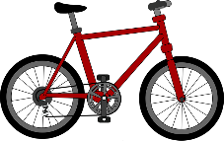
Bikability
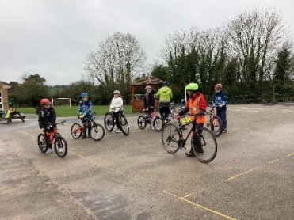
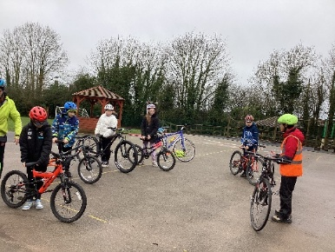
This week the pupils have been feeling excited to ride their bike somewhere different, although they may feel apprehensive. However, they know they will smash it! They are so enthusiastic to participate in this event with friends and learn to ride their bike safely around the school and the local area. Bikeability is an enjoyable and intriguing way to learn to ride your bike and you may also gain new skills. Each small group will spend time in the playground with experienced instructors, making sure they are ready to go on the road. They will complete different exercises and tests. At the end, you will feel proud of yourself for achieving success and pass the course. I spoke to the instructor today, he explained how he loved meeting new children and teaching them to gain more confidence on their bike. I interviewed a group of children before taking part and they expressed a mixture of emotions from nerves to adrenaline, but all were very eager to get going!
Sienna
Here is a heads up of what is happening next half term. A trip to the Halle Orchestra for KS2, a Viking workshop for Year 5 and 6, a WW2 workshop for Y3 and Y4, a trip to Standon Bowers for Y5 and a Laches Wood residential for Y6. Thank you for reading the Mucklestone messenger.
Bye!
Leo (Editor)

