St Mary’s, Mucklestone.
It has been a jam-packed half term with lots of fun activities going on, so sit down, get comfy, grab a snack and enjoy the Mucklestone Messenger.

Leo (Editor)
Early Years Equipment
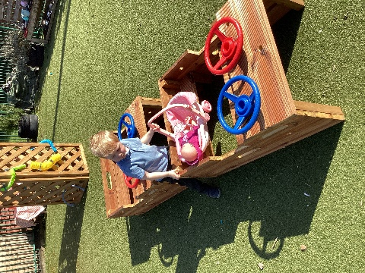
Early Years have received some money from a charity grant and they have spent it on some equipment which has been a big hit for early years. They love playing dogs, rescues, and families.
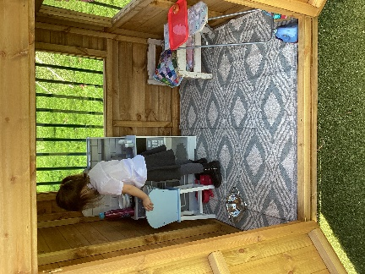
The little ones love the new equipment. There’s lots of different types of toys like the wooden cars with steering wheels the colours of the steering wheels are blue and red. They have also got some new wooden houses there also is a wooden sandpit. Their ratings out of ten are seven and over and most of their ratings were ten out of ten. Here are some brilliant pictures of them playing on the excellent equipment. Thank you to Madeley charity for supporting our school.
Molly
Laches wood
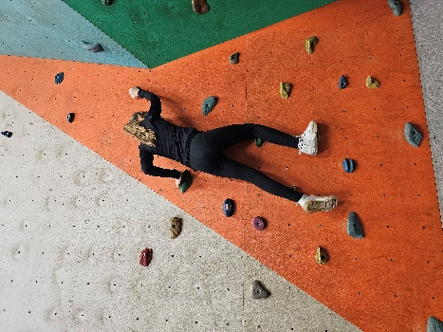
The children at St Mary ‘s went to Laches Wood with some other schools from our Academy. We were really excited and could not wait to go. We went Monday to Wednesday. On Monday we got on the bus and headed to Laches wood Everyone was excited to try new thing like tunneling and climbing when we got there we un packed and got ready to do search and rescue part one and we won. After lunch we did part two and we came second every night we had hot chocolate and biscuits. The food was great especially the cooked breakfast .
FUN FACTS ABOUT LACHES WOOD
Diverse Activities: The site offers a massive variety of activities, including high ropes, climbing walls, bouldering, indoor caving, BMXing, archery, and bushcraft.
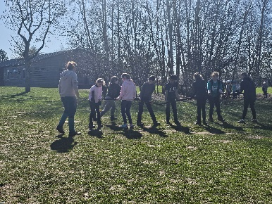
Intense Activity Stats: In a single year, Laches Wood and Standon Bowers centres have seen almost 5,000 people cycle over 5,000 km, and 4,800 people climb over 76,000 meters on the "Gladiator Challenge".

Lacey
World book day
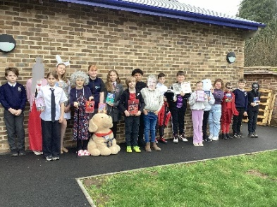
In St Mary’s everyone loves world book day because you can see all the different costumes and other books you haven’t read before. Some people dress up as the people who inspire them. Other people dress up as unique characters.
FUN FACTS
In the UK and Ireland, World Book Day is celebrated on the first Thursday of March, avoiding school holidays.
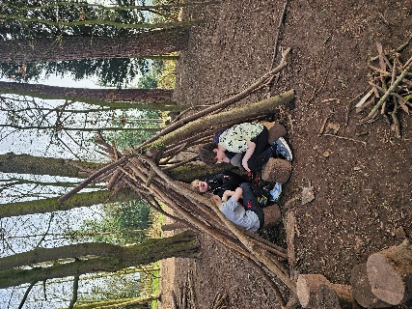
World Book Day is celebrated in over 100 Countries schools , Libraries and bookshops around the world organize reading events , storytelling sessions , and book swaps to encourage children to enjoy reading .

Anabella
Halle Orchestra
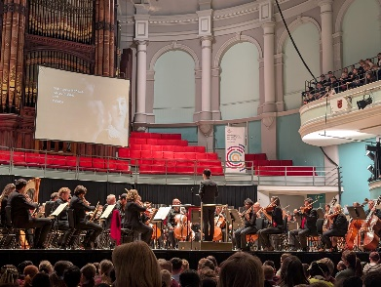
On Monday the second of March we went to see Halle Orchestra at Victoria Hall in Hanley.
All week we had been practicing a song to sing with all the other schools (how far I’ll go from Moana) . It was so fun! Everyone enjoyed it plus we learnt all about the different pieces. At the start they gave us scratch and sniff card where you could smell about the different pieces. The songs they performed were Bizet Carmen Suite, Ron Grainer & Della Derbyshire Doctor who Theme, Price Nimble Feet from Dances in the canebrakes and Laura Shigihara Grasswalk from plats vs. zombies. Personally my favourite was the Doctor Who one you could almost feel the drums.
Annabelle
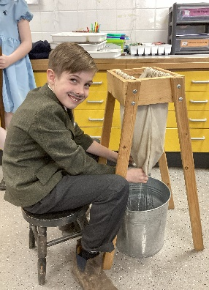
Year 5 Standon Bowers
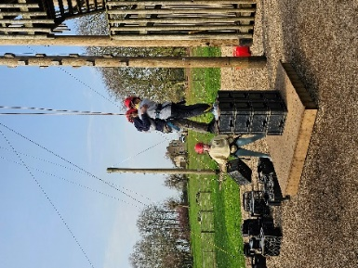
year 5 went to Standon Bowers for a day out with school! Some year 5 are excited to miss a day of school and most year 5’s are exited for all of the fun activities. The teaches that went were Mrs Mannering and Mrs Graham (Ozzy did not go as he might be a bit crazy). The activity’s that we took part in were: rifle shooting, axe throwing, den building and high ropes. In axe throwing we had a little competition which I won, we learnt how to throw the axes and learnt how to collect the axes even the teachers joined in. In team building we worked in a team to build a den. My team made an A shaped den which its name is an A shape because it looks like an A. In rifle shooting we learnt how to load the rifle and shoot the riffle. In high ropes we did the box stack where you would go on boxes and the instructor would stack loads of boxes. We did this thing that you jump of a building and all the other year 5 would catch you at the bottom in case you got jelly legs. We also did the gladiator, where we had to climb a ladder, then climb up a cargo net, then we had to climb up 2 tiers and then finely we had to stand on top. We all had a great day.
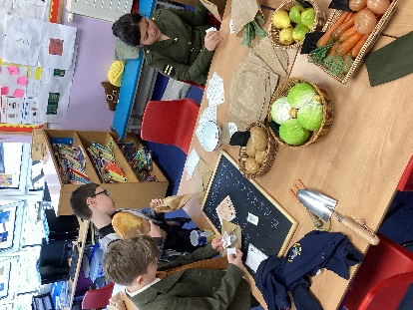
Evie
Year 3 and 4 WWII day
In class three, the pupils have been leaning about World War 2. The lady who held the work shop was full of intriguing facts that wowed class 3. They even got to milk a cow and try a gas mask on. I was exhilarated when I interviewed them because I was so curious to know what they were up to, they even told me they did trading with ration books. But over all they enjoyed it.
Sienna SSS

Thank you for reading our Newspaper , Next Term we have chocolate bingo , YEAR SIX SATS and much more fun . Have a brilliant Easter everyone , enjoy all your chocolate eggs . Martha (editor)
Design by Lucas

