

**St Mary’s Church of England Primary School**

**Parent/Carer Handbook**

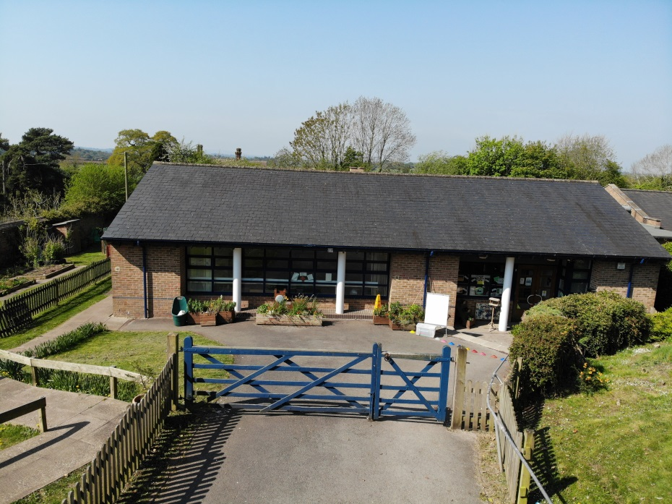

Living, Loving and Learning in God’s Care

**Vision for St Mary’s C of E Primary School**

*Living, Learning and Loving in God’s Care; our Christian values, understanding of the Bible and curriculum teach us how to live, love and learn. O Lord, teach me how you want me to live. Psalm 86:11*

**Contents**

Head Teacher’s Welcome

Parent Interaction

Building Learning Power

Curriculum

Joining St Mary’s in Class 1 / Early Years Foundation Stage

Learning Interventions and 1-1- Support

Behaviour ‘Good to Be Green’

Reading Buddies

Routines and Essential Information

The School Day

Catering (Snacks and lunches)

Additional Activities

Before School Club

After School Clubs

ParentPay

Free School Meals and Pupil Premium Funding

St Mary’s Team and Governors

Educational Visits

Community Links

PTFA

**Head of School Welcome**

I am delighted to welcome you to our school. St Mary’s is a very friendly learning community with a dedicated and caring staff team. We strive to develop each child to his/her full potential and pride ourselves on treating every child as a special and valued member of our school family.

Our small Church of England Primary School is in a rural setting, situated in the village of Mucklestone, just outside Loggerheads. Pupils at our school live in the surrounding villages including Loggerheads, Woore, Norton in Hales, Knighton and Hales. Some children come from nearby Market Drayton.

We inspire our pupils through a stimulating curriculum so our children are excited about learning.

Through caring for our children in small classes we can meet their individual needs. We support those children who require that little extra help and have staff who are trained to deliver specialist intervention schemes. More able children are challenged by opportunities for independent learning, problem solving and the chance to perform and lead.

We are able to teach our children in four cohorts to ensure smaller groups for English, Maths and Science. Currently, our hall is utilised as a fourth teaching space to enable us to deliver a more precise curriculum to all children. There are mixed ages in each teaching group due to small pupil numbers. The teachers collaborate closely to ensure that all pupils are offered a creative, inspirational and purposeful curriculum that engages our children’s interest in learning and meets all their social, emotional and academic needs.

Our pupils achieve above the national averages in all subject areas. We thoroughly track each child’s progress so we always know where to focus their learning and guide them to their next steps through specific, individual targets.

St Mary’s is committed to developing the whole child so they become confident, socially and environmentally aware, well rounded individuals.

We are able to offer each child a very special start to their school life.

Our picturesque and extensive grounds provide a safe and peaceful oasis in which to grow physically, academically, spiritually and emotionally. Our classrooms are modern and well equipped and we also have a school hall which is used as a breakout space for learning, a dining room and for our important whole school community gatherings. In addition, our library or break-out space has a calm corner for reflection and our specialist early years area features both an outdoor learning space with an all-weather Astro-Turf surface as well as an extended classroom with a covered area.

Our beautiful, walled grounds include a vegetable garden, nature pond and sports field, as well as a tarmac playground and landscaped quiet area with several spaces for both relaxing and outdoor learning.

If you haven’t visited St Mary’s and would like to see all our facilities for yourself, please ring to make an appointment, it would give me great pleasure to show you around our delightful school – every day is an open day!

We hope this handbook will give you an insight into our vision for teaching and learning in our school, as we begin to work together to develop your child’s lifelong love of learning.

Sharon Mannering.

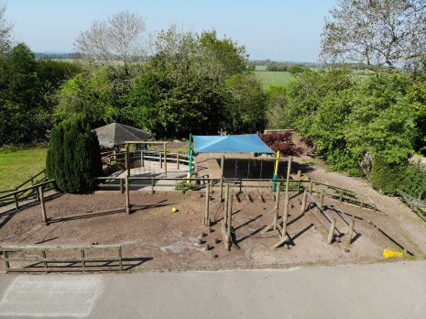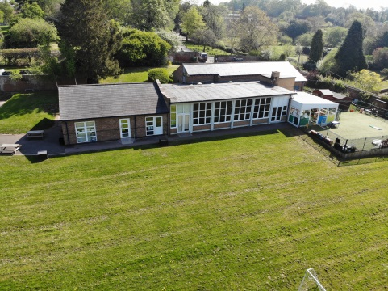

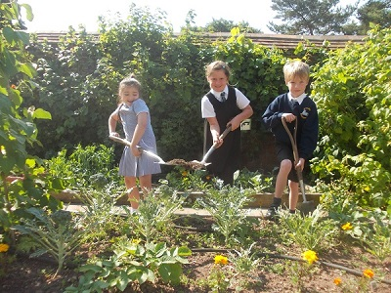

**Parent Interaction**

We encourage positive and effective relationships with parents and carers and staff are available after school if needed. If you have any concerns or questions regarding your child, we encourage parents to meet their child’s class teacher in the first instance. Mrs Mannering or Mrs Goodwin will welcome children into school on most days. We will now be operating a ‘message taking system’. Mrs Mannering l will pass messages onto Mrs Goodwin or your child’s class teacher, to prevent queues and congestion in the Reception area.

Please contact Mrs Goodwin (in the school office) 01630 672126 if you wish to make an appointment with your child’s class teacher or Mrs Mannering..

We also build family links in the following ways:

* Parent consultation sessions at three key points during each academic year – an opportunity to discuss your child’s progress with their class teacher and look at their books
* End of half term topic exhibitions
* Family finish sessions – parents and carers are invited into class to share an activity or project and experience school life
* Celebration assemblies – whole school gatherings to celebrate moments when pupils ‘shine’
* Open days
* Church and school services – we mark the end of each term with special festivals and school services in church to which parents are very welcome
* The weekly church club (that runs at various times through the school year) leads occasional Sunday services in church.

In the Autumn term we celebrate Harvest in a Sunday service and the new starters to our school are welcomed during a church service. All family, friends and members of the church and community are welcome to attend. Mothering Sunday is another time in the church year, where we encourage all staff and pupils to attend our church service in Mucklestone church. In July we say farewell to our Year 6 leavers in church and it is led by the school – **which we expect all pupils to attend.**

We are very proud to be a church school and the children take an active part in our daily worship. Over time we have established close links with St Mary’s church and our local community. We believe our Christian values support pupil’s learning and how they are encouraged to live their lives. Focus on faith days throughout the year, enable children to discover and explore other faiths, to build respect, tolerance and celebrate diversity.

A copy of this booklet, along with more useful information can be found on our website. Our school Facebook page also keeps our local community in touch with events at school.

Website: [www.st-marys-mucklestone.staffs.sch.uk](http://www.st-marys-mucklestone.staffs.sch.uk)

Facebook: St Marys C of E Primary School

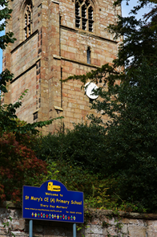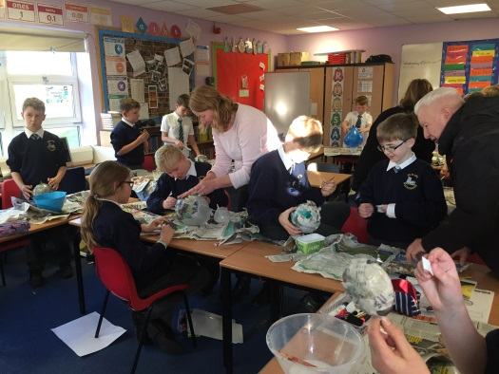

[](https://mkx20bvs5a2cy6u43bq2jqtp-wpengine.netdna-ssl.com/wp-content/uploads/2014/11/BLP_Logo1.png)**Building Learning Power (BLP)**

At St Mary’s we are committed to building children’s learning power, not just through knowledge they acquire, but more importantly how they learn. In the Early Years’ curriculum we call these the ‘characteristics of learning’.

For pupils in Key Stage One upwards this is known as BLP. We use the research from Professor Guy Claxton’s pioneering work helping children to become independent learners with four essential learning dispositions. Each disposition is represented by an animal to remind children how to use their building learning power muscles.

* Resilience Lola the ***resilient*** lion
* Resourcefulness Sid the ***resourceful*** squirrel
* Reflectiveness Ollie the ***reflective*** owl
* RelatingCharlie the ***relating*** chimp

The final disposition helps children with collaborative working, empathy, listening, imitation and interdependence***.***

Just as many of us exercise or go to the gym to develop our physical fitness, children come to St Mary’s school to develop learning fitness - as bodies become fitter, minds do too.

BLP is an integral part of lessons, activities and worship and is used across the school to encourage children to have a secure understanding of the skills they need, to underpin lifelong learning. Building learning power ensures that children have the capability to become better learners. It allows pupils to develop a common language for learning in a whole school approach and to reach their full potential.

**Our Curriculum**

At St Mary’s we offer a bespoke curriculum. Learning is tailored to each group and sequenced to provide links across all subjects ensuring that what pupils learn remains with them.

We fulfil the requirements of the National Curriculum and we also provide a variety of enrichment experiences including trips, ‘wow-days’ and experienced specialist visitors to school, who share their knowledge with the children. We provide a variety of extra-curricular opportunities for all our pupils where they can share their skills from the classroom.

**Teaching the Curriculum**

For part of the week pupils will be in four teaching groups covering Foundation subjects, Religious Education and Science. In English, we follow the ‘*Pathways to Write’* which encourages learning around a high-level text and inspires writing. In addition to this we follow ‘*Pathways to Read’* a reading programme designed to equip pupils from Y1 to Y6 with keys skills to move them through the reading process to enable them to become fluent and competent readers.

In Maths lessons we aim to help children secure their knowledge by moving through the concrete and pictorial, to the abstract, to ensure a thorough understanding is met.

For other sessions children work in their class groups and focus on a variety of subjects including; History, Geography, Art, Design &Technology, Music, PE, Computing, PSHE and French.

We lead our learning through a topic which usually has a Geography or History focus. When possible, we encourage trips and visitors to give the children a real-world experience of their learning.

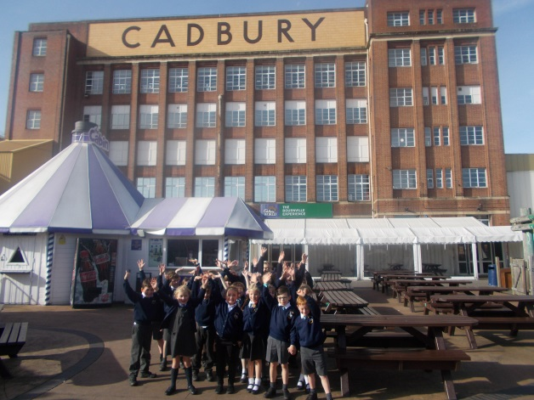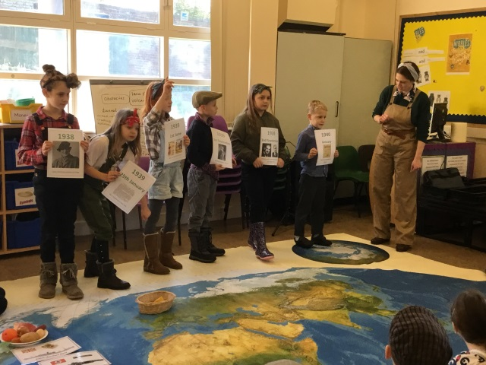

**Starting St Mary’s in Class 1**

**Nursery Provision**

When your child turns 3 years old they can join our Governor run nursery (we offer up to 30 hours’ provision), that is part of our EYFS provision within class 1. Nursery are a huge part of our school and join in with all of the events and celebrations. They learn and play within a stimulating and purposeful environment, which includes a classroom, conservatory and extensive outdoor area. Please call Mrs Goodwin 01630 672126 for more details.

**Early Years Curriculum and Structure of the Day**



During their Reception year children follow the Early Years Foundation Stage (EYFS) curriculum. This supports the essential development of children in their important formative years.

The curriculum encompasses a play-based approach, incorporating both the characteristics and key areas of learning.

At St Mary’s the learning takes place in our indoor classroom, conservatory and Astro Turf area outdoors. We have access to extensive grounds with grassy areas, different plants, trees and areas for growing. We are also fortunate to have regular access to a wooded area adjacent to our school, for us to engage in forest school activities.

The children learn by leading their own play and through guided learning with their teachers. The teaching and learning activities are adapted to support the individual needs of the children in each of the key areas.

The characteristics of learning refer to the ways each child interacts, respond~~s~~ and think~~s~~ in their environment and encompasses their engagement, motivation and thinking. The characteristics are:

* Playing and exploring
* Active learning
* Creating and thinking critically

Each characteristic feeds into the key areas which are either ‘*prime’* or *‘specific’*.

The prime areas:

* Communication and language
* Physical development
* Personal, social and emotional development

These are critical for healthy development of the child and for supporting their future learning. They also develop the skills needed for learning in the specific areas as follows:

* Literacy
* Mathematics
* Understanding the world
* Expressive arts and design

To support the children’s development, a baseline assessment is carried out in the first couple of weeks of being in Reception.

Throughout the year children are continually assessed within the seven key areas of learning, to track their development and progress, compared with their baseline starting point. This tracking enables their next steps to be identified and tailored to each, individual child.

In the Summer term an assessment called the *EYFS Profile* is carried out. This is based on the observations across all the key areas throughout the academic year and provides key information to aid the transition to the next Key Stage of learning. A formal EYFS report is then sent to parents at the end of the Reception year. All other year groups from Year 1 to Year 6 receive termly written reports, communicating NFER test results.

The teaching and learning in EYFS are continually adapted and moulded to support the child in reaching their Early Learning Goals.

**Our School Day in Class 1**

**Start of Each Day**

The school gate is opened at 8.40am and all children walk around our building and enter Class 1 by the side door where they will be warmly welcomed by the class teacher. During the first few days of the new school year or when new to our school parents and carers of Nursery and Reception children are very welcome to accompany their child to the classroom and to help them to settle into their new environment. They will enter via the conservatory door to the left side of the hall.

We start the day with table top activities, early morning activities and completing our register before jumping to our feet to do ‘Dough Disco’; an early morning activity which helps the children to wake up their fingers and hands and it’s always great fun!

**Morning Learning**

Children in Nursery and Reception always start their learning adventure with a group phonics lesson. We follow the ‘*Little Wandle*’ phonic scheme.

After phonics, children focus on English and the children will listen to stories, join in with rhymes and complete literacy based activities. Photos are taken and observations completed during this time to record their progress. We use ‘Tapestry’ in Class 1 as a method of digital method of gathering evidence and communicating with parents.

Break starts at 10.30am when children join the rest of the school on the main playground, enabling them to mix with the older children and form those really important friendships. During play time children have access to a range of outdoor equipment and are encouraged to eat a healthy snack provided from home. Alternatively, parents can purchase snacks offered at school through Parent Pay.

After break the children enjoy Maths, which involves very practical activities using play based materials and the outdoor area to explore the different mathematical concepts.

**Lunch time**

At 12 noon children enter the school hall to eat their lunch. Your child may choose between a hot meal provided by our dedicated catering staff or bring sandwiches from home. All Reception children sit together and enjoy this time to socialise. Water is provided with each hot lunch and there is always a selection of fresh fruit and vegetables to choose from.

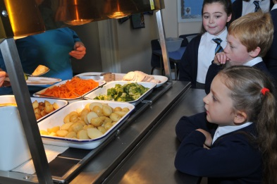Our daily menu changes throughout the year and can be found on our school website.

**Afternoon Learning**

In our afternoon learning adventure we explore the wonderful and diverse world in which we live. During our creative time we learn about different artists, explore music and how it makes us feel, investigate our world and how things work during topic and Science afternoons, and also think about how we feel and care for our bodies during PE. We explore RE themes to develop our Christian distinctive character and promote spiritual development.

All this amazing learning is documented in each child’s learning journey; a book which is a collection of independent work, photos, observations, group work and creative pieces and provides a wonderful way to see the whole child at work.

Nursery and Reception children are offered free milk to enjoy and also have afternoon free flow on their own AstroTurf area.

**End of the Day**

Every day, we end by sharing a story whilst sitting together on the carpet - this could be a class text chosen by the teacher or a book from our reading corner. It is a time for the children to calm down and reflect on a busy but very fun day!

The school day finishes at 3.20pm with children being collected from the Class 1 door, at the back of the school and sent home with a smile and the promise for another brilliant day tomorrow.

**Learning Intervention and One-to-One Support**

St Mary’s has three enthusiastic Teaching Assistants (TA’s) who offer additional support to children across all year groups and the whole school curriculum.

There are also TA’s on hand to help out with lunches, school trips, sporting adventures, artistic creations or music and drama extravaganzas!

The TA’s work in conjunction with the Class Teachers to meet the needs of pupils both collectively and individually. This may be where a child is struggling to understand a new area of learning, requires some extra practise to embed a new subject or to support a pupil with Special Educational Needs and Disabilities (SEND). They also provide encouragement and additional challenges for more able pupils, allowing them to stretch their knowledge, skills and understanding and realise their full potential.

Where a child has been assessed and provided with an EHC Plan or SEND Support Form, a TA will work with them on a regular, planned timetable to make sure they have full access to the curriculum and that their specific needs are met. TA’s also work alongside their colleagues, parents and other education professionals to ensure that learning objectives and care plan goals are achieved.

Some intervention may be a short, 1:1 session with a child to clarify a misconception and offer encouragement. On other occasions the TA may take a small group of children for ‘break out’ sessions providing some rapid intervention or more challenging tasks, as identified by the Teacher during a lesson. Imaginative learning resources are created or adapted to suit individual needs.

A child’s social, emotional and physical needs are also important aspects of their day-to-day life. Our teaching and support staff are always alert to the safety, health and wellbeing of all children in our care. Intervention or one-to-one support is available to any child needing help, medical assistance, protection, or maybe just a little bit of comfort and reassurance when they really need it.

At St Mary’s we recognise that each child is an individual with their own unique style and rate of learning. All our staff strive to make sure that every child is provided with equal opportunities to thrive and to enjoy their learning journey with us.

Booster interventions are led by the class teachers, TA’s and the Headteacher to prepare pupils for formal testing. This commences in January and comprises of after school sessions and interventions within curriculum time.

**Behaviour – Good to be Green**

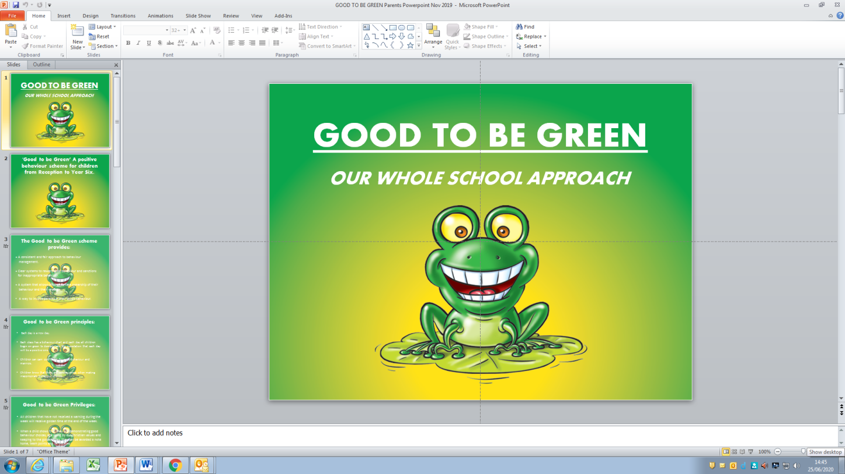St Mary’s adopts a whole school approach to behaviour management, which provides consistency and fairness for all children in all year groups.

The scheme utilises positive reinforcement, rewarding good behaviour whilst giving sanctions for inappropriate actions.

Each of our classrooms has a visible chart allowing children to take ownership of their behaviour during the day. At the start of each day all children begin with a ‘green’ status to demonstrate the expectation for the day is a good one.

Good behaviour and manners earn certificates, team points and notes home to parents. All children who have not received a warning during the week receive ‘Golden Time’ on a Friday afternoon where they are able to choose an activity they particularly enjoy.

Inappropriate behaviour receives a warning from a member of staff but if this continues a ‘yellow card’ will be given as a consequence and children miss the following break time.

Persistent inappropriate behaviour leads to a ‘red card’ meaning children lose half their Golden Time at the end of the week. A member of staff will also speak to parents and the incident is recorded in the child’s reading diary.

Staff closely monitors patterns of inappropriate behaviour with a view to preventing incidents occurring. We are proud of our children’s behaviour and always set high expectations for all children.

**Reading Buddies**

[](https://www.google.com/url?sa=i&url=https://www.pgpl.ca/events/reading-buddies&psig=AOvVaw2s-TAJ39l09nGSSUGMvNh7&ust=1594209468932000&source=images&cd=vfe&ved=0CAIQjRxqFwoTCJD8yqOLu-oCFQAAAAAdAAAAABAG)

Reading Buddies is a whole school reading initiative designed to encourage enjoyment in reading and develop relationships between pupils from different year groups who would not usually interact on a daily basis during learning sessions.

**Reading Ambassadors**

Reading buddies and reading ambassador sessions alternate through the year. Reading ambassadors have the responsibility to read weekly to a class of children (supervised by staff). They recommend books to pupils, run our school library and share their love of reading!

Every Wednesday afternoon, children take part in reading buddy or reading ambassador sessions.

[](https://www.google.com/url?sa=i&url=https://www.pinterest.com/pin/445223113136199472/&psig=AOvVaw2hvR1KVXYloSNFQ1g-B_k1&ust=1594206963221000&source=images&cd=vfe&ved=0CAIQjRxqFwoTCMDgl_2Bu-oCFQAAAAAdAAAAABAE)Reading is very important to us at St Mary’s and we hope that this weekly session will ignite your child’s love of independent reading both at home and at school.

**Routines and Essential Information – All Children**

**Uniform**

Our uniform is important to St Mary’s school as it represents that we are a whole school community who live, love and learn together. We take pride in our appearance and are ambassadors for our school.

Please label all items that come into school, including bags, book bags, shoes and water bottles.

Items your child will need are:

Nursery pupils wear a pale blue polo shirt without a tie and grey shirt or trousers or navy blue jogging bottoms.

***Uniform Reception to Year 6 for girls:***

* Grey skirt/pinafore dress/skorts/trousers or **pale blue and white** checked dress for the **summer term only**.
* Long sleeved white blouse with a stiffened collar and school tie (short sleeved in the summer term)
* Navy blue jumper or cardigan with St Mary’s logo
* Plain white or grey ankle or knee length socks
* Grey woollen tights
* Black school shoes – shoes must be plain, flat, sensible shoes. Wellingtons and boots may only be worn to and from school in bad weather and your child will then change into their school shoes for indoor use. Plain black, white or navy sandals with socks - summer term only.
* A school coat or fleece or plain, dark coloured coats

***Uniform Reception to Year 6 for boys:***

* Grey shorts or trousers
* Long sleeved white shirt with a stiffened collar and school tie (short sleeved in the summer term)
* Navy blue jumper with St Mary’s logo
* Black school shoes – should must be plain, flat and sensible. Wellingtons and boots may only be worn to and from school in bad weather and your child will then change into their school shoes for indoor use. Black or navy sandals with socks - summer term only
* Black or grey socks

***P.E. Kit***

Children need a change of clothes and footwear for P.E (for health and hygiene reasons) and a named draw-string bag in which to keep the kit at school. All school uniform and P.E. kit MUST be named. Children can become upset as a result of lost clothing, please help us by naming everything. PE lessons take place each Monday and a second session at a different time through the week.

***Girls and boys wear:***

• Navy shorts

• Plain white polo shirt with a collar

• A pair of black or white trainers

• A navy tracksuit for outdoor lessons in cold weather

Long hair must be tied up for school and make up and nail varnish are not permitted.

If children have pierced ears, please ensure clear plastic retainer studs are worn.

**Book Bags**

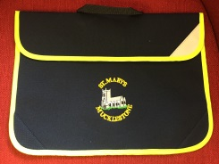Book bags are an essential part of our uniform for pupils in Class 1 as they enable the children to bring their reading books into school each day, as well as paper copies of any communication between home and school.

**Water Bottles**

Please ensure your child has a clearly named bottle filled with unflavoured, still water in school every day.

Children will be encouraged to bring their bottles home every day to be thoroughly washed.

There is a water cooler in school that is accessible to all pupils for them to refill their bottles throughout the day.

**Jewellery**

No jewellery is to be worn in school apart from a wrist watch and ‘Smart watches’ are not permitted.

**Hair and Nails**

Long hair must be tied up and off the face with hair bands, bobbles or small clips in school colours. Large exaggerated coloured bows and accessories are not permitted to be worn in school.

Haircuts must not be extreme and shaved patterns are not permitted.

Please ensure nails are kept short. Children are not permitted to wear nail varnish in school.

**Extreme weather**

Wellington boots/walking boots can be worn to school if we experience wet weather or snow.

Please send a named plastic bag in which they can be stored and provide school shoes for children to change into once they arrive at school.

Children will need a hooded, warm and water- proof coat in school every day as we do access the outdoor areas in most weathers.

On very hot days please ensure your child has sun cream applied prior to school and provide a sun hat each day. In extremely hot weather, the school tie will not need to be worn. The Head of scho will advise on these specific uniform changes.

**The School Day**



Our school gate is opened at 8.40am. Children are encouraged to say goodbye to parents or carers by the steps at the front of the building and enter school via the side gate where a member of staff will be waiting to greet them and take any relevant messages for the day.

If a different adult will be collecting your child, please make staff aware and set up a password. This will be passed onto the class teacher and used to ensure your child is handed over to an adult following parent’s consent.

Children will then go to their own classroom where early morning learning activities commence immediately. It is important children are punctual and waiting at the gate at 8.40am, otherwise essential learning time is lost and over time this becomes significant. Registration takes place at 8.50am each morning. Afternoon registration takes place at 1pm.

Parents and carers collect their children from their classroom doors at the rear of the school at 3.20pm. A member of staff will call their name and they will be handed over to you.

[](https://www.google.com/url?sa=i&url=http://clipart-library.com/clipart/1833698.htm&psig=AOvVaw2SN0nyAw9AMrUf-tnq2ZOw&ust=1593005192640000&source=images&cd=vfe&ved=0CAIQjRxqFwoTCLDw7YCFmOoCFQAAAAAdAAAAABAE)

**Morning Snacks and School Lunches**

**WE ARE A NUT FREE SCHOOL**

Due to some of our pupils having a severe nut allergy we are a nut free school, to keep our children safe. Please do not send nuts or foods that may contain nuts into school. Thank you.

St Mary’s is a healthy school and we value parental support in encouraging children to make healthy choices.

**Break Time –** At 10.30am allchildrenhave a 15 minute break where they have the opportunity to play outside.

Children may wish to have a healthy snack and are able to bring their own from home or have a warm snack supplied by our catering team. Please note, crisps and chocolate bars are not permitted at break time.

If you would prefer to purchase a morning snack for your child they are chargeable per term via our cashless system, ParentPay.

**Lunch time -** Children may choose to bring a packed lunch from home or order a cooked meal each day.

Our lunch menu changes three times per year and the main meal is always accompanied by a choice of fresh vegetables and fruit as well as water to drink.

Children eat their hot lunches in the school hall where our staff and table monitors encourage good table manners and behaviour.

Lunches are chargeable per day via our cashless system, ParentPay and the menu is available on our school website.

If you prefer to provide a packed lunch and drink for your child, please can we ask that you include contents that are suitable for a healthy lunch. Please do not send fizzy drinks or sweets.

St Mary’s is a nut free school, so we also ask that you do not send any nuts or nut products into school to ensure the safety of all our pupils.

Packed lunches are often eaten on our picnic benches outside when the weather is good.

After eating, children have time to play with friends outside, with a range of play equipment and supervised by our lunchtime supervisors (who are also our teaching assistants and teaching staff).

They play outside in all weathers so please ensure your child has a suitable coat and sun hat/sun cream depending on the weather.

**Our Church School**

St Mary’s church in Mucklestone and the local community are very important to us.

Our excellent SIAMS outcomes reflect the very strong church and school links that have been built over the years.

The staff, families and children worship in the church on significant church year events such as, Harvest, Christingle, Christmas, Mothering Sunday, Easter, Pentecost and the end of year service for leavers.

During the year children and their families regularly attend the children-led family services. These are wonderful children’s church events that allow children to prepare and lead worship.

We ask that staff, children and their families attend these church service through the year. These are held in Mucklestone church. The leavers’ service takes place in church in July each year, when our Year 6 pupils are celebrated and given a fond farewell.

These services are an important part of being a member of a church school.

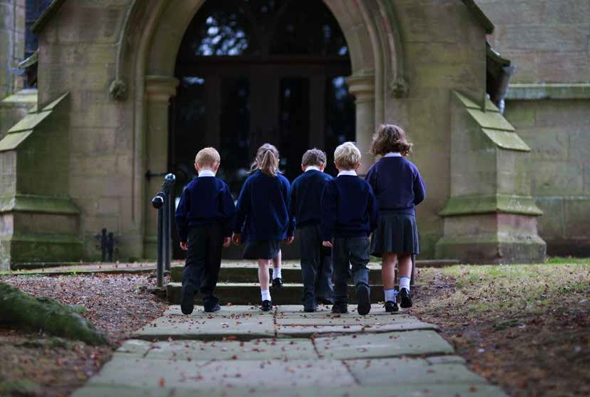

**Additional Activities**

**Before School Club**

**Come and join the fun at St Mary’s Before School Club!**

Our Before School Club provides a safe, caring and fun atmosphere for children who require care before the school day begins.

Children enjoy a varied range of activities to keep them busy before school starts.

Children should be booked into Before School Club half a term in advance via our ParentPay system. Fees are non-refundable.

**Charges:**

* Arrival from 7.45am. £4.70 – a fixed price for one session regardless of arrival time. Currently breakfast is not provided but parents and carers are encouraged to send a drink and healthy snack.

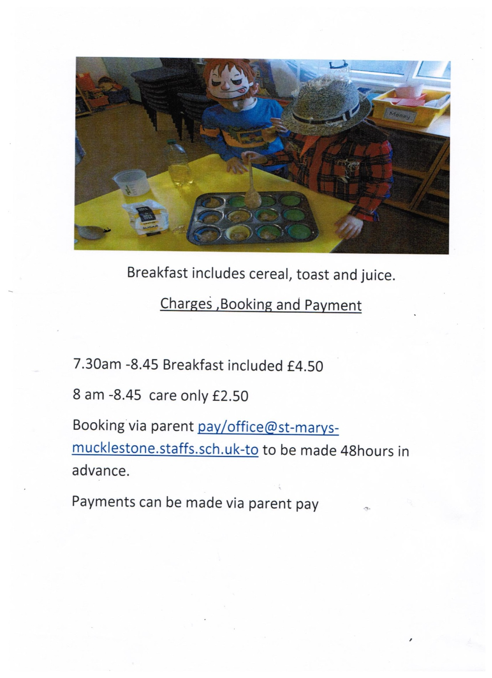

**After School Clubs**

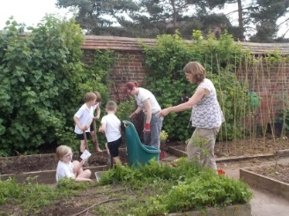The school day does not end at 3.20pm at St Mary’s!

Every day we offer an ‘After School Club’ from 3.20pm to 4.30pm to provide children with an exciting range of extra-curricular activities. The choice of clubs is refreshed every half term so there is always something for everyone to enjoy. This also provides more flexibility for parents requiring childcare beyond the normal school day.

We ensure a high standard of activities by inviting external providers into school who can offer their expertise on a wide range of activities from sport to cookery to craft-based sessions. Often our clubs are seasonal to reflect the changing areas of the school calendar for example, cricket and tennis in the summer and Christmas crafts and film club in the autumn term. We also have regular clubs which run all year such as Children’s Church Club, our ‘mid-week Sunday school.’

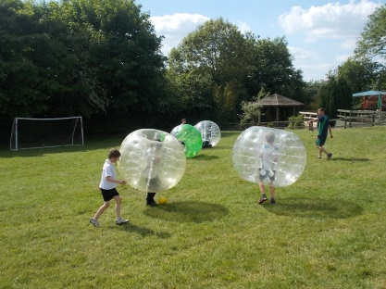All our clubs provide children with experiences which may not be offered as part of the curriculum but we hope inspires them to learn a new skill or try a different sport or activity. Where possible we like to involve local coaches providing activities for children (tennis, cricket, dance etc) so that, should children discover a skill or special interest, we can sign post them to Clubs where they can continue activities.

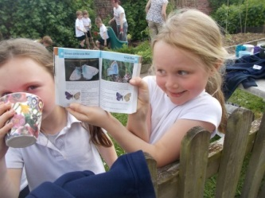There is a small charge of £4.70 per session for most of our clubs which is payable before the start of each half term via ParentPay. This charge covers the cost of staffing and any additional resources.

A flavour of our clubs is listed below but we are always looking for new and innovative ideas, and would also welcome parents who are willing to share special interests and skills with the children; all suggestions are welcome!



**Children’s Church Lunch Club**

With a view to building on the strong links between St Mary’s School and Church, and encouraging the church of the future, we run a weekly lunchtime church club for pupils of the school.

The children learn more about the Christian Faith and the Anglican Church, in particular, through Bible stories, games, drama, singing and crafts.

At various points through the church year, the children help to plan and lead the Family Service, held in the church on Sunday mornings, based on what we have recently been learning.

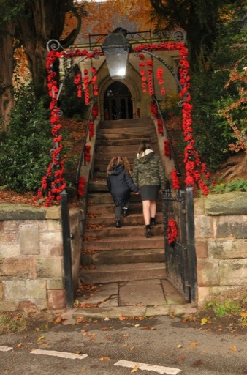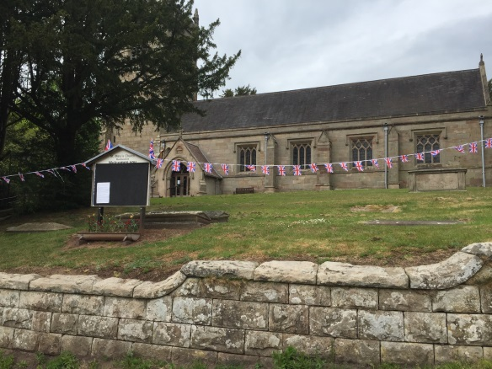

**ParentPay**

St Mary’s aims to be as ‘cashless’ as possible when taking payments from parents and carers. To facilitate this we use an online system called ParentPay.

Each child is given a ParentPay account on joining school, to enable payment to be made for items such as lunches, snacks, before and after school clubs, uniform and school trips.

**Free School Meals**

In 2014 a Government initiative was implemented meaning all children aged between 4 and 7 years old are entitled to a free school meal each day. This ensures children are provided with a healthy meal every lunch time.

The menu for our school lunches is on the school website should you wish your child to have a hot meal. Our hot meals are £3.20 each day. Please inform the school office of any dietary requirements when completing entry to school paperwork.

Children aged 8 and over are also eligible to claim free school meals if you are in receipt of the following:

* Universal Credit (depending on annual income)
* Income Support
* Income based Job Seekers Allowance
* Income related Employment and Support Allowance
* Working Tax Credit (paid for 4 weeks after you stop qualifying for Working Tax Credit)
* Child Tax Credit (dependent on annual income)

**Pupil Premium Funding**

Pupil Premium Funding for children whose circumstances mean they may need a little extra support is also available for:

* Children adopted from care
* Children with parents in the Armed Forces
* Children that are looked after (in the care of the Local Authority)
* Families who receive certain benefits

Further details are available on the Staffordshire County Council website or from our school office.

<https://www.staffordshire.gov.uk>

[office@st-marys-mucklestone.staffs.sch.uk](mailto:office@st-marys-mucklestone.staffs.sch.uk)

**Pupil Absence and Punctuality**

[](https://www.google.com/url?sa=i&url=https://www.redscopeprimaryschool.co.uk/punctuality-and-attendance/&psig=AOvVaw0VdhMw2oewPxRDmrMchvzn&ust=1593159167340000&source=images&cd=vfe&ved=0CAIQjRxqFwoTCKD818bCnOoCFQAAAAAdAAAAABAD)

We encourage all children to have a positive attitude to school life and learning and expect them to attend school when they are fit to do so. We appreciate that children need to stay at home when they are unwell and fully understand that home is the best place for them at this time.

We closely monitor attendance and punctuality of all pupils so that we can praise great attendance but also support if this becomes an issue. You will appreciate that we have your child’s best interest at heart. It is most helpful when parents follow school procedures by informing the school before 9am on each day your child is absent.

Our attendance ratings follow Staffordshire County Council’s guidance:

* Excellent attendance is considered to be 98% - 100%
* Good attendance is 95% or above
* 90% attendance = one day missed per fortnight
* 85% attendance = one and a half day missed per fortnight
* 80% attendance = two days missed per fortnight

We encourage all children to be ready to come into school at 8.40am to allow the children to get themselves organised and ready for a prompt and positive start to their day.

Each term we celebrate 100% attendance awards for pupils who have attended each day. They are rewarded with treats and fun activities at the end of the term.

In cases of sickness and / or diarrhoea, we follow Public Health England Guidelines meaning children must not return to school until 48 hours after the last episode of sickness and diarrhoea.

For any other infections/illness please seek advice from the school office for how long your child should remain absent from school. We will consult the Staffordshire Communicable Diseases Policy.

**Administering Medication**

If your child has been prescribed medicine that can only be taken during the school day, you will be asked to come into school to complete a form, giving permission for school staff to administer the medicine.

Please ensure a first dose has already been administered and inform school of any allergies when completing the data checking form or throughout the school year as needed.

**Keeping Children Safe**

**Child’s Safety – The Car Park**

For the safety of all our children at St Mary’s school we ask parents, carers and visitors to adhere to certain rules whilst using the school car park. At busy times of the day space may be limited so please allow enough time to park safely.

* All cars should be ***reverse parked*** into car parking spaces ensuring they are completely backed into the space allowing as much room for other cars to manoeuvre as possible.
* Parents, carers and children should walk along the designated, pedestrian path when dropping off and collecting.
* Due to the narrow entrance to the car park, please be considerate and drive slowly and with caution due to pedestrians.
* [](https://www.google.com/url?sa=i&url=https://www.dreamstime.com/illustration/lollipop-lady.html&psig=AOvVaw11vqU5qekHhH4j2CUCDGsO&ust=1593160057376000&source=images&cd=vfe&ved=0CAIQjRxqFwoTCLjz0PfFnOoCFQAAAAAdAAAAABAE)If the car park is full, parents and carers are advised to park on the main road through Mucklestone and walk the short distance to school. This is much safer for everyone.

Please be vigilant, courteous and park with the safety of all our school children and community in mind. We are a school who cares about our wider community.

**Safeguarding**

*“…we are a school that is committed to safeguarding and promoting the welfare of children and young people and expect all staff, community and parents to share this commitment.”*

We recognise our moral and statutory responsibility to safeguard and promote the welfare of all pupils. We endeavour to provide a safe and welcoming environment where everyone is respected and valued. We are alert to the signs of abuse and neglect and follow our procedures to ensure that children receive effective support, protection and justice. The procedures apply to all staff, volunteers and governors and are consistent with those of Staffordshire Safeguarding Children Board.

We welcome volunteering adults in school. If you would like to volunteer in school, please send a letter of interest to Mrs Goodwin via our office email [office@st-marys-mucklestone.staffs.sch.uk](mailto:office@st-marys-mucklestone.staffs.sch.uk)

Mrs Goodwin will be able to discuss the role of volunteering in school, share the policy and arrange for the required enhanced DBS clearance. Please note parent/carer volunteers do not support in the same class/year group as their own child. All of our volunteers are provided with a thorough induction session and informed about safeguarding.

**Photography and Social Media**

We understand all parents and carers will want to capture those magic moments of children participating in school events. However, due to increased levels of data protection and safeguarding measures, which schools must comply with, we ask that parents only take photographs of their own child.

Some children are not permitted to have their photograph taken in order to protect their identify or whereabouts.

We appreciate your support in respecting each child and family’s privacy and we expect all parents to refrain from uploading images of any other pupils on social media without prior parental consent.

**Our St Mary’s School Team**

**Head of School and SENDCo**

Mrs Mannering

[Headteacher@st-marys-mucklestone.staffs.sch.uk](mailto:Headteacher@st-marys-mucklestone.staffs.sch.uk)

**Governing Body**

Mrs Denise Keen Chair of Governors

[dkeen@st-marys-mucklestone.staffs.sch.uk](mailto:dkeen@st-marys-mucklestone.staffs.sch.uk)

Ivan Grove Foundation Governor

[igrove@st-marys-mucklestone.staffs.sch.uk](mailto:igrove@st-marys-mucklestone.staffs.sch.uk)

Matthew Griffin Foundation Governor

[mgriffin@st-marys-mucklestone.staffs.sch.uk](mailto:mgriffin@st-marys-mucklestone.staffs.sch.uk)

Ruth Hawkins Parent Governor

[rhawkins@st-marys-mucklestone.staffs.sch.uk](mailto:rhawkins@st-marys-mucklestone.staffs.sch.uk)

Sue Fox LA Governor

[sfox@st-marys-mucklestone.staffs.sch.uk](mailto:sfox@st-marys-mucklestone.staffs.sch.uk)

Meg Scoble Foundation Governor

[office@st-marys-mucklestone.staffs.sch.uk](mailto:office@st-marys-mucklestone.staffs.sch.uk)

**Office Support Manager**

Mrs Goodwin

[office@st-marys-mucklestone.staffs.sch.uk](mailto:office@st-marys-mucklestone.staffs.sch.uk)

**Class Teachers**

**Class 1 and Class 2**

Mrs Higgins and Mrs Mannering

[chiggins@st-marys-mucklestone.staffs.sch.uk](mailto:chiggins@st-marys-mucklestone.staffs.sch.uk)

**Class 3**

Mr Cohen

[dcohen@st-marys-mucklestone.staffs.sch.uk](mailto:dcohen@st-marys-mucklestone.staffs.sch.uk)

**Class 4**

Miss Rhodes

[rrhodes@st-marys-mucklestone.staffs.sch.uk](mailto:rrhodes@st-marys-mucklestone.staffs.sch.uk)

**Support Staff**

Mrs Jackson HLTA and Lunchtime Supervisor

[Ajackson@st-marys-mucklestone.staffs.sch.uk](mailto:Ajackson@st-marys-mucklestone.staffs.sch.uk)

Mrs Dicks TA

[hdicks@st-marys-mucklestone.staffs.sch.uk](mailto:hdicks@st-marys-mucklestone.staffs.sch.uk)

Mrs Katherine Pike TA and lunchtime supervisor

[kpike@st-marys-mucklestone.staff.sch.uk](mailto:kpike@st-marys-mucklestone.staff.sch.uk)

Mrs Sarah Kingsley TA and lunchtime supevisor

Skingsley@st-marys-mucklestone.staffs.sch.uk

**Educational Visits**

During the school year children have the opportunity to join in many curricular and extra-curricular visits and events.

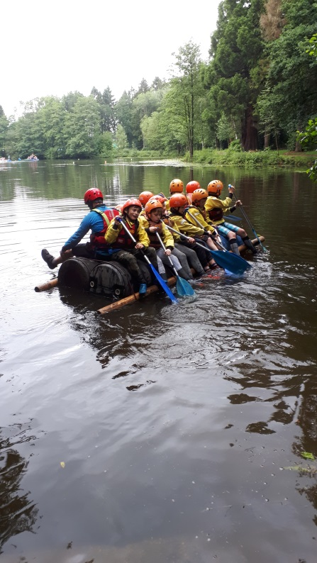A popular trip is the annual, residential week for Class 4, where learning of a different kind takes place. Throughout the week children participate in many exhilarating activities e.g. quad biking, archery, survival skills, fencing, kayaking, raft-building or taking the “leap of faith” on a high ropes course – even our most reticent children return home having experienced a week to remember and bursting with exciting tales!

Although we are a small school, competitive sports are an important part of our PE program and children participate in many local competitions throughout the year. Events include netball, archery, football, gymnastics, cross country running and swimming galas.

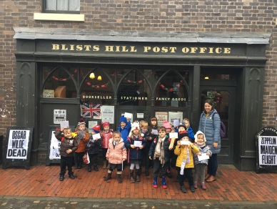At various points throughout the year all our year groups participate in trips to local attractions, chosen specifically to support the topics they are learning about within the curriculum.

Younger children visited ‘Birmingham Think Tank Museum’ and learnt how to become an astronaut as part of their topic on ’Space’. They also visited a Victorian Village to find out how the Victorians celebrated Christmas.

Older children have visited ‘Cadbury’s World’ to support our popular topic of chocolate and a Multi-Faith Centre in Derby to support our RE learning. A spectacular trip for our Class 4 children was to a local theatre to watch a breath-taking performance of ‘War Horse’ by Michael Morpurgo, a text they were studying in English.

We have invited visitors to school and children have spent a whole day immersed in a particular topic. During a focus on World War II our children came to school dressed as recruits for the Land Army and enjoyed learning how people lived during war time in England.

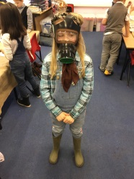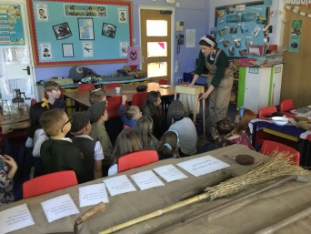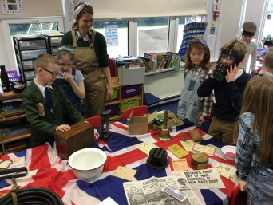

**Community Links**

St Mary’s Primary School is an integral part of our local community and we work hard to establish strong relationships with the adjacent church and community groups as well as travelling a little further afield for specific events and activities.

Our children enjoy links with Cheswardine Residential Home and visit the elderly residents there.

Over the year we have performed musical pieces, shared life experiences and held special days, where the children and residents can take part in activities together. Memorable events include Easter bonnet making, theatre company productions, childhood memories and a sports day.

Our older children have also incorporated the links into their English lessons and written letters to the residents to create a ‘pen-pal’ system.

Residents have also visited school to listen to children read.

We support Loggerheads Parish Council picking litter from our local countryside and we have also joined with Broughton Community Choir and other local schools for musical evenings.

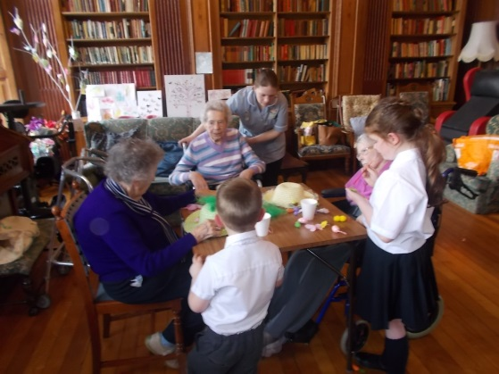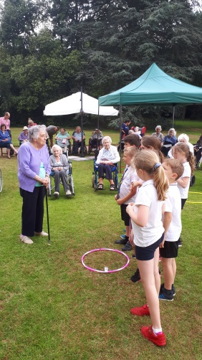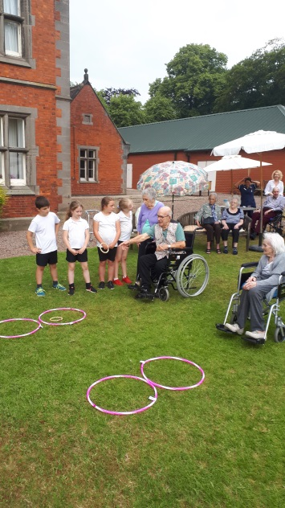

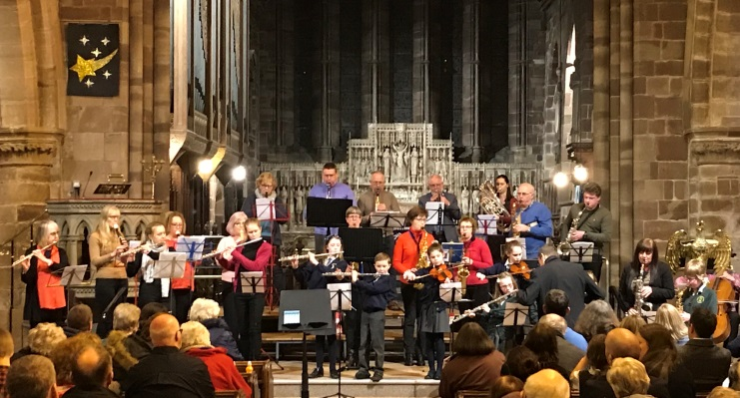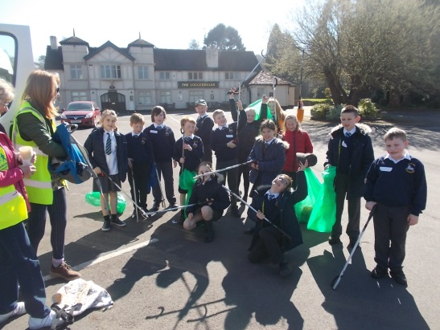

**St Mary’s PTFA**

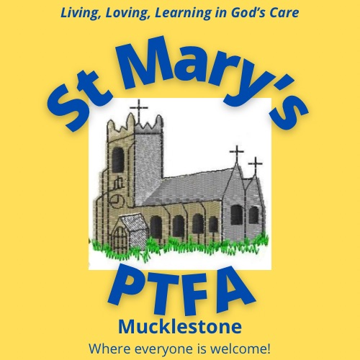

St Mary’s Church of England Parent Teacher and Friends Association Mucklestone (PTFA) is a registered charity formed to ‘advance the education of the pupils by providing items or facilities not normally provided by the Local Authority’. It makes an important contribution to enrich the educational experience of children at St Mary’s.

Thanks to the wonderful support of our parents, staff and wider community last year our fundraising efforts were able to pay for French lessons, educational visits and enrichment day visitors to school for every class, every term, curriculum resources and a whole class set of IPads.

The PTFA Committee hold regular fundraising events, some large and some small, but all make a vital contribution to providing the best possible educational experience for ***all*** our children throughout their time at school, providing things that would not always be feasible for us to achieve.

We hope all parents and carers support the PTFA either by volunteering to help or attending our fundraising events. As well as helping our children, the PTFA is a great way to meet other parents and members of our community.

If you would like more information please enquire at the school office or email office@st-marys-mucklestone.staffs.sch.uk