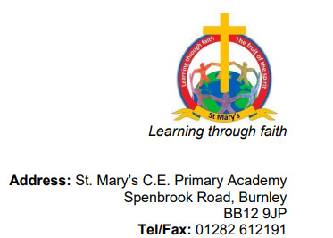

Dear parents,

Advent is fast approaching!!

We would like to invite you into school on Thursday 1st December at 08:55am to make a Christingle with your children and then take part in a Christingle service delivered by Reverend Julie.

If you are able to attend, please email Miss Hacking on nsmoffice@ciadri.co.uk to confirm your attendance. Thank you.

Best wishes,

Pauline Nightingale
Headteacher
Newchurch St Mary's CE Primary Academy
Spenbrook Road
Burnley
BB12 9JP
Tel: 01282 612191

