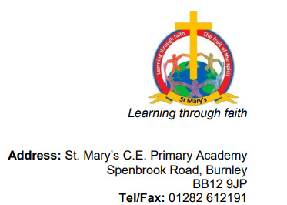

Dear parents,
As Christmas is fast approaching, please find below a list of all the fun activities planned for the coming weeks:
Tuesday 6th December – Dress rehearsal for the infant’s nativity, Everyone Loves a Baby. Memories Made videoing and taking photographs.
Wednesday 7th December- Afternoon performance of ‘Everyone Loves a Baby’ at 2:00pm
Thursday 8th December- Reception and KS1 Christmas stay and play – 2:30pm-3.30pm.
Thursday 8th December at 3.30pm – Gardening club bulb sale on the school yard. This is the last gardening club session until 24th February 2023.
Thursday 8th December – Evening performance of ‘Everyone Loves a Baby’ at 6.00pm, all performers to be in school for 5.30pm.
Wednesday 14th December- Christmas lunch for all children paid for by Friends of Newchurch
Wednesday 14th December – Christmas parties, fun and games for all children in the afternoon.
Thursday 15th December- Friends of Newchurch Christmas Jingle Jog and tombola – 2:45pm- 3.30pm. Parents and grandparents please come along to support the Jingle Jog and tombola.
Friday 16th December- Christmas Carol Service at church 1:00pm. All parents and grandparents are invited to attend, please wear Christmas hats and other Christmas attire to ensure the last service of the year is a fun and festive occasion. Parents that attend the service can take their children home once the service has finished.
Friday 16th December- School closes at 2:00pm.
Best Wishes P. Nightingale

