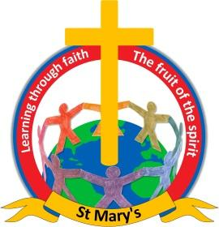

Dear parents,

Unfortunately I have some very sad news to share with you, Mrs Loach's father passed away last night.

Whilst Mrs Loach is on compassionate leave we have organised cover to teach the children in the Infant Class. Miss Parkes has been highly recommended by Randstad, our supply agency. If you have any questions please do not hesitate to contact me.

I am sure you will join the staff and I, in keeping Mrs Loach and her family in your thoughts and prayers at this difficult time.

Best wishes,

Pauline Nightingale
Headteacher
Newchurch St Mary's CE Primary Academy
Spenbrook Road
Burnley
BB12 9JP
Tel: 01282 612191

