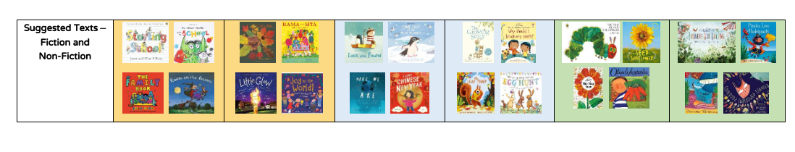

| Our Enquiry questions. | Autumn 1  Why is it good to be me? | Autumn 2  How do we celebrate? | Spring 1  Fantastic journeys  How can we explore our world? | Spring 2  Once upon a time | Summer 1  How does our garden grows? | Summer 2  Our amazing world.  Where do all the wonderful creatures live? |
| --- | --- | --- | --- | --- | --- | --- |
| English | Starting School  The Colour Monster  Leaf Man | Room on a broom  Little Red Hen  The Leaf Thief  Little Glow | Lost and Found  Chinese New Year | Goldilocks and the three bears  Egg Hunt | The Very Hungry Caterpillar  Superworm  Olivers vegetables | Commotion in the ocean  A shell to share  Pirate Pete |
| Number | Number 0-5  Position and direction | Number and place value more and less  shape and measure  problem solving | Number 0-10  Place value  Problem solving  measure | Number and place value comparison  shape direction and position  problem and solving | Number 0-20  Place value  shape measure  problem solve | Number and place value  shape position and problem solving |