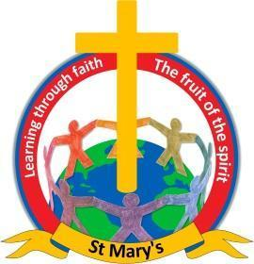

*“At St Mary’s we believe that ordinary people can chose to be extraordinary”*

**2024-25 End of Year Statutory Assessments**

**EYFS**

|  |  |
| --- | --- |
| Year Group | % who met GLD |
| Reception- 8 Pupils | 6/8 = 75% |

**Year 1 Phonics Screening Check**

|  |  |
| --- | --- |
| Year Group | % Who met expected standard |
| Year 1 – 9 Pupils | 8/9 = 88% |
| Year 2 Retake – 1 pupil | 100% |

NOTE – ARE means Age Related Expectations.

**Year 2 SAT’s TA – 8 Pupils**

|  |  |  |  |  |
| --- | --- | --- | --- | --- |
| Subject | Working towards ARE | ARE and above | Greater Depth ARE | National average ARE 2023 |
| Reading | 25% (2/8) | 75% (6/8) | 12.5% (1/8) | 68% |
| Writing | 12.5% (1/8) | 87.5% (7/8) |  | 60% |
| Maths | 12.5% (1/8) | 87.5% (7/8) | 12.5% (1/8) | 70% |

**Year 6 SAT’s**

**R, W and M Combined = 83.3% National Average 62%**

|  |  |  |  |  |
| --- | --- | --- | --- | --- |
| 6 Children in  Year 6 | Below ARE | ARE and above | Greater Depth | National average ARE 2025 |
| Reading |  | 100% (6/6) | 62.5% (5/6) | 75% |
| Maths |  | 100% (6/6) |  | 74% |
| GPS |  | 100% (6/6) | 16.6% (1/6) | 73% |
| Writing (TA) | 16.6% (1/6) | 83.3% (5/6) | 16.6% (1/6) | 72% |
| Science (TA) |  | 100% (6/6) |  | 81% |