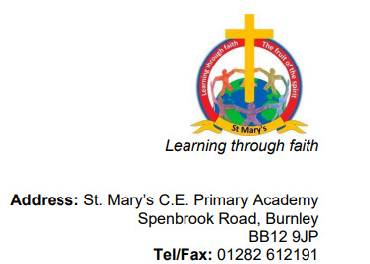

Date- 21st September 2022
Dear parents,

Harvest Festival

We would like to invite parents and grandparents to a church service celebrating the Harvest Festival. The service will take place on 6th October 2022 at 9:15am.

For Harvest this year, with more people than ever relying on food banks, St Mary's church and school are supporting the charity 'Pendle Food For All Club.' The charity has asked if we can collect food items for their Christmas Hampers. In particular they have requested dry foods with a long best before date such as:
Chocolate
Biscuits
Christmas Pudding
Tinned fruit
Rice pudding
Savoury biscuits.

We know that any food items donated would be very gratefully received. If your family is able to provide any food items for the Christmas Hampers, please send them into school by the 4th October. The donated food will then be presented to Reverend Julie during the service, she will then deliver your kind offerings to the charity. Thank you.

Best wishes,
Pauline Nightingale
Headteacher

