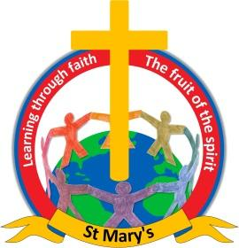

Dear parents,

As Holy Week approaches, we would like to invite the children to make an Easter Garden with their family at home. We will be asking the children to bring their Easter Gardens into school on Wednesday 29th March, so that they can take them into church for our Easter Service on Thursday 30th March at 9:10am. As always parents and grandparents are very welcome to join us for the church service.

The Easter Garden can be made on any scale, from a clean yoghurt pot to a take-away tub or on a tray, please see the pictures below, other resources you might need are:
- Some soil
- Twigs
- Moss
- Small stones
- Bigger stone for the entrance of the tomb
- Glue or string

We hope you will have fun with your children creating your very own Easter Garden.

Best wishes,

Pauline Nightingale
Headteacher
Newchurch St Mary's CE Primary Academy
Spenbrook Road
Burnley
BB12 9JP
Tel: 01282 612191

