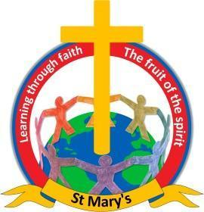

Learning through faith

Address: St. Mary’s C.E. Primary Academy
Spenbrook Road, Burnley
BB12 9JP
Tel/Fax: 01282 612191
Date: 22nd May 2023

Dear parents,

On Friday 26th May we are having an Intra School Sports Day. Please can we ask you to send your child into school wearing their PE kits and school jumper - PE kits will be sent home today unless they attend one of our after school clubs.

Your children will also require a bottle of water and a sun hat, please can we also ask you to apply sun cream before they come to school. Children can bring their own sun cream into school, but they will have to reapply it themselves.

As we live in Pendle and the weather is changeable, children can bring tracksuit bottoms to wear if it is a cooler day. Thank you.

Best wishes,

Pauline Nightingale
Headteacher
Newchurch St Mary's CE Primary Academy
Spenbrook Road
Burnley
BB12 9JP
Tel: 01282 612191

