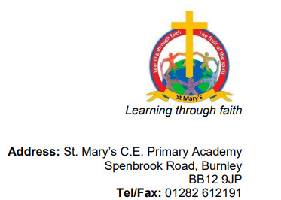

Dear all, Date: 30th September 2022

Macmillan Coffee Morning

The children will be hosting a Coffee Morning at their 'KIDZ Cafe' to raise money for Macmillan Cancer Support on Friday 14th October. The KIDZ Cafe will be serving coffee/tea and cake from 9:15am until 11am.

Please can we ask for donations of cakes and biscuits to support the event. Our children are so looking forward to opening their cafe and serving their loved ones tea and cake!!!

Please can you let me know if you are able to donate a cake or biscuits, as we would hate to run out of goodies.

Please come along and support this fabulous cause - there is a cuppa with your name on it!!!
Thank you.

Best wishes,

Pauline Nightingale
Headteacher

