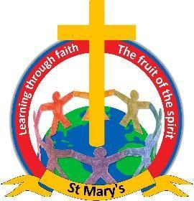

**Newchurch St. Mary's Primary School**

**‘Learning through faith’**

**Phonics Policy**

**Phonics Policy**

**SSP Programme – The Phonics Bug**

Phonics is taught using a whole class approach and it is taught daily for 30 minutes in Early Years and Key Stage One following the Phonics Bug SPP programme.

Bug Club Phonics teaches a new grapheme and related phoneme, or alternative spellings to previously-taught phonemes, in every Phoneme Session. This fast pace, backed up by daily revision of past teaching, has proved the most effective and successful method of phonic training. This means that the basic 40+ phonemes (Units 1–12), and then the alternative spellings of these phonemes (Units 13–30), are acquired quickly, and early reading skills develop rapidly. Decodable readers are introduced after just 10 days’ teaching at the end of Unit 2. This enables children to apply the taught strategies and enjoy contextualised reading early on. The order of grapheme introduction (see below) ensures that children start reading and spelling a wide range of words at the earliest possible stage.

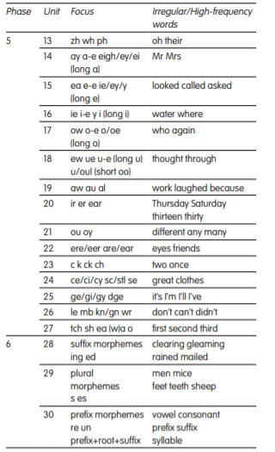

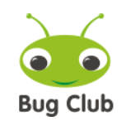

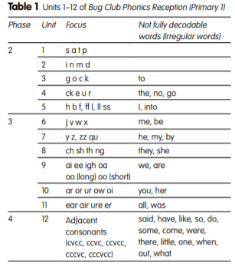

**Planning and the Teaching Sequence**

Reception children will receive a strong foundation of Phase 1 teaching across all areas of provision. The children in Reception will be immersed in a learning environment rich with Phase 1 and 2 opportunities during the first weeks of the Autumn term as well as daily adult-led sessions.

Phase 2 to 4 are delivered throughout Reception and Phases 5 and 6 in Key Stage 1. Children are taught as a whole class within their year group

Phonics planning is provided within our SPP programme. The Phonics Bug planning follows the same teaching sequence for each lesson delivered through each and every phase: Introduce, Revisit, Teach, Practice and Apply.

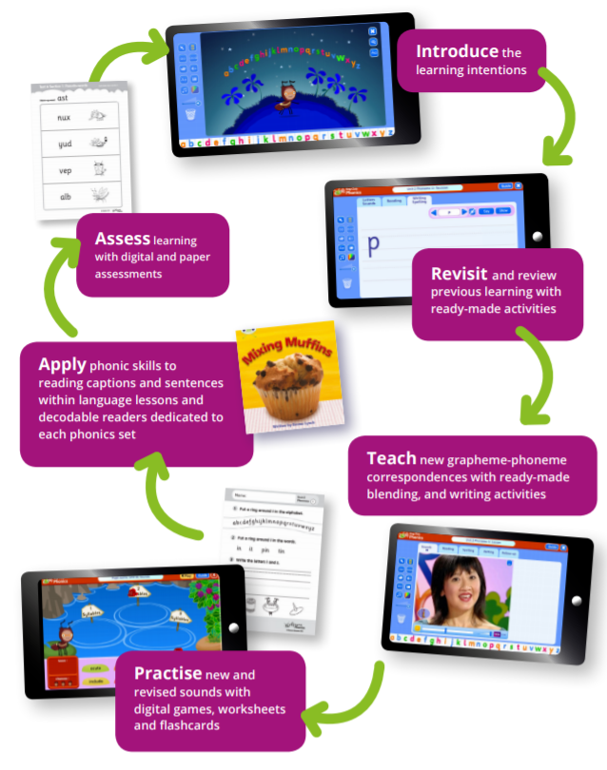

**Resources**

Children begin to learn to spell simple words in Reception by using magnetic letters and when ready move onto writing these words on a lined whiteboard. They have GPC mats in front of them to support them.

The Phonics Bug provides a range of digital resources that can be allocated to the children post direct teaching sessions such as interactive games that allow for the application of newly taught knowledge.

All classrooms must display friezes and/or grapheme wall posters that match the GPCs and progression of the Phonics Bug Programme.

Early Years classrooms support the children to apply their sounds by means of a challenge area that allows them to practise and apply their skills. In Year 1 children take part in an early morning task whereby they are asked to read sounds and words that they have been learning.

**Organisation**

Children are taught as a whole class, allowing for full exposure of sound teaching to all children.

**Letter formation**

Bug Club Phonics teaches letter formation as it introduces each grapheme. We use handwriting symbols and phrases to support children to form each letter correctly.

**Assessment**

Teachers assess children’s understanding of phonics half-termly using the assessment tools provided by the Phonics Bug. These can be reviewed alongside the assessment data generated from their online reading quizzes/interaction to provide a level of understanding within their phase. This is recorded using Insight Tracking for each child stating whether they are working within or are secure within a phase.

The data inputted on Insight Tracking include assessment for each phase and a pre-phase 1 assessment. The data is analysed half termly to provide an overview of children’s phonics stages in classes, key stages and overall.

**Home Reading**

Bug Club Phonics is supported by decodable readers which match the order of phoneme introduction. All of our home readers are decodable and have been organised to match the Bug Club Phonics progression. There are a variety of books to match each unit of the teaching programme. Following half termly assessments children are matched to the correct unit of home reader. Thus providing an opportunity for the children to practise and consolidate their learning at each stage.

When the children have completed the first two units of Bug Club Phonics, they will have acquired a sufficient number of grapheme–phoneme correspondences to start reading their own books. Prior to this there is a strong focus on communication and language where pre-readers will be sent home with guidance for parents.

The Bug Club also provides a library of e-books that can be allocated to individual children. The children read these books in our guided reading sessions and will be allocated following the sessions. The Bug Club Phonics readers are designed to support children in practising and consolidating the knowledge they acquire during the guided teaching sessions. Bug Club’s online reading world helps children improve core reading skills at school or home with exciting texts and fun rewards. It also enables teachers to monitor every child’s progress.

Children will bring home a hard copy of the reading book that they have been reading during their guided reading sessions. They will have read this book aloud 3 times in school, therefore should be able to read this book independently at home. This same book will also be allocated to your child on the Bug Club portal as an e-book. They will also bring home a reading for pleasure book that may be above their reading ability. This is so that you can read a story to your child and help to foster a love of reading.

**Meeting the need of the lowest 20% of children**

A phonics baselining assessment is completed during the first six weeks of the school year. This aids the identification of those children who required additional support.

Children working within the lowest 20% will be supported by the following provision:

* eBooks and digital games by phonics set allocated and monitored weekly by the class teacher.
* Children will be given intervention on a one to one basis in class to target precise gaps in sounds.
* Children read their guided reading book daily to an adult to support fluency.
* Rapid Phonics will be delivered to children who need further support in years 2-6

**Support/Guidance for Parents/Carers**

Communication between home and school occurs daily through the children’s home reading logs.

A guide to the phase is provided each time a child moves into a new phase within their home readers. The guide includes a glossary, a list of phonemes, a list of tricky words and suggestions for how to share their home readers with their child.

Phonics workshops will take place during the academic year to provide extra information on how you can support your child at home.

Phonics and reading photographs and videos are shared regularly on class dojo. Video recordings of class teachers are also shared to guide parents/carers in the best way to support their children in reading at home.

**MONITORING and REVIEW**

It is the responsibility of the staff to follow this policy. This policy will be reviewed before the start of each academic year and will evolve to incorporate the views of all staff concerned.

**Mrs K Bell Foundation Stage Lead/ Phonics Lead Autumn 2024**