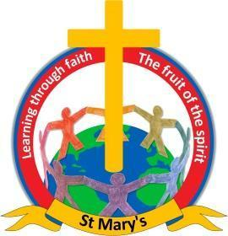

*Learning through faith*

**OPAL Area Equipment Safety Checklist**

**Please ensure all OPAL equipment is checked on a daily basis, to ensure it is in good working order and safe. Please tick and initial once checks have been completed.**

|  |  |  |  |  |  |  |  |
| --- | --- | --- | --- | --- | --- | --- | --- |
|  | **Tyres** | **Tarpaulins** | **Crates** | **Mud Kitchen** | **Ropes** | **Pallets** | **Kitchen utensils** |
| **Monday** |  |  |  |  |  |  |  |
| **Tuesday** |  |  |  |  |  |  |  |
| **Wednesday** |  |  |  |  |  |  |  |
| **Thursday** |  |  |  |  |  |  |  |
| **Friday** |  |  |  |  |  |  |  |