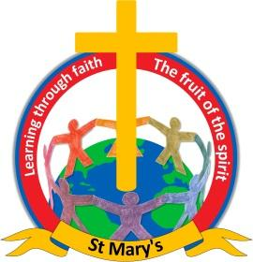
Dear all,

We have been asked to inform parents about a fabulous storytelling event at Nelson Library - here are the details:

Good Morning,

I was hoping you could share the information for this fabulous storytelling event at Nelson Library. This will be a great FREE opportunity for local families to take part in during the school holidays.

Tuesday 11th April 2023
At Nelson Library, Market Square, Nelson BB9 7PU.
2 performances 11am and 1pm

Join us at Nelson Library for an interactive Storytelling session.

Ramadan Kareem is one girl's inspiring story of determination and self-belief.
Our story begins by transporting us to Karachi in Pakistan, before Ramadan and captivates audiences as they learn how to spot the moon and its phases to know when Ramadan begins.
This interactive storytelling show introduces children of all cultures and faiths to the traditions of Ramadan, and sparks the senses as they are asked to listen, touch, smell and even taste dates, the traditional food often chosen to break the fast. At points in the story, items are shared with the audience.
This is an important story to tell, so not only Muslim children can see their own stories recreated, but also because it is a wonderful way to introduce all children to Muslim traditions and culture, so that they might better understand their friends, neighbours and classmates.

This is also a story of sincerity, determination and of belief in yourself.

Suitable for all ages, but especially suited to ages 3 – 8.
Duration: 20 mins and after performance optional play with the drums and question session.

FREE – funded by Arts For Wellbeing Pendle, Arts Council England and Levelling Up Funding.

No need to book, just turn up!

