SEND Information Report
Approved on:
July 2023
Next review:
June-July 2024
St Mary’s Catholic Primary School
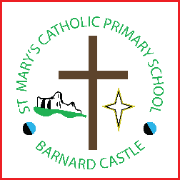

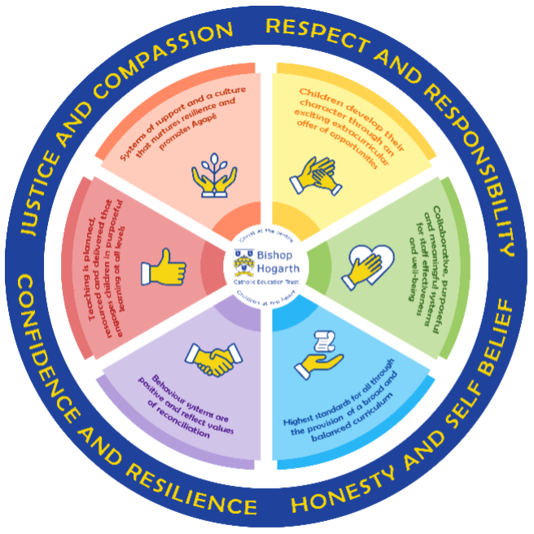
As part of the family of Bishop Hogarth Catholic Education Trust, our school has at its core, the virtues, and values of:
Respect for others and themselves, recognising that we are all created in the image of God and therefore must be compassionate towards others, especially the vulnerable. ​
Confidence in their own abilities, knowing that their talents are gifts from God and resilience to persevere when things become difficult. ​
Honesty in regard to the world around them and themselves and the ability to take responsibility for the times we may fall short of the mark. ​
Gratitude for all the amazing gifts from God and willingness to share their gifts both personal and material. ​

As an inclusive school, all teachers are teachers of pupils with Special Educational Needs & Disabilities. We deliver a curriculum and create an environment that meets the needs of every pupil within our school. We ensure that every pupil with Special Educational Needs and / or disabilities makes the best progress possible. We foster and promote effective working partnerships with parents / carers, pupils, and outside agencies. We consider the ‘whole’ child and strive to ensure that all our SEND pupils are prepared for adulthood.​

Our school’s approach to supporting pupils with SEND

St Mary’s Primary School takes a positive and inclusive approach to supporting all our pupils. We believe that pupils with Special Educational Needs or Disabilities (SEND) should access a broad and balanced curriculum in line with the DfES Special Educational Needs Code of Practice: 0-25 (2014).
The school’s SEND Policy may be found on our website and a hard copy can be requested. Our policy is a detailed document which encompasses Bishop Hogarth Catholic Education Trust’s high standards of support for children with SEND.
We strive to provide a nurturing and supportive learning environment in order for children to fulfill their potential. We promote and welcome the involvement of parents and regard home school partnerships as crucial to individual pupil’s success.
We have a graduated approach to SEND, ensuring early identification of needs and a continuum of support for children to enable them to make progress.
Our SEND policy and provision is monitored by our SEND governor.

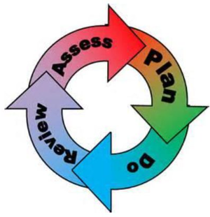
How will the school staff support my child?
The graduated response-Identifying, planning for and supporting pupils with SEND
Where a pupil is identified as having a special educational need, School will follow a graduated approach which takes the form of cycles of ‘Assess, Plan, Do, Review’. ​
• Assess a child’s special educational need. ​
• Plan the provision to meet your child’s aspirations and agreed outcomes. ​
• Do put the provision in place to meet those outcomes. ​
• Review the support and progress.

How does the school know if children need extra help and what do I do if I think my child has special educational needs?

- Assess
In deciding whether to make special education provision to support the educational, social, physical or emotional needs of a child, we draw information from a range of sources:
- Learning walks
- Observations
- Views from parents and pupils
- Assessment data
Advice may also come from external support services.

- Plan
Information gathered is used to develop interventions and adaptions to the environment and the curriculum.
Advice from outside agencies including ‘schools and families’ specialist services, the Educational Psychologist, behaviour support, the Emotional Health and Wellbeing Lead and Speech and Language therapists may be accessed.
The class teacher will work alongside the SENDCO to plan the most appropriate interventions.

- Do
Our teachers are skilled at adapting teaching and learning to meet the diverse needs in each class. ​
Daily planning considers individual children’s needs and requirements and is annotated and adapted according to need. Explicit reference is made in the teacher’s planning to the needs of those children identified with SEND. ​
Adaptive teaching is approached in a range of ways to support access to the curriculum and ensure that all children can experience success and challenge in their learning. ​
Grouping arrangements consider the different skills and abilities of each child. This ensures that learning is maximised. ​

Additional adults support groups and individual children with the long-term goal of developing independent learning skills. The class teacher monitors this support to avoid students becoming over reliant on this. ​
We fully encourage parental support and offer opportunities for individual meetings with parents/carers to provide clarity and recommendations on how they can support their child at home.

- Review
Your child’s progress will be continually monitored by their class teacher and reviewed each term through pupil progress meetings. A range of assessment tools are used in school which show children’s attainment in more detail.
Where necessary, children will have a coordinated Support Plan based on targets specific to their needs which will be agreed by teachers, parents, the SENDCO and/ or external agencies. Targets will be designed to accelerate learning and close any gaps. Progress against these targets will be reviewed regularly, evidence for judgement assessed and a future plan developed.
An annual review will take place for all children with an EHCP. All adults and relevant professionals involved with the child will be invited to attend with the aim of reviewing the current level of support the child receives.
The SENDCO will meet with class teachers on a termly basis to check that each child is making good progress in their work. Regular book scrutiny and lesson observations are carried out by members of the senior leadership team (HT/DHT) to ensure that the needs of all children are met.

How will the curriculum at our school be matched to my child’s needs?
For many children, their specific targets will be linked to learning and will often be specifically related to English and maths. However, for other children they may be related to social interaction, communicating with children and adults or emotional difficulties. The most important factor is that the targets and support provided are particular to the needs of each individual child.
At St Mary’s, we offer many different forms of additional provision, including:
- additional support both in and out of class;
- one-to-one support when appropriate;
- flexible groupings (including small group work);
- access to specific resources and learning programmes;
- Counselling/ Nurture;
- access to a wide range of outside agencies.

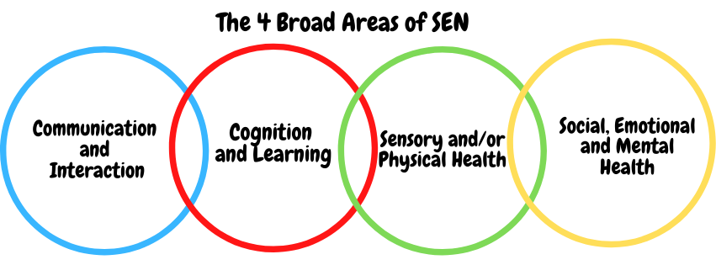SEN needs are classified under four broad areas of need. Below are the strategies, in class support and interventions that school may put in place to support your child.

Communication and Interaction
Strategies to support children with these needs include:
Children and young people with speech, language and communication needs (SLCN) have difficulty in communicating with others. This may be because they have difficulty saying what they want to, understanding what is being said to them or they do not understand or use social rules of communication. The profile for every child with SLCN is different and their needs may change over time. They may have difficulty with one, some or all of the different aspects of speech, language or social communication at different times of their lives.
Children and young people with ASD, including Asperger’s Syndrome and Autism, are likely to have particular difficulties with social interaction. They may also experience difficulties with language, communication and imagination, which can impact on how they relate to others.
How support will be provided:
- access to small group and/or individualised interventions to develop skills in communication and interaction with others;
- visual timetables;
- flexible approaches to timetable when necessary;
- access to additional aids/technology ;
- explicit teaching of generalising skills from one context to another;
- careful planning of transitions, e.g. advance notice, familiar resources;
- mentoring and/or buddy systems.

Cognition and Learning
Strategies to support children with these needs include:
Support for learning difficulties may be required when children and young people learn at a slower pace than their peers, even with appropriate differentiation. Learning difficulties cover a wide range of needs, including moderate learning difficulties (MLD), severe learning difficulties (SLD), where children are likely to need support in all areas of the curriculum and associated difficulties with mobility and communication, through to profound and multiple learning difficulties (PMLD), Specific learning difficulties (SpLD), affect one or more specific aspects of learning. This encompasses a range of conditions such as dyslexia, dyscalculia and dyspraxia.
How support will be provided:
- regular, individual or small group focused interventions, e.g. phonics 1:1 intervention,
- increased access to small group support in class;
- practical aids for learning, e.g. place value counters, number lines, pictures, photos, coloured overlays, accessible reading material suited to age and individualised success criteria;
- flexible groupings;
- access to technical aids e.g. spell checker, ICT software and/or hardware;
- adaptations to assessments to enable access e.g. readers, scribe, ICT;
- curriculum/delivery adaptations to meet the learning needs of individuals;
- frequent repetition and reinforcement.
- adaptations to environment e.g. seating

Sensory/Physical
Strategies to support children with these needs include:
Some children and young people require special educational provision because they have a disability which prevents or hinders them from making use of the educational facilities generally provided. These difficulties can be age related and may fluctuate over time. Many children and young people with vision impairment (VI), hearing impairment (HI) or a multi-sensory impairment (MSI) will require specialist support and/or equipment to access their learning. Children and young people with an MSI have a combination of vision and hearing difficulties.
Some children and young people with a physical disability (PD) require additional ongoing support and equipment to access all the opportunities available to their peers.
How support will be provided:
- occupational therapy support sought when necessary and suggestions followed;
- concrete apparatus available to support learning, e.g. Numicon materials (numeracy);
- sensory resources available e.g. , seat wedge, writing wedge;
- access to support for personal care, e.g. school nurse service;
- adaptations made to the curriculum when needed to avoid sensory overload.

Social, Emotional and Mental Health
Strategies to support children with these needs include:
Children and young people may experience a wide range of social and emotional difficulties which manifest themselves in many ways. These may include becoming withdrawn or isolated, as well as displaying challenging, disruptive or disturbing behaviour. These behaviours may reflect underlying
mental health difficulties such as anxiety or depression, self-harming, substance misuse, eating disorders or physical symptoms that are medically unexplained. Other children and young people may have disorders such as attention deficit disorder, attention deficit hyperactive disorder or
attachment disorder.
How support will be provided:
- access to time out/individual work area such as the nurture pod/ cosy cones (KS1)
- access to in-house programmes and intervention including mindfulness, NOW programme
- access to counselling services, e.g. CAMHS, Road Centre Counselling;
- bereavement support
- when possible, increased access to additional adults in and out of the classroom
- Supported/ additional transition programme with chosen secondary school;
- applications made to Social, Emotional Mental Health Services (SEMH) when necessary.

What training is provided for staff supporting children with SEND?
We work closely with BHCET and the Local Authority to ensure staff are trained so that they can fully support all children in their classroom environment. Specific training is also prioritised, according to individual needs of both children and staff.
The SENDCo attends regular network meetings with BHCET and Durham LA so that we are well informed of the most up to date training and pedagogy to support children with specific needs.

How do we support transition in our school?

Transition within classes/key stages: ​
Transition to a new school
If your child leaves St Mary’s, the SENCO will ensure that all SEND information is passed onto the next school to ensure that they are fully aware of any additional needs your child may have. If necessary, a meeting will be arranged with other professionals. For those who may be joining specialist provision, staff may attend initial visits with child.
Transition to a new year group/Key Stage
During the summer term staff meet to share information and for those children who require provision that is additional to or different from quality first teaching we make additional arrangements to support these children through the transition.
All pupils across school will take part in six weekly ‘moving on up’ sessions whilst our new starters attend their taster sessions. This gives each pupil the opportunity to meet the teacher, become familiar with new environments and meet the mixed age cohort.
We have flexible entry to Early Years Foundation Stage dependent on need.
Children who require additional support to ensure a smooth transition to their new class, will be included in a programme supported by the SENDCO and the class teacher.

Transition to Secondary settings: ​
We work closely with all secondary schools in the area.
- Teesdale
- Carmel
- St John’s
- Staindrop Academy
As part of our transition package, the SENCO (Mrs Box) will ensure that all SEND information is passed on to the next school to ensure they are fully aware of any individual needs. The SENCO will work closely with families to ensure that these needs are met to the best of her ability. For example, extra transition visits for both parents and pupils or support around the social or emotional well-being of the pupil.
The transition process will begin early, usually in Y5, for some of our more vulnerable children.
Meetings are held for the transfer of essential information relating to EHCPs, Child and Family Services and pastoral matters.
When reviewing an EHCP for children in Y6, staff from the secondary school will always be invited to the review meetings.
During the last term, secondary school staff come to meet our Y6 children and in addition to this, our Y6 children attend their chosen secondary school for a period of transition days decided by the secondary school.

Where can I get further information about services for my child?
SEN Code of Practice (graduated response) https://www.gov.uk/government/consultations/revision-of-the-send-code-of-practice-0-to-25-years
Local Authority’s Local Offer
https://www.durhamfamilies.
School Website
https://www.stmarysprimary.co.uk/send-special-educational-needs-and-disabilities

Council for Disabled Children
http://www.councilfordisabledchildren.org.uk

The Durham Local Offer
http://durham.fsd.org.uk/kb5/durham/fsd/send.page

Independent Parental Special Education Advice (IPSEA)
http://www.ipsea.org.uk

British Dyslexia Association (BDA)
http://www.bdadyslexia.org.uk

National Autistic Society (NAS)
http://www.autism.org.uk

RNIB
http://www.rnib.org.uk

National Deaf Children’s Society
http://www.ndcs.org.uk

What key school documents refer to support and provision for pupils with SEND?

- SEND Policy​
- Admissions Policy​
- Supporting Pupils with Medical Needs Policy​
- Accessibility Plan​

Accessibility
With due regard to our Admission Policy, parental choice and accessibility of the school building, all children with special educational needs, who apply, will be accepted by the school.
All of the ground floor is fully wheelchair accessible.
Disabled toilet facilities are located through the school entrance near the school office.
Communication with parents whose first language is not English is supported by advice from the local authorities EAL (English as an additional language team.)
When necessary, translators are booked for meetings and documents are translated.

Activities Outside of School

St Mary’s is an inclusive school, and we will put in place appropriate support, whenever possible, to enable your child to be educated alongside their peers. This may include extra staffing and/or equipment.
Staff who are arranging an offsite trip will discuss with parents and the SENDCO any requirements needed and the suitability of any trip which the school is taking part in.
We will not stop your child from going on a trip due to their special educational needs and/or disability if the trip is suitable for your child and their safety and the safety of others is not compromised.
The Headteacher oversees all trips to ensure children are safe and included where possible.

What to do if you have a complaint, a compliment, or a query.

The school details and relevant contacts
- Mrs Lesley Box – Headteacher/Designated Safeguarding Lead
- Mrs Leanne Porter– Deputy Head/Deputy Designated Safeguarding Lead
- Mrs L. Lewandowski – Wellbeing Team/Nurture Leader​
- St Mary’s RC Primary School, Birch Road, Barnard Castle​
- Tel: 01833 637029
- Website – https://stmarysbc.bhcet.org.uk/
- Email – office@stmarysbc.bhcet.org.uk​
- Durham County Council website https://www.durhamnow.co.uk/local_offer
- Bishop Hogarth Catholic Education Trust website – https://bhcet.org.uk
- Trust contact – Mike Shorten (CEO) 01325 254525

​

Name of school SEND governor.
- Mrs J. O Byrne- West- SEND link Governor
- Chair of governors- Mrs E. Curran

