Key Learning

To understand & explore the four stages of Design Technology-
Research/investigation, Design, Make, Evaluate
(using prior learning),
How to measure, mark out, cut and shape materials and components using appropriate tools.
Explore the different & best ways to assemble, join and combine materials and components.

Knowledge
By the end of this unit of study, pupils will be able to:
One | Use a range of materials to create models.
Two | Explore how to make structures stronger.
Three | Investigate different techniques stiffening a variety of materials.
Four | Test different methods of enabling structures to remain stable.
Five | Join appropriately for different materials & situations.
Six | Mark out materials to be cut using a template.

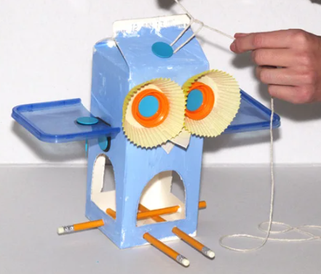


Key Vocabulary

Structure, free standing, stability, support, join, fix, frame, base, user,

