Key Learning

To understand & explore the four stages of
Design Technology-
Research/investigation, Design, Make, Evaluate
(using prior learning),
How to measure, mark out, cut and shape materials and components.
How to assemble, join and combine materials and components using appropriate method.
That fabrics can be decorated using buttons, beads, sequins, ribbons, etc.
That fabrics can be coloured using fabric paints, printing, etc.
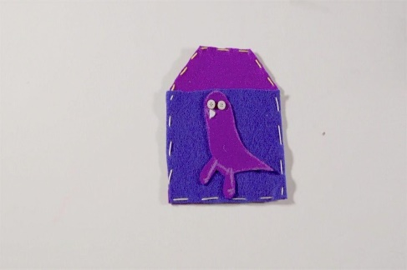
Knowledge
By the end of this unit of study, pupils will be able to:
One | Cut out shapes which have been created by drawing round a template onto the fabric.
Two | Join fabrics by using, e.g. running stitch, glue, staples, over sewing, tape.
Three | Decorate fabrics with attached items, e.g. buttons, beads, sequins, braids, ribbons.
Four | Colour fabric using a range of techniques, e.g. fabric pints, printing, painting.


Key Vocabulary

decorate, fabric/ material, fabric glue, knot, needle, needle threader, running stitch, sew, template, thread, running stitch, fabric paint,

