Key Learning

To categorise foods using taste, smell, texture, feel & talk about what they like and dislike about products
Understand the need for a variety of foods in a diet.
Know that all food comes from plants or animals and that food has to be farmed, grown or caught
How to measure & weigh food using non-statutory measures.
How to prepare simple dishes safely and hygienically, without using a heat source
How to use techniques such as cutting, peeling and grating safely

Knowledge
By the end of this unit of study, pupils will be able to:
One | Develop a food vocabulary using taste, smell, texture & feel.
Two | Sort & group food products.
Three | Explain where food comes from.
Four | Cut, peel, grate, chop a range of ingredients.
Five | Measure & weigh food items non-statutory measures e.g. spoons cups.
Six | Work safely & hygienically.

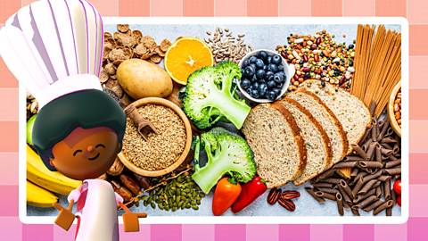

Key Vocabulary
cutting, peeling, grating, hygiene, ingredients, farmed, grown, caught, variety, taste, smell, texture,

Key Vocabulary

