Key Learning

Using a variety of natural, recycled & manufactured materials for sculpting, e.g. straws, card, boxes and explore joining and construction techniques.
Identify and use a variety of technique of a malleable media , e.g. rolling, cutting, pinching
Using a variety of shapes including lines & texture
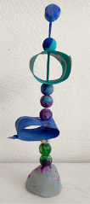
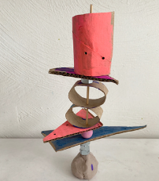
Knowledge
By the end of this unit of study, pupils will be able to:
One | Explore using a variety of materials for sculpting including rolling & kneading
Two | FORM: Experiment with constructing & joining recycled natural and manmade materials.  Use simple 2D shapes to create 3D form
Three | TEXTURE: Change the surface of a material e.g. build a texture tile
Four | Use sculpture to develop & share their ideas, experiences & imagination

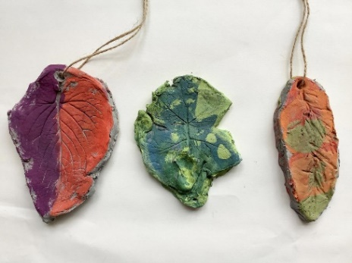
Key Vocabulary
Sculpture, statue, model ,3D, sculptor, carving, abstract, texture

“Sculpture is a great way to develop & share ideas, experiences & imagination”

Artist
Andy Goldsworthy, Richard Long
(outdoor art)

