Key Learning

To reinforce the four stages of Design Technology-
Research/investigation, Design, Make, Evaluate
(using prior learning),

To be able to use unit related vocabulary where appropriate.
To create a pneumatic system with a desired motion.

To be able to manipulate materials to create different effects. E.g. cutting, creasing, folding, weaving.
To be able to test & modify an outcome.
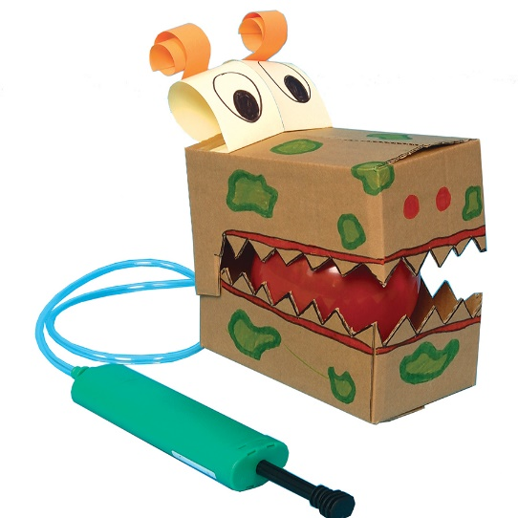
Knowledge
By the end of this unit of study, pupils will be able to:
One | Develop a technical vocabulary appropriate to the unit.
Two | Understand how pneumatic systems work  Know that mechanisms are a system of parts that work together to create motion Know that a pneumatic system can be used as part of a mechanism Know that pneumatic systems are used in a range of everyday objects Know that a pneumatic system can force air over a distance to create movement
Three | Design a toy that uses a pneumatic system & will help younger children understand that air can be used to create motion.
Four | Make a toy that includes a pneumatic system
Five | To test and finalise ideas against design criteria. Evaluating final product.

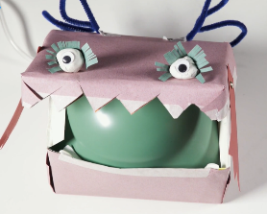
Key Vocabulary

mechanism, function, pivot, linkage system, pneumatic system, input, output, motion, exploding diagram,

