Key Learning

To reinforce the four stages of Design Technology-
Research/investigation, Design, Make, Evaluate
(using prior learning),
To be able to identify different sorts of structures.
(Frame & Shell)

To explore & create frame & shell structures, identifying where structures need reinforcing.
To know that diagonal struts will strengthen a frame & that a wide base will give a structure stability.
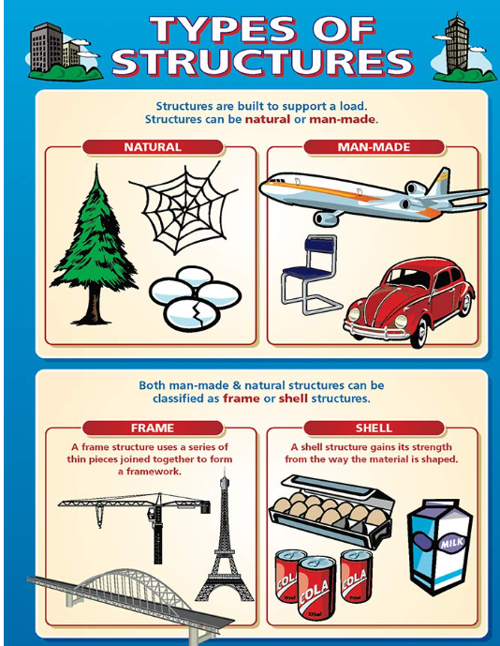
Knowledge
By the end of this unit of study, pupils will be able to:
One | Develop vocabulary related to a project.
Two | Create shell or frame structures, choosing appropriate sheet materials for the purpose.
Three | Strengthen frames with diagonal struts.
Four | Make structures more stable by giving them a wide base.
Five | Measure a cut appropriate length materials accurately. Join materials using appropriate methods.

Key Vocabulary

Structure- object constructed of several parts Shell Structure – hollow structure with a thin strong outer Frame Structure – ridged parts that form a frame work rigid, corrugated/accordion, assemble, stability, accuracy, joint, reinforce, prototype,

stiffness Beam Bridge
reinforce Arch Bridge
net
prototype

