Key Learning

To name the main food groups and identify foods that belong to each group.

To have a better awareness of what constitutes a healthy diet, and how to make healthier choices.

To start to understand the importance of each of the food groups within our diet.
What is the job of each food group in our diet?
To follow a recipe & work safely & hygienically.

To know what is meant by seasonal & to have a better understanding where our food comes from.

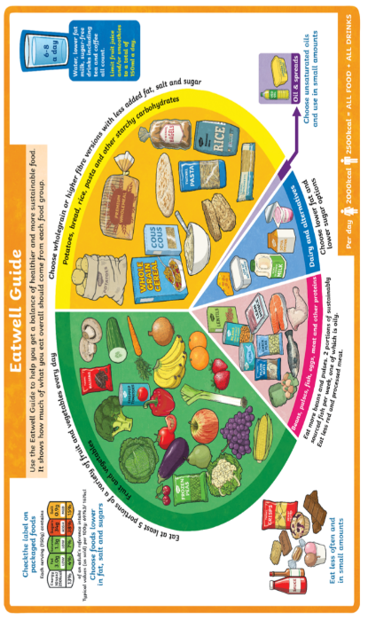
Knowledge
By the end of this unit of study, pupils will be able to:
One | Develop sensory vocabulary/ knowledge using, smell, taste, texture & feel.
Two | Analyse the taste, texture, smell & appearance of a range of foods.
Three | Make healthy eating choices –using the Eatwell Plate.
Four | Follow instructions(recipe) & join / combine a range of ingredients
Five | Explore seasonality & country of origin of a range of fruit & vegetables.
Six | Develop an understanding of how meat / fish are reared/caught.


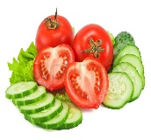
Key Vocabulary

recipe/ ingredients, method, Eatwell Plate (food groups),
carbohydrates, proteins, climate, reared, caught, farmed, seasonal

