Key Learning

Demonstrate learnt collage skills to create their own piece of work, making links to artists’ work.
Improve their mastery of using a combination of materials that have been cut, torn & glued.
Sort, arrange and select materials by texture and colour, appropriate for a piece of work.
Explore working on different scales.
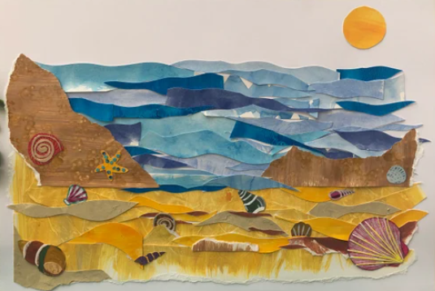
Knowledge
By the end of this unit of study, pupils will be able to:
One | Select colours and materials to create effect, giving reasons for their choices.
Two | Refine work as they go to ensure precision.
Three | Learn and practise a variety of techniques, e.g. overlapping, tessellation, mosaic and montage.

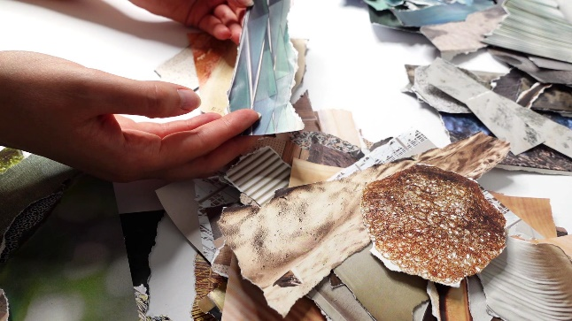
Artists
Kurt Schwitters
Hannah Hock
Ben Giles
Key Vocabulary
collage, texture, shape, form pattern, mosaic, montage, scale, combination

