Key Learning

Experiment with variety of skills from fabric printing, dyeing and weaving.
Select an appropriate way to join textiles.
To know that you can decorate textiles using beads, buttons, feathers etc. and that it is called applique.
To explore that colour can be added to fabric either by printing, dipping or fabric crayons.

Knowledge
By the end of this unit of study, pupils will be able to:
One | Use a variety of techniques, e.g. printing, dyeing, weaving and stitching.
Two | Develop skills in stitching, cutting and joining.
Three | Apply decoration using beads, buttons, feathers etc.
Four | Apply colour with printing, dipping, and fabric crayons
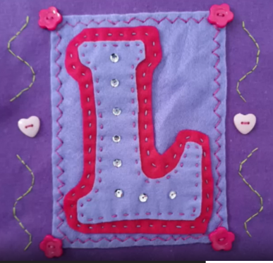
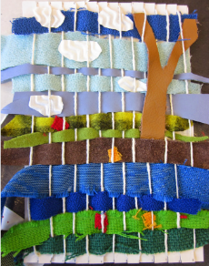

Key Vocabulary
printing, weaving, stitching, joining, dipping, running stitch, applique

