Key Learning

To understand where meat comes from – learning that it is reared & processed, including key welfare issues.
To understand where ingredients are grown & processed.
To know how to adapt a recipe ( to make it healthier or due to allergies)
To understand what cross-contamination means,
To make an appealing, healthy & nutritious food product.
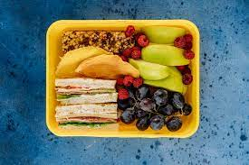
Knowledge
By the end of this unit of study, pupils will be able to:
One | Prepare food products taking into account the properties of ingredients & sensory characteristics.
Two | Weigh & measure using scales.
Three | Select & prepare foods for a particular purpose using a range of cooking techniques.
Four | Show an awareness of a healthy diet (Eatwell Plate)
Five | Know where & how ingredients are grown & processed.
Six | Know where & how meat is reared & processed.

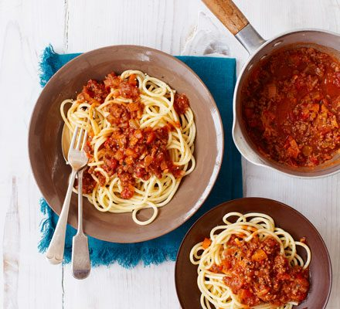
Key Vocabulary

reared, processed, ethical, welfare, allergy, balanced,
cross-contamination

