Key Learning

To reinforce the four stages of Design Technology-
Research/investigation, Design, Make, Evaluate
(using prior learning),
To understand how mechanical systems which include pulleys, levers, gears & cams work & appear in everyday life.
To understand the effect different shape cams will have on the movement.
To know that in a series circuit electricity only flows in one direction.
To know that when there is a break in a series circuit, all components turn off.
To know that an electric motor converts electrical energy into rotational movement, causing a motors axle to spin.
To put findings from practical research into practice to develop a unique product.
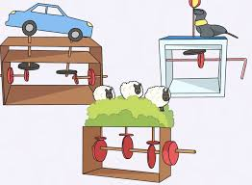
Knowledge
By the end of this unit of study, pupils will be able to:
One | Develop a technical vocabulary appropriate to the unit.
Two | Use mechanical system such as cams, pulleys & gears.
Three | Use an electrical system to power a motor.

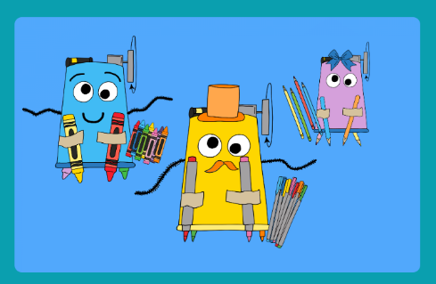

Key Vocabulary

pulley, cam, gear, lever, technical, circuit component, rotational, current, series circuit, develop, convert, electrical energy, problem solve, investigate, motorised, motor

