Key Learning

To reinforce the four stages of Design Technology-
Research/investigation, Design, Make, Evaluate
(using prior learning),
To explore & create a frame structure with focus on triangulation.
How to measure, mark out, cut and shape materials and components accurately.
Explore how to assemble, join and combine materials and components using appropriate method.
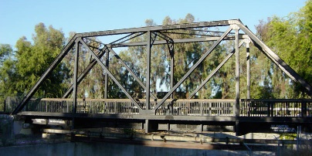
Knowledge
By the end of this unit of study, pupils will be able to:
One | Use the correct terminology for tools , materials & processes.
Two | Designing a stable structure or frame work that is able to support weight.
Three | Cut dowel to an accuracy of 1mm.  Selecting appropriate tools and equipment for particular tasks.
Four | Join materials using appropriate methods.
Five | Identifying where a structure needs reinforcement
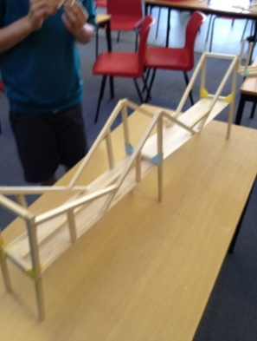

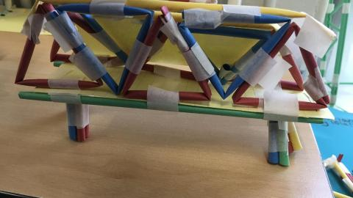
Key Vocabulary

truss bridge, beam bridge, arch bridge, accuracy, joint, assemble, corrugation, stiffness, rigid, factors, reinforce, stability,

