Key Learning

To reinforce the four stages of
Design Technology-
Research/investigation, Design, Make, Evaluate
(using prior learning),
How to make a quality 3D product, by creating & using a pattern & allowing a seam allowance,
To assemble, join and combine materials and components by mastering a variety of stitches.
To decorate using a range of components.
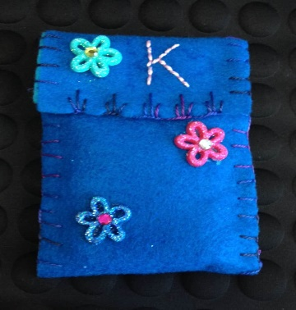
Knowledge
By the end of this unit of study, pupils will be able to:
One | Create 3D products using patterns pieces & seam allowance.
Two | Pin & tack pieces together.
Three | Choose appropriate stitch for joining fabrics- running, back, over, blanket, cross stitch.
Four | Combine fabrics to create more useful properties
Five | Decorate textiles appropriately (often before joining components).  Applique
Six | Make quality products.

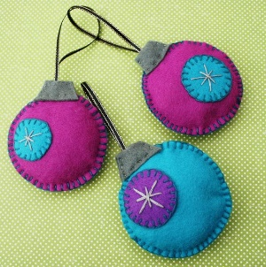
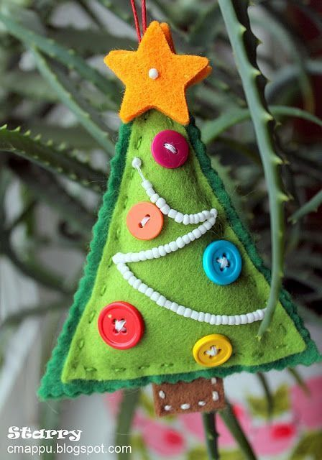

Running stitch/back stitch/ over stitch/blanket stitch
Thread/ Yarn - a length of interlocked threads
Material / cloth / fabric/ textile is something made from interlocking yarns or threads.
Sampler - a piece of sewing.
Embroidery - decorative stitching.
Appliqué - adding shapes of fabric. Embellish - add additional details. Sequin - a small shiny disc sewn onto fabric. Seam
Template - a paper shape used in sewing.
Key Vocabulary

