Key Learning

To experiment with more complex techniques.
To use a range of media alongside print.
Choose and use a variety of backgrounds.
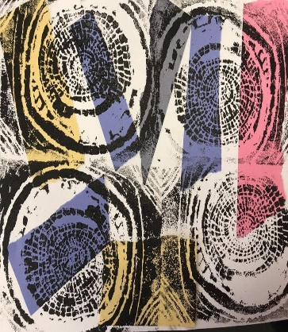
Knowledge
By the end of this unit of study, pupils will be able to:
One | Design and create complex printing blocks/ tiles.
Two | Develop techniques in mono, block and relief printing.
Three | Work into prints with a range of media e.g. pens, colour pens and paints.
Four | Explore different colourways and different types of backgrounds e.g. paper, magazine pages, newspaper, for their prints.

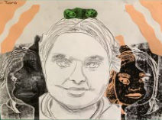
Artists
Kurt Schwitters
Hannah Hock
Ben Giles
Key Vocabulary
mono print, block print, relief print, tile

