Key Learning

To master the techniques of using paper mache to create a sculpture.
To explore and select from a variety of natural, recycled & manufactured materials for sculpting, e.g. straws, card, boxes. Explore joining and construction techniques.
Identify and use a variety of technique of a malleable media , e.g. using wire, coils, slips
Using a variety of shapes including lines & texture
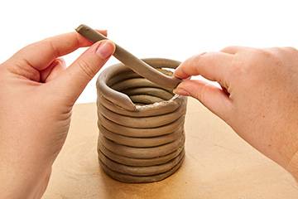
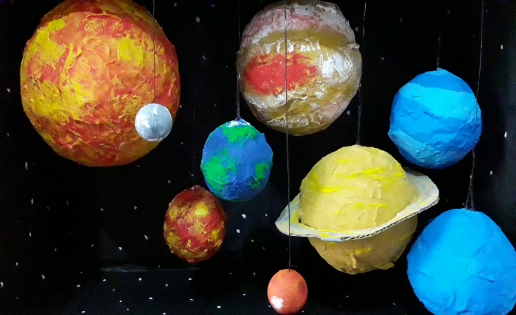
Knowledge
By the end of this unit of study, pupils will be able to:
One | Plan a sculpture through drawing and other preparatory work.
Two | Shape, form and construct models from observation and imagination.
Three | Experiment with constructing & joining recycled natural and manmade materials.
Four | Using paper mache to create a simple 3D object
Five | Change the surface of a material by adding texture and pattern.
six | Develop skills in using clay including slabs, coils, slips etc.
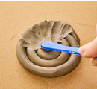
“Sculpture is a great way to develop & share ideas, experiences & imagination”

Key Vocabulary
sculpture, model ,3D, sculptor, carving, coil, slip, slab, abstract, texture

