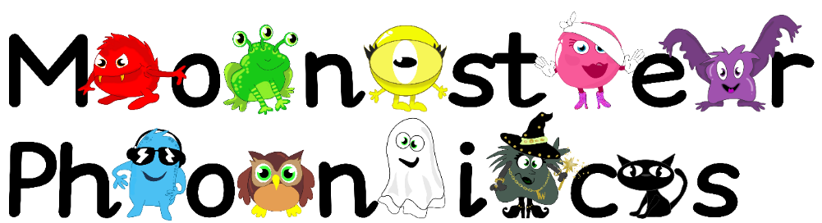
28.9.2020
Dear Parents,
This week we will be learning the following letter sounds in phonics.
The Black Cat sounds- m, d and g
The children are learning the sound the letter makes in phonics. This will help them to read and spell as early as possible. Hear the pure sounds here - https://youtu.be/mRoFpvC0yn0
This week we will practice reading words with these sounds in such as; gap, dad, mat, nap, map, pig, dig, gig, dip
We will focus on learning the following key words by sight:
on am up was
Please encourage your child to look out for these sounds and these words in the environment, at home and in books. This will help put learning at school into a different context. I have also added activities with these sounds in to each child’s Education City homework account to support their learning at home. Remember your child’s username is their name with a 0 at the end e.g Tom0 and the password is dog. It would be fantastic if you could practice writing the letters i and n at home too. This could be done in foam, sand, on paper, with chalk- whatever you like! Send me a picture on your Class Dojo portfolio so we can see how you have been learning phonics at home.
We appreciate your support.
Thank you!
Mrs Coleman-Harris

