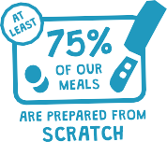
ST. MARY’S SCHOOL MENU Option A – vegetarian/vegan Option B – non-vegetarian/vegan
All menu items are subject to change, based upon availability and in the event of unforeseen circumstances.

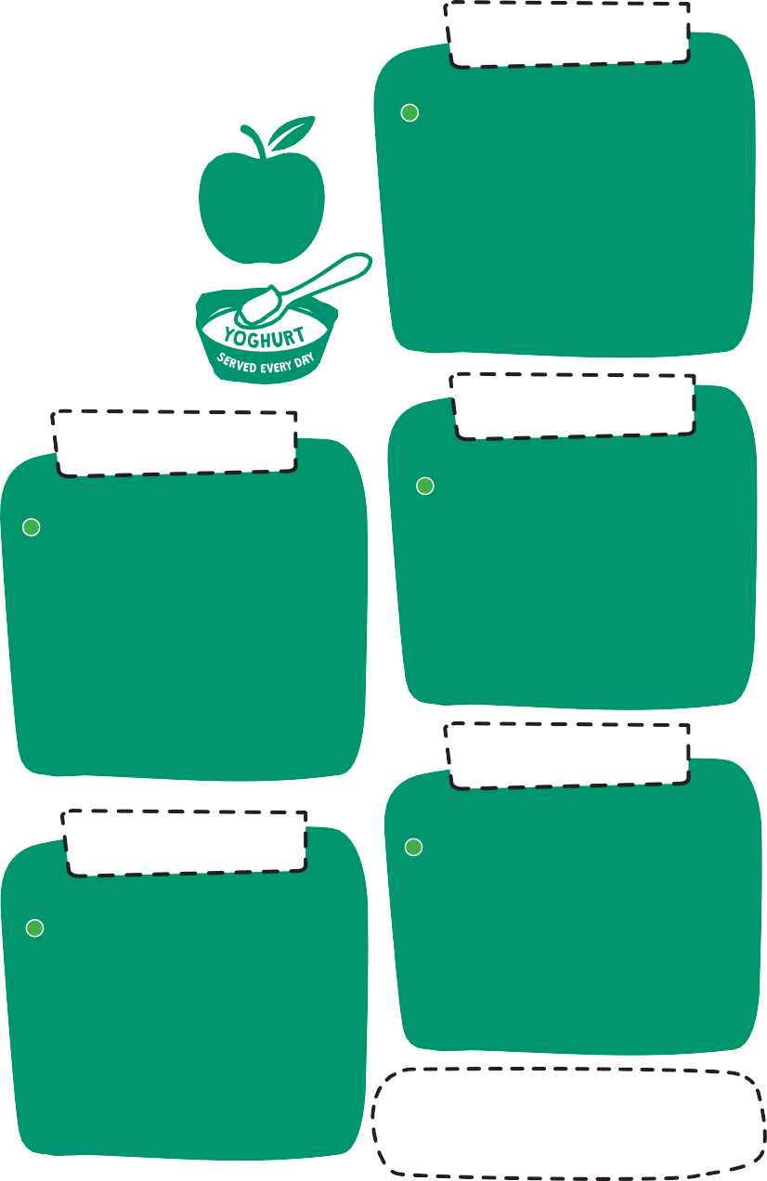

WEEK 3
w/c:
04/03/24
08/04/24
29/04/24
03/06/24
24/06/24
15/07/24

WEEK 2
w/c:
26/02/24
18/03/24
22/04/24
13/05/24
17/06/24
08/07/24

Our primary
WEEK 1
w/c:
19/02/24
11/03/24
15/04/24
06/05/24
10/06/24
01/07/24
22/07/24

MONDAY
CHOOSE FROM
Vg Plant-based burger in a bap with diced potatoes
Spaghetti bolognaise
ON THE SIDE
Vegetables of the day
TO FINISH
Yoghurt, fruit and freshly baked mini shortbread biscuit
MONDAY
CHOOSE FROM
Vg Meat-free hotdog with diced potatoes
Cottage pie
ON THE SIDE
Vegetables of the day
TO FINISH
Yoghurt, fruit and freshly baked mini shortbread biscuit
MONDAY
CHOOSE FROM
V Somerset cheddar cheese and tomato quesadilla with diced potatoes
Pork sausage roll with diced potatoes
ON THE SIDE
Vegetables of the day
TO FINISH
Yoghurt, fruit and freshly baked mini shortbread biscuit

school menus comply with the Government’s food and nutritional standards, meeting an average of
530 calories
for each meal
FRESH
FRUIT SALAD SERVED EVERY DAY
MADE
DAILY

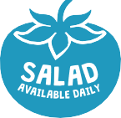

WEDNESDAY
CHOOSE FROM
V Handmade margherita pizza Bubble salmon
ON THE SIDE
Vegetables of the day and crinkle cut wedges
TO FINISH
Fruit and jelly
TUESDAY
CHOOSE FROM
V Macaroni cheese with Somerset cheddar
Chicken curry with a blend of brown and white rice
ON THE SIDE
Vegetables of the day
TO FINISH
Jam sponge
TUESDAY
CHOOSE FROM
V Tomato pasta
Italian style chicken goujons with diced potatoes
ON THE SIDE
Vegetables of the day
TO FINISH
Chocolate brownie
WEDNESDAY
CHOOSE FROM
V Handmade margherita pizza with crinkle cut wedges
Chicken and oriental style vegetable rice
ON THE SIDE
Vegetables of the day
TO FINISH
Fruit and jelly
TUESDAY
CHOOSE FROM
V Roasted vegetable lasagne
Chicken nuggets with diced potatoes
ON THE SIDE
Vegetables of the day
TO FINISH
Apple flapjack
WEDNESDAY
CHOOSE FROM
V Handmade margherita pizza with crinkle cut wedges
Ham carbonara with penne pasta
ON THE SIDE
Vegetables of the day
TO FINISH
Fruit and jelly

FRIDAY
CHOOSE FROM
Vg Vegetable and bean burrito Baked fish fingers and chips
ON THE SIDE
Vegetables of the day
TO FINISH
Freshly baked marble shortbread biscuit
THURSDAY
CHOOSE FROM
V Quorn chicken pieces in a Yorkshire pudding
Sliced beef and Yorkshire pudding
ON THE SIDE
Vegetables of the day, roast potatoes and gravy
TO FINISH
Lemon drizzle sponge
FRIDAY
CHOOSE FROM
Sweet potato and lentil curry with a blend of brown and white rice
Baked fish fingers and chips
ON THE SIDE
Vegetables of the day
TO FINISH
Ice cream topped with cream
FRIDAY
CHOOSE FROM
V Somerset cheddar cheese and potato frittata
Baked battered fish and chips
ON THE SIDE
Vegetables of the day
TO FINISH
Homemade cookies
THURSDAY
CHOOSE FROM
Vg Vegetable pastry crown
Roast chicken and Yorkshire pudding
ON THE SIDE
Vegetables of the day, roast potatoes and gravy
TO FINISH
Victoria sponge
THURSDAY
CHOOSE FROM
V Somerset cheddar cheese and tomato puff
Roast chicken and Yorkshire pudding
ON THE SIDE
Vegetables of the day, roast potatoes and gravy
TO FINISH
Chocolate orange sponge
Vg

Light bite options available. Daily sandwiches, jacket potatoes with fresh daily fillings

v – vegetarian vg – vegan

School dinners are charged at £2.80 per day for children in Nursery and Years 3-6.

All children in Reception, Year 1 and Year 2 are entitled to Universal Infant Free School Meals. Your child may also be entitled to free school meals if you meet certain economic criteria: https://www.staffordshire.gov.uk/Education/Educational-awards-benefits/FreeSchoolMeals/Apply-online.aspx

If children are going on a school trip you may book them a school packed lunch, which will be charged at the usual price of £2.80 for Nursery and Years 3-6:

ham or cheese sandwich
homemade cake
plain crisps
carrot or cucumber sticks
fruit shoot drink
sausage roll

Trip packed lunches must be ordered, by email or telephone, by 10am on the school day before the trip, (10am on Friday, if the trip is on Monday; last day of half-term if the trip is on the first day of half-term). No orders will be accepted after this time.

