This is just a little message for our schools’ newsletters to go alongside my summer term CEO letter which I write for staff and parents at the end of each half term. Our newsletters include important information tracking the development of our schools and Trust, together with local community connections and lots of pictures showing our many activities. You can review these newsletters at: <https://tssmat.staffs.sch.uk/about-us/letters-from-the-ceo> 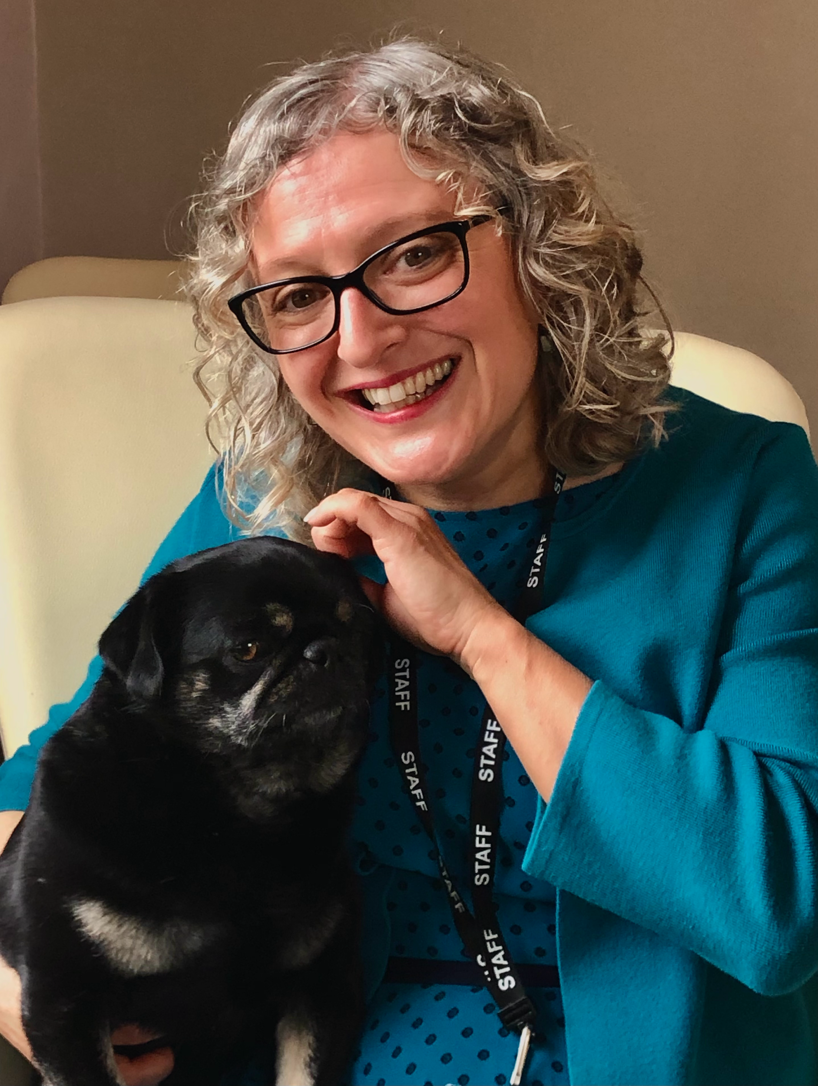

I’ve been in my wonderful part time CEO role for two years now and visit all our schools as regularly as I can to connect with staff and children, engage in events and enjoy school life whilst maintaining a strategic role of Trust development. This last year has been very busy and has seen the culmination of some big and exciting projects around school leadership and Trust growth. These impact directly on your children and strive to continue improving the quality of education that TSSMAT delivers. Some of the projects have included the constitution of 3 local governing bodies invested in your schools achievement and improvement, the development of the leadership structure to include an Executive Headteacher structure and Deputy Headteachers in each school as well as the next steps in trust Growth with a ‘yes’ from the Regional School Directorate (the local arm of the DFE Department for Education) for The Mease, Mary Howard and St Andrews Primary schools to join our Trust (subject to effective due diligence). We’ve had many more developments such as new menus and kitchen standards, all schools’ assets have been surveyed and targeted and we have centralised safeguarding and school compliance systems as well as a big decarbonisation plan and work towards this around chemical and plastic usage - it’s been fun and rewarding!

I am blessed to work with an excellent leadership team of Headteachers, our central team including our Finance Manager and Business Operations Manager and our new appointment of clerk and PA outlined in my letter, as well as our Trust leaders.

We have sent out an overview before but feedback suggests that some parent want to understand but don’t understand our structure, it’s hard to get to grips with Trust structures so here is a reminder! We have:

5 Members who play a limited but crucial role in safeguarding TSSMAT governance

9 Directors who are on the Trust Board which is the decision-making body of TSSMAT and is accountable and responsible for all of our academies equally in the MAT. The Trust Board is the employer of all staff. The Trust Board operates and makes decisions to further the Trust’s charitable objectives and the general control and management of the administration of TSSMAT. They have the following roles.

1. Chair of the Board of Directors. Director of Curriculum, Performance and Standards.
2. Vice Chair of the Board of Directors. Director of IT strategy, security and data protection
3. Director of Finance, Trading and Risk Management. Director of Whistleblowing. Director of Environmental Responsibility. Chair of Finance, Audit and Risk Committee
4. Director of Corporate Affairs Human Resources, Equality, Diversity and Inclusion.
5. Director of Wellbeing. Director of Stakeholder engagement
6. Director Pupil Care. (Safeguarding, vulnerable groups, nurture, provision and achievement.
7. Director of Strategy, Strategic Leadership and Development. Director of Christian
8. Director of Premises and Health and Safety. Director of Legal, Compliance and Audit
9. MAT Chief Executive Officer and Accounting Officer

4 Local Governing committees with between 5 and 9 Governors for each school.

I look forward to seeing parents, carers and wider families and communities as we enter our new academic year in September. I expect some of the first events will be Harvest Services, which we always love! Have a wonderful summer and see you soon.

.

Kind Regards,

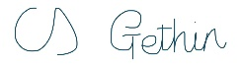

Mrs Charlene Gethin (CEO) and Ralph.