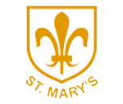
Class 4: Spring Term 2021
Overview
Congratulations on completing a long and challenging term! The children have been absolutely amazing and have continued to embrace their learning enthusiastically, even during these uncertain times.
We wish you all a restful and enjoyable Christmas break and we look forward to seeing you again in 2021!

Key information
Forest School | This half term there will be no forest school for Class 4. Forest school will continue as soon as possible.
Spellings | Spellings will be given out on a Monday and tested the following Monday.
Reading Diaries | Please aim to read 5 times a week. Diaries need to be in school every day. Books will be changed when completed and checked most days. Children are encouraged to fill in their own diaries in school and at home. One page of the diary should be used for one week of school.
Homework | Year 6 will receive regular homework in preparation for SATs. It is very important that they complete this each week as it will be used in class time.  TT Rockstars should be completed 5 times a week, reading books should be read daily and spellings should be learnt for our weekly spelling tests on a Monday. Spellings will be taught in class every day to allow children to develop their knowledge of the spelling rules and patterns. There will be no Big 60 tests anymore. Please see the spelling section of our Class page for more details.
PE Kits | PE lessons will take place every Monday and Thursday. Please continue to wear PE kits to school on these days. Hoodies and waterproof coats may be needed if sessions are held outside. There are still a number of tops that are not school uniform being worn please ensure they are plain black.
Mile a Day | Please have trainers easily accessible in school for our Daily Mile.
Coats | Please bring a coat to school. Please also make sure coats are labelled with your child’s name.
Uniform | Please remember that a blazer and tie are compulsory parts of the uniform and that your child should wear these at all times unless given permission otherwise. Please make sure all uniform is clearly labelled to avoid any loss.

What are we doing next term?
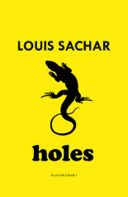  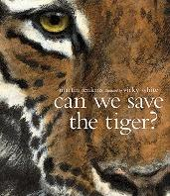  English | For our narrative text next term, we will be studying ‘Holes’ by Louis Sachar and using ideas generated from this for our creative writing lessons. We will also be using our reading skills to answer comprehension questions on the text, based on VIPERS.  We will then be looking at the non-narrative text ‘Can We Save The Tiger’ by Martin Jenkins.  Finally, we will have a poetry week, concentrating on the classic poem ‘The Tyger’ by William Blake and creating work in his style.  Please continue to support your child to learn their spellings and complete their homework.  CREATIVITY – RESILIENCE- PERSEVERANCE
Maths | In Maths this term, Year 5’s focus will be on multiplication and division, followed by fractions. Year 6 will be studying decimals and percentages, followed by algebra.  At home, please continue to use TT Rockstars as much as possible.  PROBLEM SOLVING - PERSEVERANCE - RESILIENCE
Geography | We will be looking at natural resources in Geography and discussing how their distribution affects human geography. Renewable and non-renewable resources will also be investigated and their strengths and weaknesses will be discussed.  Food sources of developed and less-developed countries and the impact of water distribution on them will also be researched and discussed.  LEADERSHIP - TEAM WORK
Art  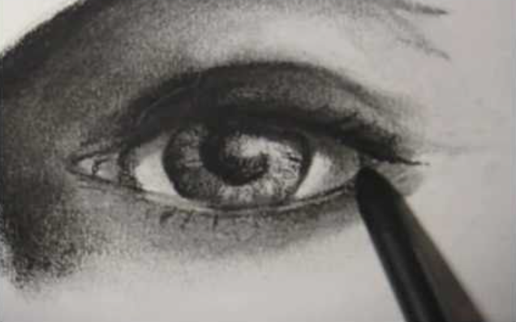 | In Art, we will be using charcoal and discussing the positives and negatives of using it. We will be using shading to create 3D images and to indicate light from various angles, along with giving depth to an image.  PERSEVERANCE - RESILIENCE - CREATIVITY
Science  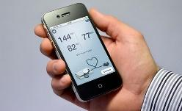 | This term in Science, we will be looking at the human circulatory system. We will be learning about its components, how it works and the factors which can positively and adversely affect it.  PROBLEM SOLVING - PERSEVERANCE - TEAMWORK
Religious Education | We will be learning about the Gospel and discussing, ‘What would Jesus do?’  The key messages of gospel stories will be identified and their impact on Christian beliefs will be discussed.  PERSEVERANCE - CALMNESS - CREATIVITY
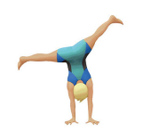  PE | PE will be Dance and Gymnastics this term. In dance, we will be concentrating on performance in groups, incorporating canon and unison techniques.  In Gymnastics, we will create routines demonstrating a variety of balances and ways of travelling, we will then build up to partner balances and ones involving apparatus.  RESILIENCE-PERSEVERANCE-TEAMWORK
Computing | We will be Coding this term. This will be a creative and engaging topic centred around Google and Google Classroom.  CREATIVITY-PROBLEM SOLVING-RESILIENCE

