KS2- Maths Bingo
Draw and label a street scene using 3 d shapes.  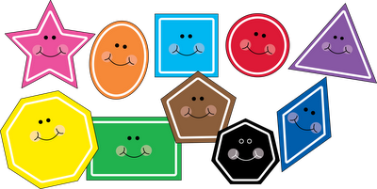 | Shop time!  Play shops by making amounts to pay in different ways for items!  Create amounts with decimals.  For example  £1.25, £3.56 | Problem of the Day!  https://whiterosemaths.com/resources/classroom-resources/problems/ | Andy Goldsworthy  Create a pattern using  Nature. Leaves, twigs and look at shapes, angles you have used. | Explore equivalent fractions  https://www.purplemash.com/#app/games/fracwall
Make cards of number bonds to 100 or decimal numbers adding up to 1.  Place them upside down and play memory game by matching the correct pairs. | Symmetry  Create a symmetrical pattern. | Look around you.  What can you see that has a mathematical connection? Write or draw any mathematical words or shapes in and around the space you are in. | Explore maths in Purple mash | Create a themed times tables chart.
Follow a recipe and weigh the ingredients using a scale. | Collect data on favourite colours and make a chart to show results using:  Bar chart, pictogram, tally chart | Look around your house to see how many angles you can spot:  Right, acute, obtuse, reflex . | Write your numbers to 100 and colour in the prime numbers. | Make a times tables rap.  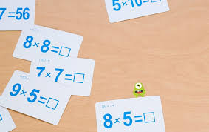
Write your numbers to 100 and colour in the square and cube numbers. | Go to your garden and make a target board with numbers.  Hit two number and multiply them.  Try other calculations. | Choose 5  2 -digit numbers. How many add/ su  btract sums can you make using them? | Choose 5  2- digit numbers. How many multiplication/ division sums can you make using them? | Write word problems.  Ask your house hold adults, siblings to solve it
Create your own maths game. | Play a game of snakes and ladders. | Tessellations  Create a tessellation pattern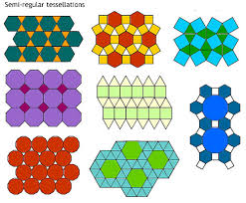 | What’s the time Mr Wolf?  Create a schedule of your day and add up time you spent on technology, exercising etc | How many different ways can you make 500 using various calculations.

