

**Christians show they want to be close to God through obedience, worship and saying sorry.**

**God offers forgiveness even when his people keep falling short.**

**Human beings do best when they listen to God.**

**The Bible shows that God wants to help people to be close to him -he keeps his relationship with them.**

**God the Creator cares for the creation, including human beings.**

**The Bible tells a story (in Genesis 3) about how humans spoiled their friendship with God (the fall).**

**LKS2 Unit 2A.1 – Creation/ Fall**

**What do Christians learn from the Creation Story?**

**Outcomes**

· Place the concepts of God and Creation on a timeline of the Bible’s ‘Big Story’.

Make clear links between Genesis 1 and what Christians believe about God and Creation.

Describe what Christians do because they believe God is Creator. (For example, follow God, wonder at how amazing God’s creation is; care for the earth in some specific ways.)

Ask questions and suggest answers about what might be important in the creation story for Christians living today, and for people who are not Christians.

**Key Vocabulary**

**Creation**

Causing something to exist

**Creator**

The maker; God

**Human**

A person

**The Fall**

The breakdown of the relationship between God and his people.

**Genesis**

The first book of the Bible

**Stewards**

Stewardship is a theological belief that humans are responsible for taking care of the world

**Ten Commandments**

A set of rules/laws given to Moses for the people by God

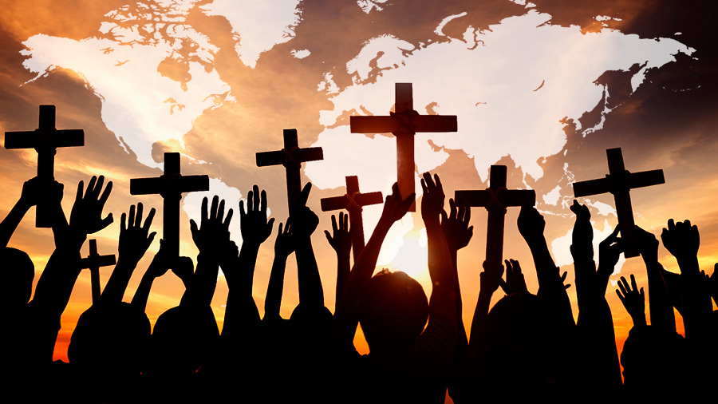

**Christians believe following God includes: trusting, obeying and believing God’s promises.**

**Noah was trying to do away with evil in the world and make it a better place.**

**People of God believe that God promises to stay with them.**

**Noah was one of the people of God trying to follow his commands.**

**.**

**The Old Testament tells the story of the children of Israel (People of God).**

**The People of God try to follow God by following his commands.**

**Outcomes**

· Make clear links between the story of Noah and the idea of covenant.

Make simple links between promises in the story of Noah and promises that Christians make at a wedding ceremony.

Make links between the story of Noah and how we live in school and the wider world.

**LKS2 Unit 2A.2 – People of God**

**What is it like to follow God?**

**Key Vocabulary**

**Covenant**

Promises made by two people to each other

**Command**

Being told to do something

**Promise**

Saying you will do something.

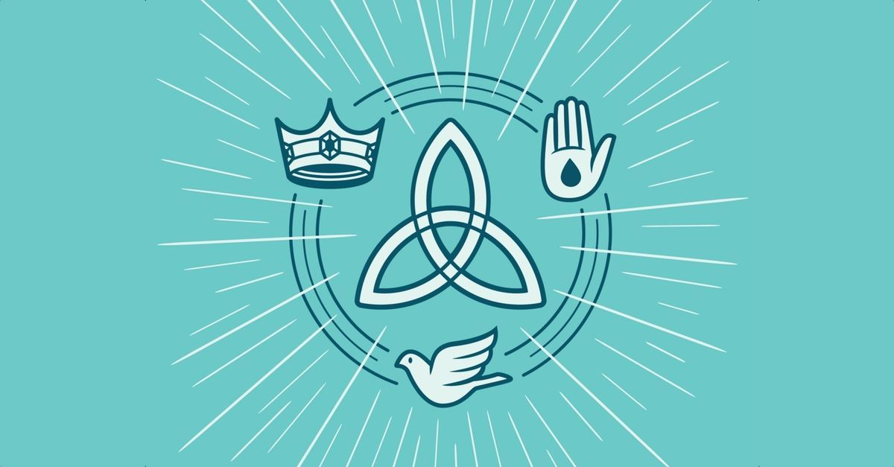

**Christians believe the Holy Spirit is God’s power at work in the world and in their lives.**

**Christians try to describe God using symbols, similes & metaphors, song, stories, poems and art.**

**Christians use art to represent the Trinity**

**Christians find learning about God a challenge.**

**Christians believe the Son sends his Holy Spirit to His followers.**

**Christians believe the Father sends the Son.**

**Christians believe God is Trinity: Father, Son and Holy Spirit.**

**Key Vocabulary**

**Incarnation**

God in human form

God in the flesh

**Trinity**

The three persons in one God.

Father, Son, Holy Spirit

**Baptism**

Welcome into the Christian church using water

**Immersal**

Dip the whole body in water for baptism**.**

**Outcomes**

· Identify the difference between a ‘Gospel’, which tells the story of the life and teaching of Jesus, and a letter.

Offer suggestions about what texts about baptism and Trinity might mean.

Give examples of what these texts mean to some Christians today.

Describe how Christians show their beliefs about God the Trinity in worship (in baptism and prayer, for example) and in the way they live.

Make links between some Bible texts studied and the idea of God in Christianity, expressing clearly some ideas of their own about what the God of Christianity is like.

.

**LKS2 – Unit 2A.3 – Incarnation/ God What is the Holy Trinity?**

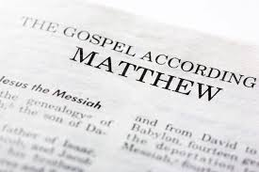

**Christians try to be like Jesus, using his example in worship and by helping people.**

**Christians believe Jesus shows love and forgiveness to unexpected people.**

**Jesus sets the example of putting others first,**

**Christians believe Jesus shows people how to love God and their neighbour.**

**Christians believe Jesus shows people how to live.**

**Outcomes**

Identify this as part of a ‘Gospel’, which tells the story of the life and teaching of Jesus.

Make clear links between the calling of the first disciples and how Christians today try to follow Jesus and be ‘fishers of people’.

Offer suggestions about what Jesus’ actions towards the leper might mean for a Christian.

Make simple links between Bible texts and the concept of ‘Gospel’ (good news).

Give examples of how Christians try to show love to all, including how members of the clergy follow Jesus’ teaching.

Make links between the Bible stories studied and the importance of love, and life in the world today, expressing some ideas of their own clearly.

.

**Key Vocabulary**

**Gospel**

The books of the Bible which are about Jesus’ life.

**Disciple**

Someone who follows Christ

**Leprosy**

A disease of the skin. People have sores on their body

**LKS2 – Unit 2A.4 – Gospel**

**What kind of world did Jesus want?**

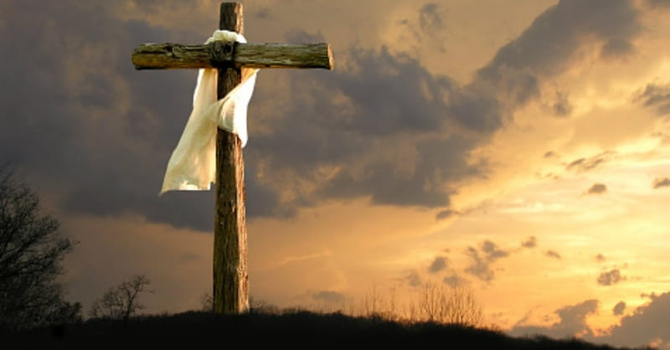

**Christians remember and celebrate Jesus’ last week, death and resurrection at Easter.**

**Outcomes**

. Order Creation and Fall, Incarnation, Gospel and Salvation within a timeline of the Bible’s ‘big story’.

Offer suggestions for what the texts about the entry into Jerusalem, and the death and resurrection of Jesus might mean.

Give examples of what the texts studied mean to some Christians.

Make simple links between the Gospel texts and how Christians mark the Easter events in their church communities.

Describe how Christians show their beliefs about Palm Sunday, Good Friday and Easter Sunday in worship.

Make links between some of the stories and teachings in the Bible and life in the world today, expressing some ideas of their own clearly.

.

**Christians believe that Jesus is still alive today.**

**Christians believe that Jesus rose from dead.**

**The Last Supper and other events from Holy week were important in showing the disciples what Jesus came to earth to do.**

**Christians see ‘Holy Week’ as the most important part of Jesus’ life resulting in his death and resurrection.**

**Key Vocabulary**

**Incarnation**

God in human form

God in the flesh

**Salvation**

Jesus rescuing people

**Crucifixion**

being killed by being nailed to a cross

**Resurrection**

coming back alive

**Easter**

Festival when Christians celebrate Jesus resurrection

**Holy Week**

The week leading up to Easter including Palm Sunday and Good Friday

**Betrayal**

**LKS2 – Unit 2A.5 – Salvation**

**Why do Christians call the day Jesus died Good Friday?**

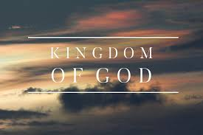

**Christians believe the Holy Spirit is a helper, comforter and guide in their lives.**

**Christians celebrate Pentecost as the beginning of the Church.**

**Key Vocabulary**

**Pentecost**

The day when the Holy Spirit was given to Christians.

**Holy Spirit**

One of the three persons of the Trinity of God.

**Guide**

Someone who shows the way.

**Comforter**

Looks after in times of need.

**Christians believe that the Holy Spirit shows Jesus’ kingdom by living lives reflecting love.**

**Christians believe after Jesus died he sent the Holy Spirit to his followers.**

**Christians believe Jesus is still alive and rules in their hearts by the Holy Spirit.**

**Christians believe Jesus’ life shows that God is King in heaven and on earth.**

**Outcomes**

· Make clear links between the story of the Day of Pentecost and Christian belief about the Kingdom of God on Earth.

Offer suggestions about what the description of Pentecost in Acts 2 might mean.

Give examples of what Pentecost means to some Christians now.

Make simple links between the description of the Day of Pentecost in Acts 2, the Holy Spirit and the Kingdom of God, and how Christians live their whole lives and in their church communities.

Make links between ideas about the Kingdom of God explored in the Bible and what people believe about following God in the world today, expressing some of their own ideas.

**LKS2 – Unit 2A.6 – Kingdom of God**

**When Jesus left what was the impact of the Pentecost?**