Class 4 Home Learning – Week 1
 | Monday | Tuesday | Wednesday | Thursday | Friday
Activity 1 | Reading  The Final Push (Fiction) | Reading  The Conquest of Everest (Non-Fiction) | Reading  River Rescue  (Fiction) | Reading  The River Amazon  (Non-Fiction) | Topic: Art  - What is surrealism?  -Who is Salvador Dali?  -Draw like Dali
Activity 2 | Maths  Place Value | Maths  Place Value | Maths  Place Value | Maths  Place Value
Activity 3 | Writing  Subordinate Clauses | Writing  The Lighthouse – Continue the Story | Writing  Sort persuasive vocabulary | Writing  For Sale! Write a persuasive advert
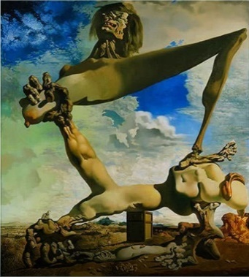
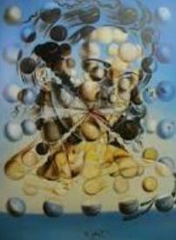
Topic Focus: Art – Surrealism
This week, we are going to be finding out about Surrealist art and the famous Surrealist artist Salvador Dali.
Explore this website to find out more - https://www.tate.org.uk/kids/explore/what-is/surrealism

Please continue to read every day and record it in your reading record.
Use TT Rockstars to improve your times-table fluency.
MATHS
The activities provided in this home-learning booklet are generic challenges to improve fluency in Mathematics.
Please contact the school for your child’s White Rose Maths booklet in order for your child to continue their current learning. Directions will be given to the appropriate teaching videos to support each lesson.

Subordinate Clauses
Watch the videos at BBC Bitesize before completing the activity to give you a reminder about subordinate conjunctions
https://www.bbc.co.uk/bitesize/topics/zwwp8mn/articles/zqk37p3
The Lighthouse
Writing Challenge

Continue the story. Try and include a range of subordinating conjunctions e.g. while, as, when, although

Think about these questions before you start writing.

-Can you describe what it feels like to be caught in a storm?
-What do you think the men heard when they listened to the storm?
-Who might the men in the lighthouse be?
-Why are they huddled together?

The storm had been raging for hours. Like a besieging army tormenting an enemy’s ramparts, the waves battered on the lighthouse walls.
A group of men huddled in one of the cylindrical shaped rooms, flinching every time a wave rocked the lighthouse. Their hearts were in their mouths with every devastating blow: they half expected the walls to come tumbling down at any moment.
They turned their heads and listened to the sound of the storm. What they heard was truly terrifying…
_______________________________________________________________________________________________________________________________________________________________________________________________________________________________________________________________________________________________________________________________________________________________________________________________________________________________________________________________________________________________________________________
Persuasive Writing
Sorting Advertisement Vocabulary
Write the vocabulary in the correct column in the table
-20% off! Whilst stocks last -The Moon orbits the Earth
-Bang! The fireworks exploded -Do you want bright, white teeth?
-Cut along the dotted line -I am writing to request…
-For a limited time only -Blizzards set to blast country
-Be the envy of all your friends -Cool trainers designed for cool kids
-Many thanks for your reply -Smart people choose smart prices!
-Our breathtaking beach resort offers -How does a telescope work?
a small slice of paradise

I should use these in an advertisement | I should not use these in an advertisement

Challenge: Can you think of any more statements you could use in an advertisement to persuade someone to buy your product?

For sale!

Imagine you are an estate agent and you have got to sell this celebrity mansion. Write a paragraph that will entice a buyer into investing in this property. What details can you include to make it desirable?

Toolkit
Example
For sale!
Wouldn’t you love to be owner of this amazing property? This celebrity mansion is perfect for people who like to party and live the high life. It is ideally placed for the city centre railways. The spacious garden and parking area is an added bonus. It comes with an exquisite view that money just can’t buy and the giant pool adds that wow factor. You won’t be disappointed if you choose to be the proud owner of this house. A snip at 10 million pounds!
-rhetorical questions (Have you dreamed of…?/Wouldn’t you
love to….?)
-superlatives/exaggeration (the best…., the most…., the biggest
-positive adjectives and feelings ignoring any negatives
- a hook or a promise (you won’t be disappointed…)

_____________________________________________________________________________________________________________________________________________________________________________________________________________________________________________________________________________________________________________________________________________________________________________________________________________________________________________________________________________________________________________________________________________
Maths – Place Value
Information for Parents
Place value is the value of each digit in a number. For example, the 5 in 350 represents 5 tens, or 50; however, the 5 in 5,006 represents 5 thousands, or 5,000. It is important that children understand that whilst a digit can be the same, its value depends on where it is in the number. It is essential that children understand this whether they are working with two digit numbers or seven digit numbers.

millions |  |  | hundreds |  |  | ones
h | t | o | h | t | o | h | t | o

Often children are asked to compare two (or sometimes more) numbers using inequality symbols (< and >). To help your child remember which symbol to use it is useful to remind them that the open side of the symbol should be closest to the larger number. These images can be useful with that.
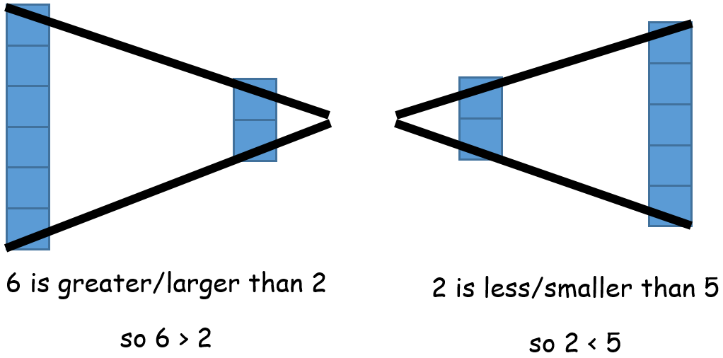

Key Vocabulary
more greater less smaller digits value compare order

If you would like further support with how to help your child more with understanding place value please have a look at the following website which contains a number of useful video clips.
https://www.oxfordowl.co.uk/for-home/advice-for-parents/learning-at-home-videos/parent-how-to-videos/how-to-help-with-place-value-videos/

Monday
Activity 1
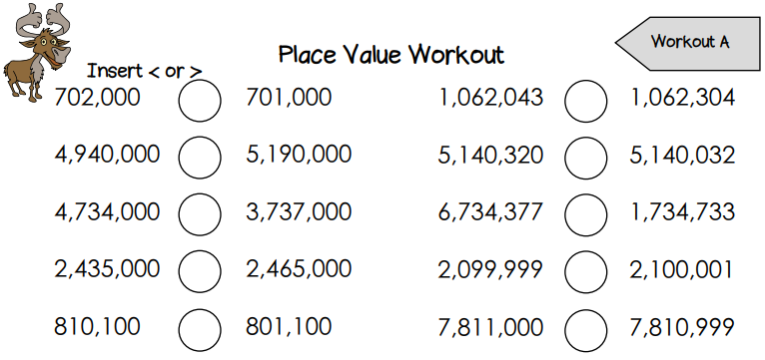

Tuesday
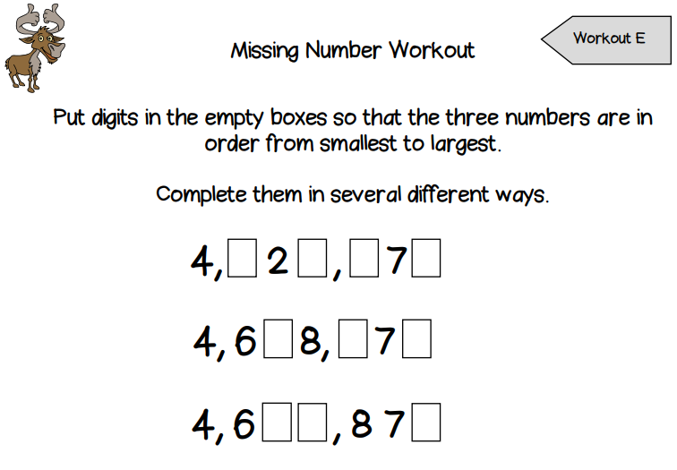
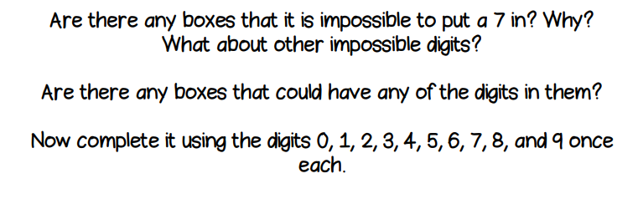

Wednesday
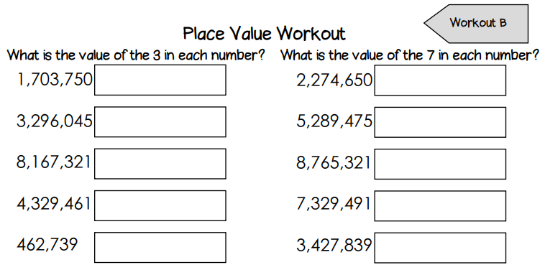

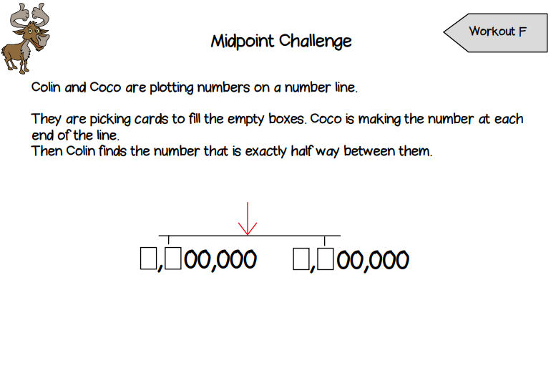
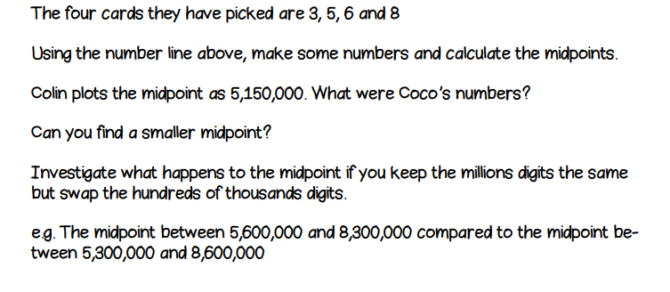
Thursday
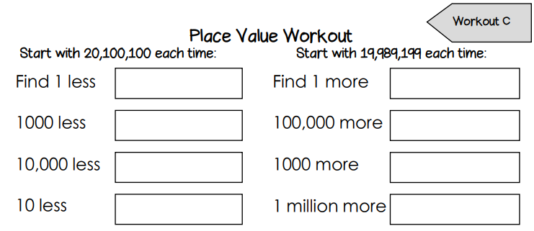

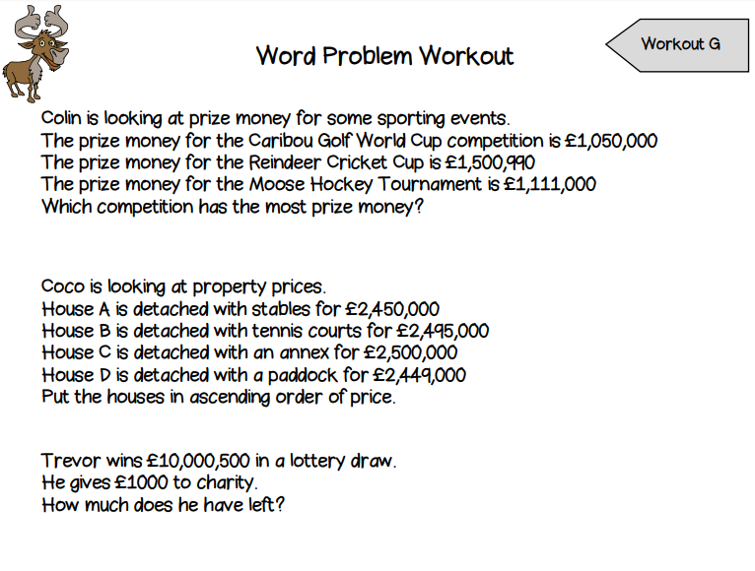
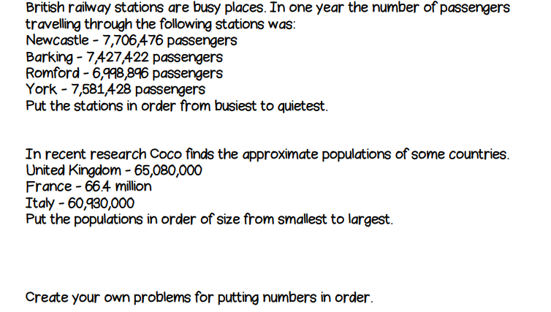

Optional
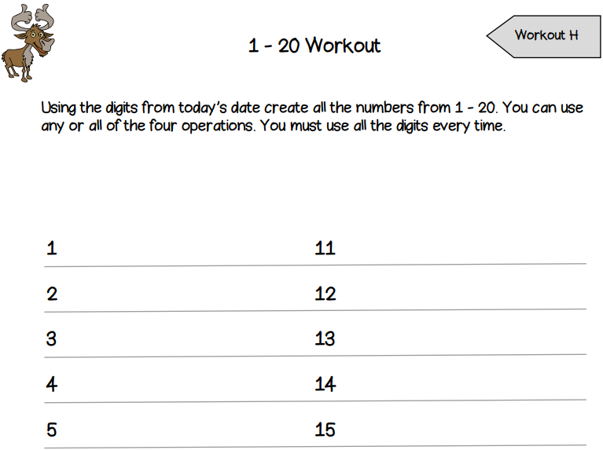

Activity 1 – What is Surrealism?
Watch this video to find out more about Surrealism and answer the questions below.
https://www.tate.org.uk/kids/explore/what-is/surrealism
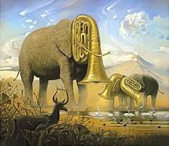
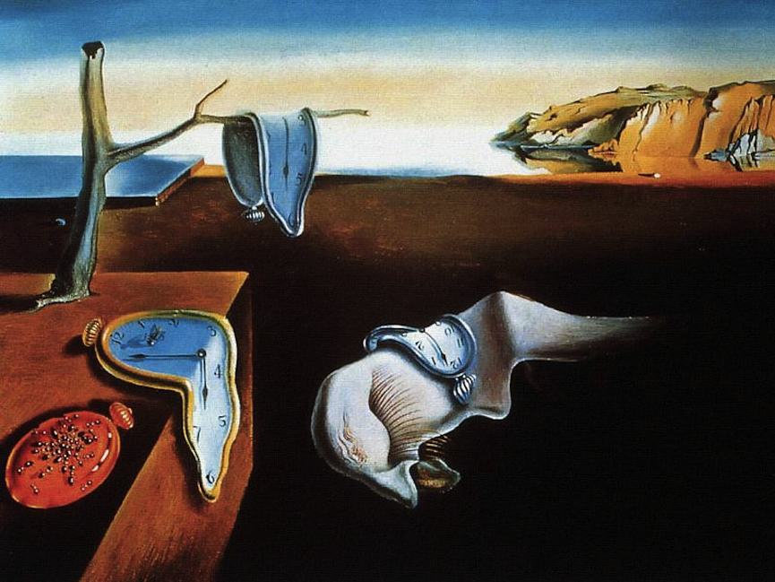
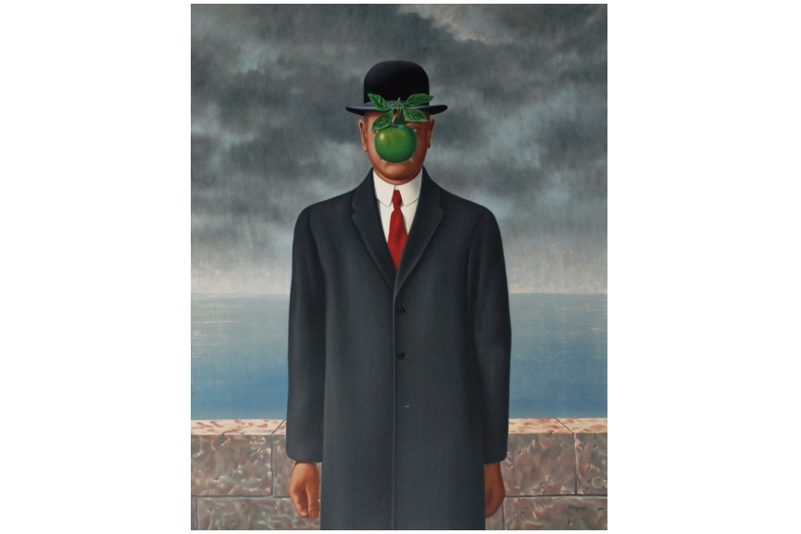
- Who started the Surrealist art movement?

- Describe the two types of Surrealist art.
i.____________________________________
ii.____________________________________

3) Which country did Salvador Dali come from?

Activity 2 – Who is Salvador Dali?
Welcome to the weird and wonderful world of Salvador Dali.
Salvador Dalí made paintings, sculptures and films about the dreams he had. He painted melting clocks and floating eyes, clouds that look like faces and rocks that look like bodies.
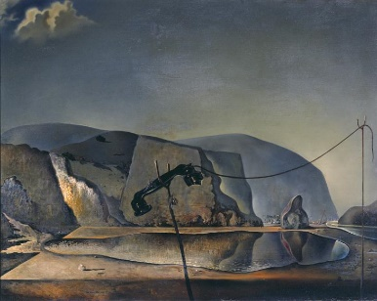
Sounds weird right? Think about what your paintings would look like if you painted your dreams? I bet they would be pretty weird too!
Dalí was involved with surrealism. This was an art movement where painters made dream-like scenes and showed situations that would be bizarre or impossible in real life. Look at this painting – does the lake look like a fish to you?
Surrealist artists were influenced by a famous psychoanalyst called Sigmund Freud. A psycho analyst is a doctor who studies the human mind and tries to understand it. Freud believes our mind was divided into two parts: the conscious part and the unconscious part. The conscious mind is what we use to make decisions every day, like whether we walk or ride a bike to school. The unconscious mind is where our memories are stored. Most of the time we are not aware of our unconscious mind, but sometimes the memories stood there get mixed up in our dreams and this is what Dali tried to paint.
Dali was born in 1904 in Figueres, Spain which is near the Pyrenees Mountains. Surrounded by this landscape as he was growing up, Dali often included the scenery he saw as a boy in his paintings.
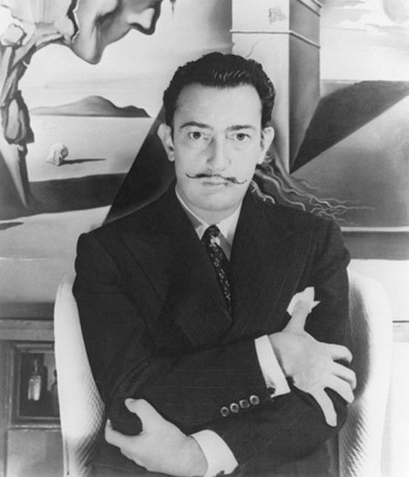
Salvador Dalí was a very eccentric man. Here is a picture of him
You can always recognise him because he has a funny moustache. He liked to dress in crazy clothes and have long hair which people found very shocking at the time.
Dalí was even expelled from art school just before his final exams because he said that none of the teachers were qualified to examine him. Cheeky!
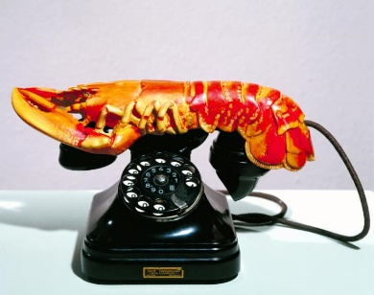
Salvador Dali went to Paris after leaving art school, which was where he met surrealists. The surrealists appealed to his wild sense of humour, they invented surrealist games and enjoyed putting different objects together to make something playful and disturbing at the same time. Here is Dali’s version of a surrealist sculpture. It is called Lobster Telephone.
When Dalí was in Paris he also made a film with the director Luis Buñuel called Un Chien Andalou (An Andalusian Dog). It was the first surrealist film and had no plot, just a series of scenes that only slightly link together. Later, Dalí went to Hollywood and worked on other films with famous directors like Alfred Hitchcock and Walt Disney.
Dalí liked to use lots of different materials to make art, including paint, sculpture and film. He even designed furniture, jewels and scenery for theatre production. He was a man of many talents and he is still seen as a great artist who influences many artists today!
What do you think of Dalí's artwork? Is it funny, weird...scary?
Questions
- Who was a big influence on surrealist artists like Salvador Dali?
- What year was Dali born?
- Which city did Dali move to after leaving art school?
- Dali was described as a man of many talents. In addition to painting, write down 2 other things he did in his life.
i)
ii)

Activity 3 – Draw like Dali?
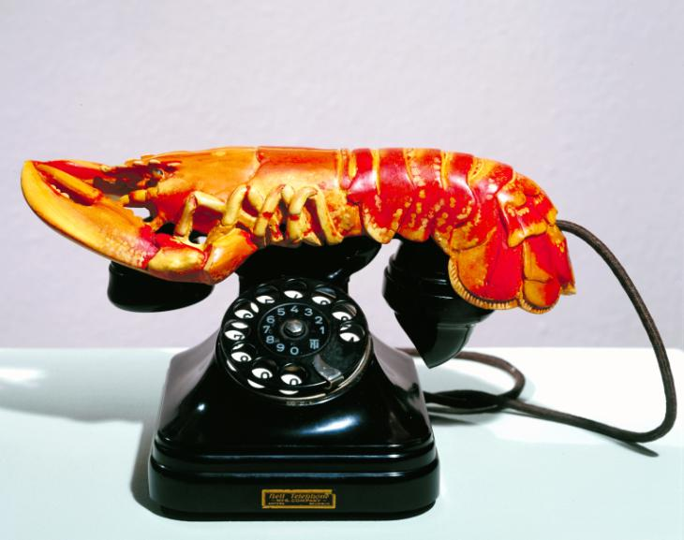
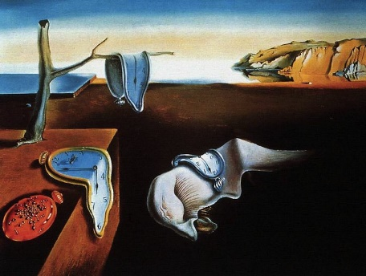
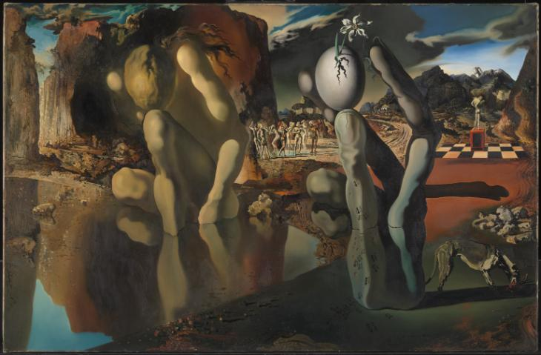
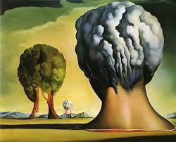

Dali drew some crazy and memorable pictures! Why don’t you have a go at drawing your own Dali picture?
You could follow a tutorial online at https://www.youtube.com/watch?v=H025Ekv6KVY
Or…you could create your own picture by combining some everyday objects.
Pick 3 objects, combine them and create a Dali style picture like this strange ice cream fish riding a bike with doughnuts for wheels.

