Class 4 Home Learning – Week 2
 | Monday | Tuesday | Wednesday | Thursday | Friday
Activity 1 | Reading  Stranded in a cave (Fiction) | Reading  The Cave  (Poetry) | Reading  The History of Castles (Non-Fiction) | Reading  The Family Outing (Non-Fiction Playscript) | Topic: Oceans  -Label the oceans.  -Research the oceans of the world.  -Create an ocean creature.
Activity 2 | Maths  Add decimals within 1 | Maths  Subtract decimals within 1 | Maths  Fractions, Decimals, Percentages | Maths  Fractions, Decimals, Percentages
Activity 3 | Writing  Fronted Adverbials | Writing  Continue the story  New York Is Falling | Writing  Poetic Sentences | Writing  Relative Pronouns
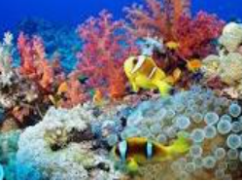
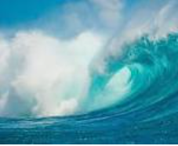
Topic Focus: Oceans
World Ocean Day is celebrated in June every year. Visit this website for lots of amazing information and videos about the ocean
https://worldoceanday.school/

Please continue to read every day and record it in your reading record.
Use TT Rockstars to improve your times-table fluency.
MATHS
The activities provided in this home-learning booklet are generic challenges to improve fluency in Mathematics.
Please contact the school for your child’s White Rose Maths booklet in order for your child to continue their current learning. Directions will be given to the appropriate teaching videos to support each lesson.

Fronted Adverbials
A fronted adverbial is a word, phrase or clause that is placed at the start of a sentence. They are used to explain how (manner), when (time), frequency or where (place) something happens. A fronted adverbial is separated from the main clause with a comma. For example:
Like a speeding bullet, Superman flew through the sky.

New York is falling!
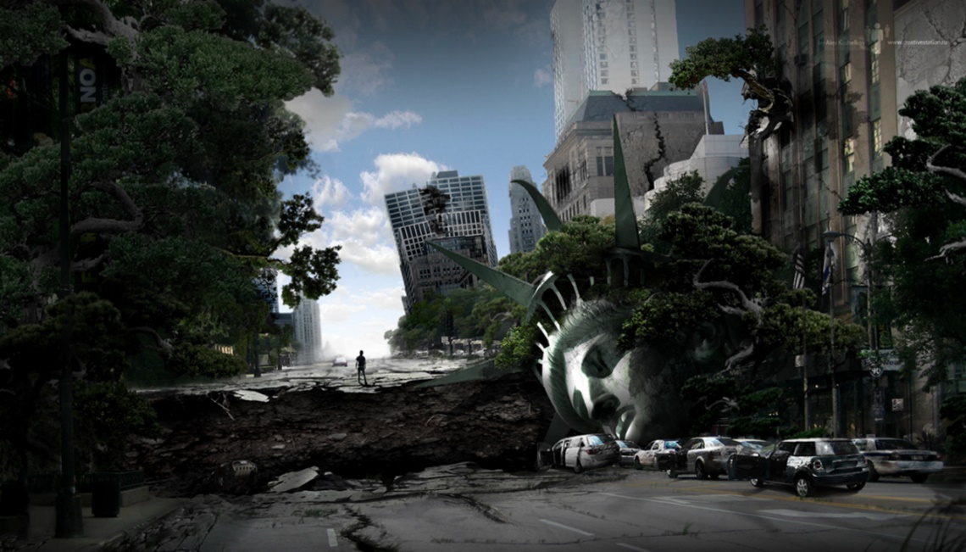
Writing Challenge

Continue the story. Try and include a range of Fronted Adverbials.

Read the opening to the story and think about these questions before you start writing.

-Why had the radio stopped working?
-Why hasn’t Jim heard any words for three days?
-What has happened in New York?
-How do you think Jim is feeling?
-What will he do next?
-What would you do in Jim’s position?
-Has this disaster struck in just this city, or are others affected?

New York is falling!
The words rang in Jim’s head. They were the last words to crackle out of the radio before it stopped broadcasting. That had been three days ago. Jim had not heard any words since then…
________________________________________________________________________________________________________________________________________________________________________________________________________________________________________________________________________________________________________________________________________________________________________________________________________________________________________________________________________________________________________________________________________________________________________________________________________________________________________________________________________________________________________________________________________________________________________________________________________________________________________________________________________________________________________________________________________________________________________________________________
Poetic Sentences

This is an excellent game for helping improve our language and ideas.
- In this activity we will use a repeating pattern to help emphasise the idea of writing interesting sentences, e.g.

In my magic box there is a leaping lizard.
In my magic box there is a cool cloud.
In my magic box there is a terrifying tiger tickling a trout’s tail.
In my magic box there is a red bus trundling along.
In my magic box there is a fingernail just like a thin moon…

- Now it’s your turn. Write your own interesting sentences. Try and include alliteration, similes, expanded noun phrases, interesting verbs.
In my magic box there is a ___________________________________________
In my magic box there is a ___________________________________________
In my magic box there is a ___________________________________________
In my magic box there is a ___________________________________________
In my magic box there is a ___________________________________________

Relative Pronouns
Relative pronouns are used to combine ideas/information and extend sentences.
Your challenge below is to make two sentences become one by changing the pronoun in the second sentence into a relative pronoun and joining the two together (remember to add a comma before the relative pronoun). For example:
Mrs Smith was my teacher. She taught me in Year 2.
Mrs Smith was my teacher, who taught me in Year 2.

Maths (Monday)
WALT: Add decimals within 1
Top tip: Don’t forget to line up the digits in their correct place value when using the column method.
Warm Up
  - 0.64 + 0.32 2) 0.472 + 0.02 3) 0.185 + 0.234 4) 0.891 + 0.017
Do it
Solve it
Twist it

Maths (Tuesday)

WALT: Subtract decimals within 1

Do it
Solve it
Twist it

Maths – Fraction, Decimals, Percentages (Wednesday)

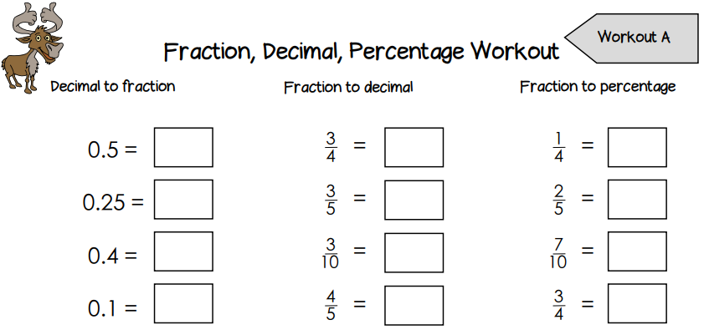

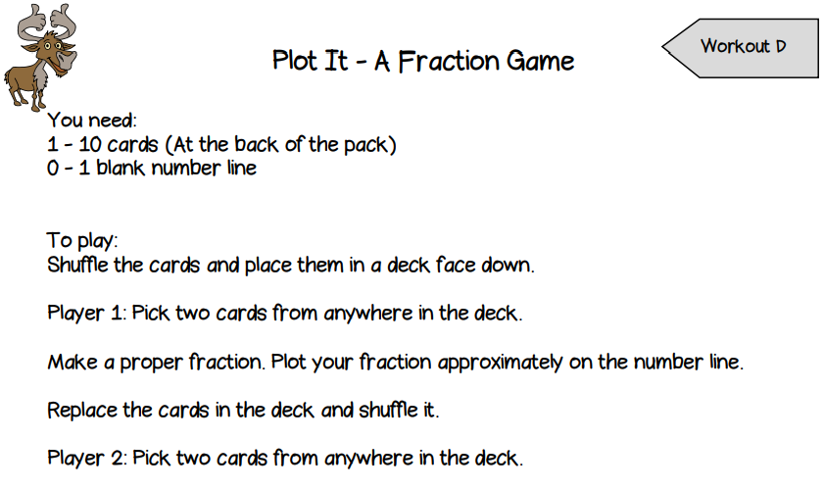
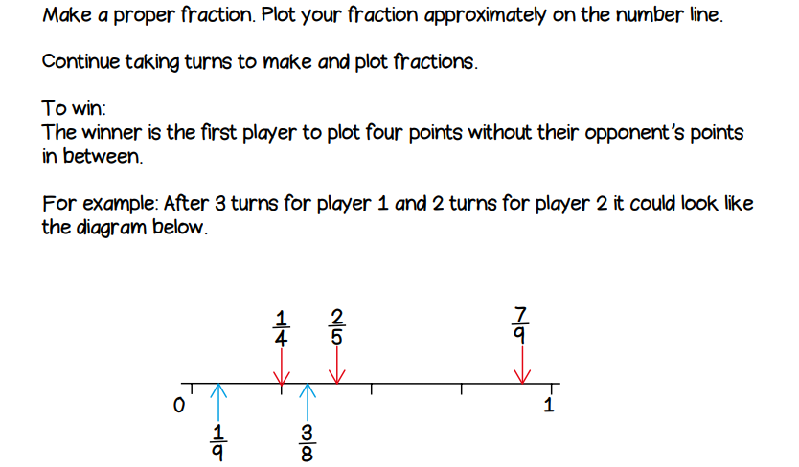
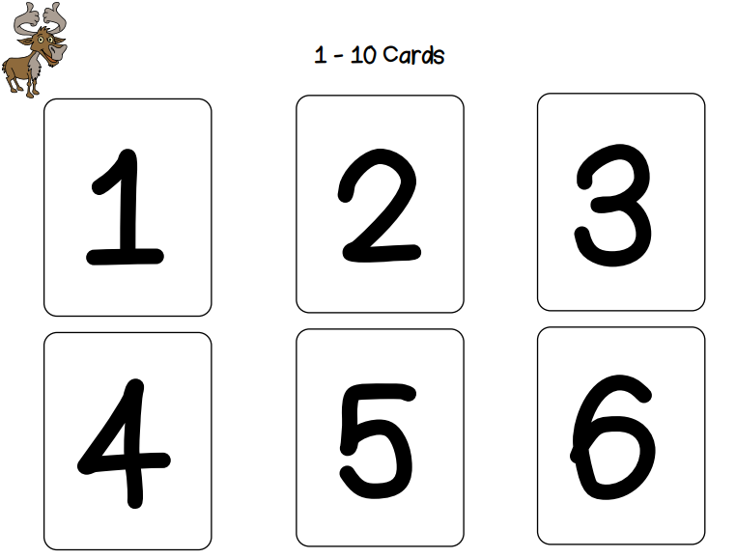
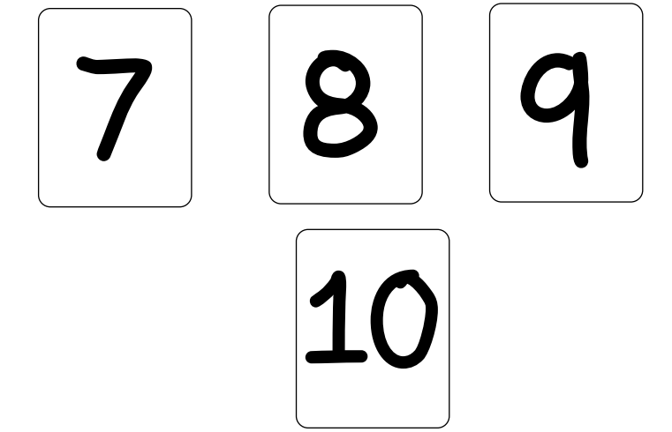
Maths – Fraction, Decimals, Percentages (Thursday)
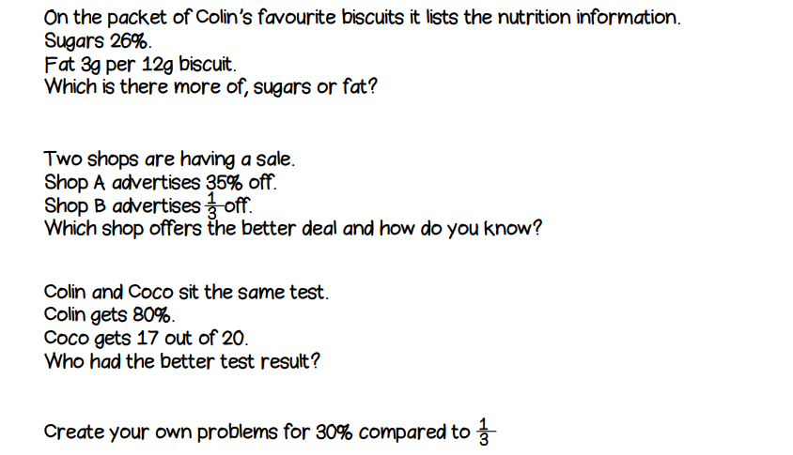
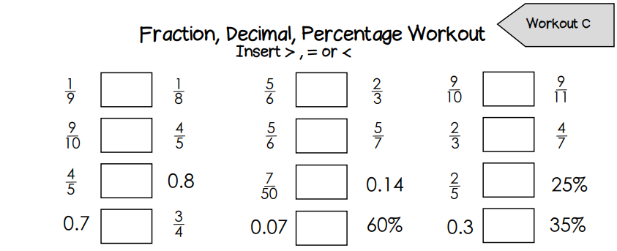

Topic: Oceans
Activity 1: Label the oceans of the world

Activity 2: Find out facts about each ocean.
You should be able to write a sentence about each ocean.
You could produce a fact file for one of the oceans, like the example below:

Activity 3: Create a Cool Ocean Creature
The Ocean is full of cool, colourful sea creatures.
Can you create your very own sea creature to live in one of the world’s oceans?
You could design and draw a colourful sea creature, design and junk-model a 3-D creature out of things lying around the house (ask permission first!) or create a new species for the oceans.
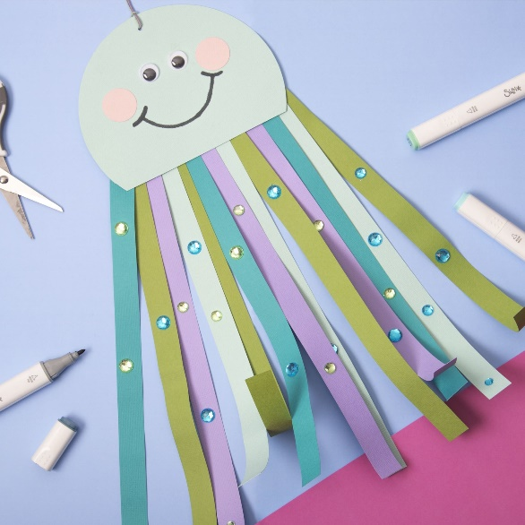
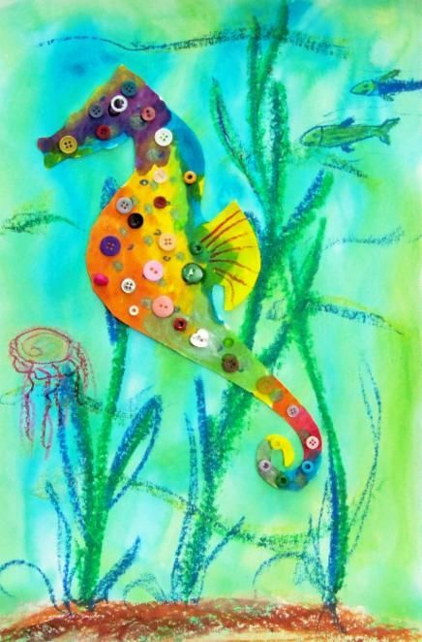
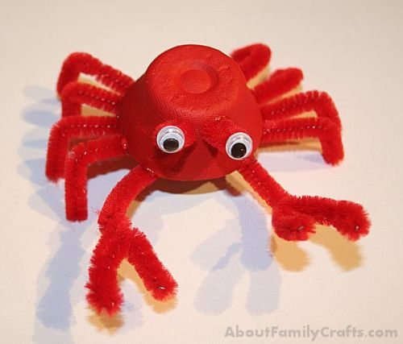
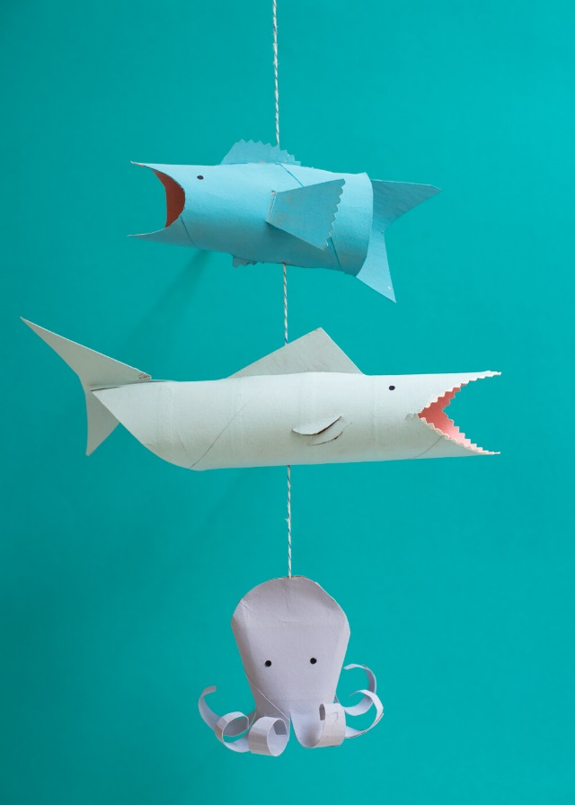
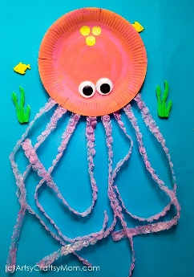
Here are a few examples….

